THE SUSCEPTIBILITY OF FRESHWATER

FISHES TO ROTAVIRUS INFECTION

MARZOUK, M. S.¹, M. M. Ali², M. A. A. ESSA ³ and M. D. IBRAHEM ¹

- Department of Fish Disease and Management, Faculty of Veterinary Medicine. Cairo University, Giza- 12211, Egypt.
E mail: mai_ibrahim12@yahoo.com
- Department of Veterinary hygiene and Management, Faculty of Veterinary Medicine. Cairo University, Giza- 12211, Egypt.
- Department of Fish Disease and Management, Faculty of Veterinary Medicine. BaniSuef University, Egypt.

Abstract
Experimental infection of Oreochromis niloticus and Cyprinus carpio with bovine rotavirus (NCDV) using various routes (intraperitoneal injection, immersion and per/os) revealed that O. niloticus infected by oral route developed skin darkening, hemorrhages, tucked up abdomen and tail fin rot. Internally, severe degeneration in the liver, distention of the gall bladder, inflammation of the intestine and enlargement of the spleen were observed. Unlike O. niloticus, C. carpio did not show any characteristic clinical signs except for petechial hemorrhages on the skin. Redetection of the inoculated virus was carried out from both types of fish using Latex agglutination test and Antigen capture ELISA .
Histopathological examination of experimentally inoculated specimens revealed the presence of degenerative changes in the hepatocytes, congestion of hepatoportal blood vessels, aggregation of melanomacrophages, lymphocytes and RBCs in between the hepatocytes, while the most common lesions in the intestine were the desquamation of the tips of the villi in the intestine.

Key words: Rotavirus, Oreochromis niloticus, Cyprinus carpio L, experimental infection, Latex agglutination, Antigen capture-ELISA, Electron microscopy

INTRODUCTION
Fish culture is a major of investment for commercial production. The expense of rations and their ingredients constitute the most important factors manipulating the outcome of fish culture projects especially those of semi-intensive and intensive nature. The trend to decrease the cost of ration formulation has been directed to either enhancing the natural food, namely the phyto- and zooplankton, or the use of animal manure as a source of fish diet (Marcel Huet, 1986, Keiser, et al. 2005, FAO, 2007 and Rogers, et al. 2008).
The application of organic fertilizers as well as the use of agricultural drainage water or even treated sewage water usually cause drastic deterioration of water quality parameters leading to elevated levels of ammonia, nitrites and nitrates, especially in farms which do not use any sort of biological water filters (Costa et al., 1985, IFC ,2007 and Vilaseca,2007).
The intensification of any stressed fish species, is usually connected with several problems of which infectious diseases caused by different types of infectious agents, take a superior importance (Noga 1996). The investigation of the effect of viral diseases on different fishes in the subtropics has been ignored partially due to the usually high water temperature and the very short life-span of fish viruses in the aquatic environment (Post 1987 and Sudthongkong, et al., 2002). The frequent occurrence of disease outbreaks among cultured fish and the possibility of subsequent consumers’ health hazards could increase the suspicions of the mixed etiology of which viruses could play an important role particularly due to their immuno-suppressive biological characters on fish as well as their intracellular habitation that leads to reduced or absent response to therapeutic mettles (ELLis, 1988 and Webster , 2004).
The role of the non-specific viral pathogens namely, Rota viruses in the pathogenesis of fish disease outbreaks is expected because of the frequent deterioration of the aquatic environment under high organic load, (Nagiub et al., 1997 and El-Shafai, et al, 2004). Therefore, this study was planned to fulfill the following objectives:
- Investigation of the histo-pathological lesions in different experimentally inoculated fish organs.
- Demonstration of the viral particles in experimentally inoculated fish in the target organs through electron microscopic examination.
MATERIALS AND METHODS

Fish used in experimental studies
A total number of 240 apparently healthy specimens (120 O. niloticus and 120 C. carpio L) were used in the inoculation experiments. O. niloticus were obtained from private fish farm, Khaliobia Governorate 100-150 g and 12-15 cm, respectively. C. carpio were obtained from the Central Laboratory for Aquaculture Research, Abbassa, Sharkia Governorate with a body weight and length range of 150- 200 g and 15-20 cm, respectively. The fish were acclimatized in twelve glass aquaria with dimensions of 40x 30x80 cm filled with chlorine-free tap water under experimental conditions (pH 7.8, DO 6.5 mg/L, total hardness 190 mg/L as CaCO₃, total alkalinity 117 mg /L as CaCO₃. Water temperature was maintained at 22 ± 2ºC. A locally produced fish diet containing the principal nutritional requirements for tilapia and carp according to Jauncy and Ross (1982) was used for feeding the fish throughout the experiments.

Experimental design

The experimental fishes in each species were divided into 4 groups of 10 fish each. Prior to the experiment, fish were acclimatized to the environmental conditions for 7-10 days. Feeding was stopped two days before the start of the experiment. Random samples of the experimental fish were sacrificed. Intestinal scraps and intestinal contents were tested virologically by Antigen capture-ELISA to ensure their negativity for rotavirus.

the Adaptation, cultivation, propagation and titration of bovine rotavirus NCDV strain was done on tissue culture (Monuz et al, 1994), (.the virus titer was 1X10⁶). The first groups of O. niloticus & C. carpio were experimentally infected with Nebraske calf diarrhea virus (NCDV) through intra-peritoneal inoculation, while the second group was experimentally infected through immersion method. The third group was infected orally. A parallel 4th group was maintained in a virus free environment. The duration of the experiment was 7 days. The experiment in each group of both fish types was carried out in triplicate as shown in table (1)
Table 1. Route, dose and Rotavirus titer in experimentally inoculated fishNile tilapia and common carp.

Type of fish. | Route of inoculation | Dose | Virus titer/infection dose | Water temperature
O. niloticus | I.P | 0.2m/fish | 1X10⁶ | 22 ± 2ºC
O. niloticus | Immersion | Mixed with water | 1X10⁶ | 22 ± 2ºC
O. niloticus | Per/os | Mixed with food | 1X10⁶ | 22 ± 2ºC
O. niloticus | Control | - | ⁻ | 22 ± 2ºC
C. carpio | I.P | 0.2m/fish | 1X10⁶ | 22 ± 2ºC
C. carpio | Immersion | Mixed with water | 1X10⁶ | 22 ± 2ºC
C. carpio | Per/os | Mixed with food | 1X10⁶ | 22 ± 2ºC
C. carpio | Control | ⁻ | ⁻ | 22 ± 2ºC

Clinical and post mortem examination of experimentally inoculated fishes
Clinical examination of experimentally inoculated fish was carried out according to the methods described by Amlacher (1970).

Sampling
The tissue samples, i.e., liver, spleen, and intestine, were collected from recently dead experimentally infected fish and then from all the fish at the end of experimental period (7 days). The collected samples were divided into three portions, for virological examination samples were collected and stored in sterile cryotubes at - 80 ºC as stated by Hetrick (1989). The samples were used for Latex agglutination and Antigen capture-ELISA

For histopathological examination tissue samples were fixed in 10% buffered neutral formalin solution, processed by standard paraffin methods, sectioned at 4-5 um and finally stained with Haematoxylin and Eosin stain as reported by (Bancroft et al., 1996). For electron microscopy, intestinal samples that were positive for the the Latex agglutination and Antigen capture-ELISA tests were further identified using the negative transmission electron microscopy technique according to Ellis and Daniels (1988) using Electron microscope (JEOL100C). Aust pty Ltd, Dee why, New Sourth Wales.
Antibodies against NCDV strain

Polyclonal antibody to rotavirus:

A reference titrated polyclonal antibody against bovine rotavirus was used in a dilution of 1/20 as working dilution

Monoclonal antibody to Rotavirus:

The Map used in a dilution of 1/20 as working dilution. Both types of antibodies were used for the Antigen captures ELISA technique.

Latex agglutination kits

Rotazyme latex agglutination kit was used. (Bio Merieux, France.), according to Nagiub et al, (1997).

Antigen captures ELISA
It was performed according to Marzouk et al., (1991).

Results
Experimental infection of Oreochromis nitolicus and Cyprinus carpio fishes with bovine rotavirus (NCDV) using different routes
The signs recorded in O. niloticus were manifested by skin darkening, hemorrhages, tucked up abdomen especially in orally-inoculated fish (Figs. 1 and 2). Severe degenerative changes in the liver, distended gall bladder and enlarged spleen with inflamed distended intestine were the characteristic postmortem findings (Fig. 3) in O.niloticus. C. carpio showed only some petechial hemorrhages on the skin. The morbidity, mortality and case fatality rates are shown in Table (2).
Table 2. Rate and percent morbidity, mortality and case fatality in experimentally inoculated fish.
Type of fish | Route of inoculation | Number of fish | Morbidity |  | Mortality |  | Case fatality
Type of fish | Route of inoculation | Number of fish | Rate | % | Rate | % | Rate | %
O. niloticus | I.P | 30 | 0 | 0 | 0 | 0 | 0 | 0
O. niloticus | Immersion | 30 | 8 | 26.7 | 8 | 26.7 | 8/8 | 100
O. niloticus | Per/os | 30 | 23 | 76.7 | 23 | 76.7 | 23/23 | 100
O. niloticus | Control | 30 | 0 | 0 | 0 | 0 | 0 | 0
C. carpio | I.P | 30 | 0 | 0 | 0 | 0 | 0 | 0
C. carpio | Immersion | 30 | 0 | 0 | 0 | 0 | 0 | 0
C. carpio | Per/os | 30 | 0 | 0 | 0 | 0 | 0 | 0
C. carpio | Control | 30 | 0 | 0 | 0 | 0 | 0 | 0
Detection of the bovine rotavirus (NCDV) antigen in the experimentally infected O. niloticus and C. carpio L.
Results of viral antigens detection using latex agglutination test and Antigen capture ELISA for rotavirus are shown in Tables (3 and 4).
Table 3. Rate and percentages of rotavirus in infected fishes by latex agglutination test.
Type of fish | Number of fish | Water temperature | Rout of inoculation | Latex agglutination test
 |  |  |  | + ve | %
O. nilotcus | 30 | 20 ± 2⁰C | I.P | 0 | 0
O. nilotcus | 30 | 20 ± 2⁰C | Immersion | 0 | 0
O. nilotcus | 30 | 20 ± 2⁰C | Per/os | 3 | 3
O. nilotcus | 30 | 20 ± 2⁰C | I.P | 0 | 0
O. nilotcus | 30 | 20 ± 2⁰C | Control | 0 | 0
C. carpio | 30 | 20 ± 2⁰C | Immersion | 0 | 0
C. carpio | 30 | 20 ± 2⁰C | Per/os | 3 | 3
C. carpio | 30 | 20 ± 2⁰C | Control | 0 | 0
Total | 240 | - | - | 6 | 0.25%

Table 4. Rate and percentage of rotavirus in infected fishes by Antigen capture ELISA.
Type of fish | Number of fish | Water temperature | Route of inoculation | Antigen capture ELISA
 |  |  |  | + ve | %
O. niloticus | 30 | 20 ± 2⁰C | I.P | 0 | 0
O. niloticus | 30 | 20 ± 2⁰C | Immersion | 0 | 0
O. niloticus | 30 | 20 ± 2⁰C | Per/os | 3 | 3
O. niloticus | 30 | 20 ± 2⁰C | control | - | -
C .carpio | 30 | 20 ± 2⁰C | I.P | 0 | 0
C .carpio | 30 | 20 ± 2⁰C | Immersion | 0 | 0
C .carpio | 30 | 20 ± 2⁰C | Per/os | 3 | 3
C .carpio | 30 | 20 ± 2⁰C | control | - | -
Total | 240 | - | - | 6 | 0.25%
The histopathological results

A- Histopathological examination of O. niloticus inoculated with bovine rotavirus through different routs:
The results of histopathological examination of orally-infected O. niloticus revealed the presence of tissue alterations. The intestine had necrosis and sloughing of the epithelial tips of the intestinal villi together with complete destruction and necrosis of the epithelial lining. Hyperplasia of the mucosal associated lymphoid tissue in the submucosa 72 hr post infection was noticed. The Liver showed vacuolation of the hepatocytes and pyknosis of their nuclei and focal areas of mononuclear cell infiltration around the hepatoportal blood vessels. In other cases focal aggregations of the melanophores in the hepatic tissue were noticed. Marked swelling of the pancreatic duct epithelium and melanophores aggregations in the area of hepatic pancreas were seen after 3 days of oral infection by bovine rotavirus. The spleen showed severe congestion of the splenic ellipsoids, lymphoid depletion and melanophore aggregations around the blood vessels, fragmentation of melanomacrophage centers was common at this stage.
B- Histopathological examination of C. carpio inoculated with bovine rotavirus by different routs:
Histopathological changes one day post oral inoculation in C. carpio showed vacuolar degeneration of the hepatocytes where the cytoplasm of the cells appeared with unstained vacuoles with nearly compression of the hepatic sinusoids. Congestion of the hepatoportal blood vessels was prominent with focal area of necrosis in hepatopancreas. The hepatopancreas showed focal areas of vacuolation and necrosis, hemorrhage and hymphocytic infiltration. Abnormal structures an eosinophilic material was noticeable in the hepatic tissue surrounded with a large number of lymphocyte, edema and hemorrhage. The spleen showed congestion of the splenic ellipsoids and deposition of golden brown pigments along the splenic tissue (melanin and hemosidrin pigments). Large sized homogenous eosinophilic material was observed in the splenic tissue.
In the third day, the liver suffered from diffuse areas of necrosis in the hepatic tissue with complete destruction of the hepatopancreas. The necrotic tissue showed RBCs aggregation and hymphocytic aggregation. Severe congestion of the splenic ellipsoids and red pulp with prominent lymphocytic depletion were observed, especially, in the subcapsular region with hemosiderin deposition along the splenic tissue. Prominent intra epithelial aggregation of melanophores was found in the intestine. The melanophores appeared either between the epithelial cells of the intestinal villi in lamina propria or in the peri-glandular region. Prominent goblet cells activation and areas of the intestinal epithelium showed destruction and sloughing of the epithelial cells into the lumen.
The electron microscopy results
Intestinal tissue and content from those positive ELISA samples were also subjected to electron microscopic examination using the negative transmission electron microscopy technique .The results showed typical round rotavirus particles as shown in Fig (4).

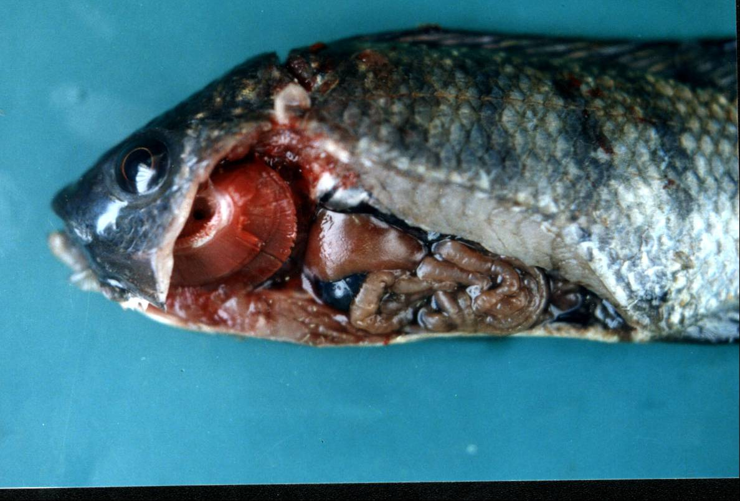
Fig. 1. O. niloticus suffering from Skin darkening.

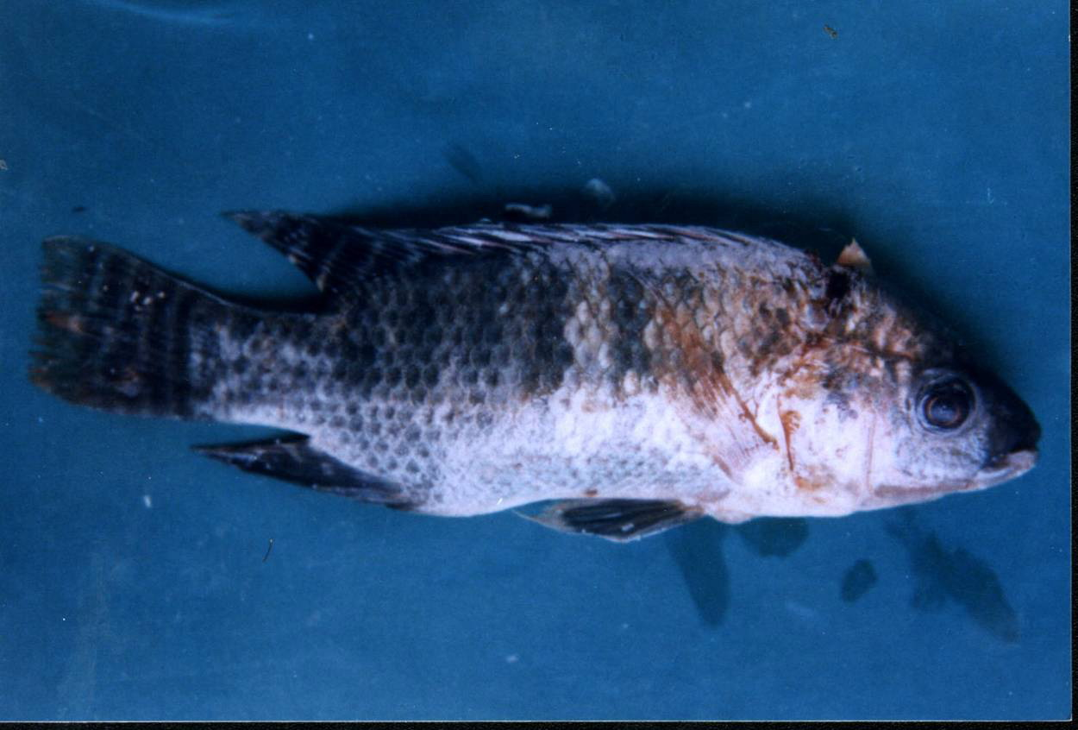
Fig. 2. O. niloticus suffering from hemorrhages tail and fin rot and tucked up abdomen.

Fig. 3. O. niloticus suffering from severe degenerative changes in liver, and distended gall bladder.

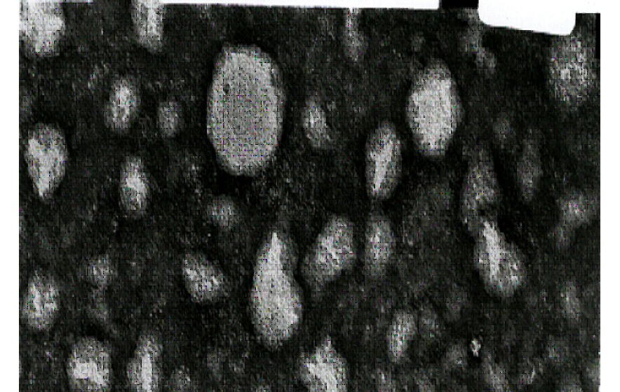
Fig. 4. Positive result for rotavirus by negative transmission electron microscope.

DISCUSSION
The results of experimental infection indicated that the oral route was the most common route of infection where the morbidity and mortality rates were 76.7 %, 76.7 %, respectively, producing a case fatality of 100%. The immersion route resulted in morbidity, mortality and case fatality of 26.7%, 26.7% and 100%, respectively, making it the second most effective route of infection. After intra peritoneal inoculation, O. niloticus apparently normal and did not show any abnormal manifestation throughout the experimental observation time (7 days). This suggests that the intra peritoneal route may not be a suitable one for infection. In C. carpio L., the results of experimental infection indicated the complete absence of clinical sings and / or mortality among the experimental fish. The results of latex agglutination test and Antigen capture ELISA (Tables 6 and 7), indicated that 3% of orally infected O. nilotcius and C. carpio L. were positive for antigen virus detection. The orally infected O. niloticus showed some clinical manifestation and deaths where C. carpio L. did not show any changes. It could be attributed to some extent to the difference in sensitivity of O. niloticus and C. carpio L. to Bovine rotavirus. The low percentage of viral antigen detection may also indicate the lack of susceptibility for Bovine rotavirus C. carpio L. as they just passed the virus. This may also explain the low percentage of viral antigen detection in these samples. These results are supported by the findings of (Mcallister 1979, Samal et al., 1990, lupiani et al., 1994, XU et al., 2000).
The investigation of tissue alterations in body organs and tissues could be an important aid for diagnosis of infectious diseases. From this point of view, experimentally inoculated fish were subjected to histopathological examinations.
Histopathological investigation of the intestine and other visceral organs in O. niloticus indicated the presence of necrosis and sloughing of the epithelial tips of the intestinal villi with complete necrosis of the epithelial lining and hyperplasia of the mucosal associated lymphoid tissue in the submucosa. These results go parallel with Holmes (1988) and Jiang and Ahne (1989) where the findings of their observation were shortening and fusion of the villi with intestinal epithelial damage. The lymphoid activation in the mucosal associated lymphoid tissue could be due to the tissue reaction against viral infection. On the other hand, the lymphoid depletion was observed in the intestine and spleen of both O. niloticus and C. carpio infected with bovine rotavirus although no clinical signs are reported in C.carpio fis experimentally infected with rotavirus. More or less similar results were reported with Roberts (2001), who stated that most of the viral diseases cause lymphocytic reaction, plasma cell activation as well as lymphoid hyperplasia.
Hepatic alterations in both O. niloticus and C. carpio infected with bovine rotavirus varied from vacuolation of hepatocytes and pyknosis of their nuclei with focal area of mononuclear cells infiltration around the hepato-portal blood vessels and swelling of pancreatic duct epithelium to complete necrosis of the hepatic cells and hepatopancreas in a focal manner. These findings are in agreement with those of Jiang and Ahne, (1989), who studied the aqua-reovirus infection in some marine fish species and clarified that the hepatic tissue in case of such infection showed focal hypertrophy of the liver and multifocal hepatocellular necrosis. The hepatic affection in such cases was a constant finding in all the examined fish.
The spleen showed severe congestion of splenic ellipsoids, lymphoid depletion and melanophores aggregations around the blood capillaries and fragmentation of melanomacrophage centers. These findings indicate that the virus showed clinical manifestations in O. nilocticus associated with histopathological changes in target organs (Intestine and liver). Such changes suggest that an acute clinical disease could be awaited. The failure to detect characteristic clinical signs in experimentally infected fish with presence of some histopathological alteration of target cells in C. carpio L. indicated that the virus could produce a more or less sub-clinical infection (Marzouk et al., 1991, Naguib et al., 1997). This could be attributed to the regular use of organic fertilizers in some fish culture facilities to enhance the growth of phyto- and zooplankton, the main components of natural fish food. The presence of these bacterial organisms is not of specific pathogenic significance to the fish, but their presence in water could indicate the intimate relationship with the enteric viruses of bovine or even human origin which could be traced in fish and so play an important role in the epizootiology of such viruses. Saha et al., 1999. The detection of Bovine rotavirus in the examined fish may be a dangerous signal to the role of fish under culturing conditions comprising periodical use of animal manure or those exposed to sewage pollution as vehicles to disseminate the different human and animal important viruses among aquatic environment and consequently re-infection to animals and man.
REFERENCES
- Bancroft, D., A. Stevens, and R. Turner. 1996. Theory and Practic of Histological Techniques, 4th ed. Churchill Livingstone, Edinburgh, London, Melbourne.
- Costa-Pierce, B. A., SR. Malecha, and E. A. lows .1985. Effects of polyculture and manure fertilization on water quality and heterotrophic productivity in Macrobracium rosenbergii ponds Trans. Am. Fish soc.,114:826-836
- Ellis A. E. 1988. Fish vaccination Textbook. Academic Press. Harcourt Brace Jo vanovich publishers. London sandiego New York Sydney Boston Berkeley Tokyo Toronto.
- Ellis, G. R. and E. Daniels. 1988. Comparison of electron microscopy and enzyme immunoassay for detection of rotavirus in calves, lambs, piglets and foals, Aust. Vet. J. 65: 133-125.
- El-Shafai, S. A, H. J. Gijzen, F. A. Nasr, and F. A. EL- Goharey. 2004. Microbial quality of tilapia reared in fecal-contaminated ponds.Environ Res., 95(2):231-8.
- FAO. 2007. Fisheries and fresh-water forum. Fish and wild life services U. advameg Inc.
- Hetrick, R. P. 1989. Fish viruses in method for microbiological examination of fish and shellfish text book by Austin and Austen, Ellis Horwood limited.
- Holmes, I. H. 1988. Reoviridae: The rotaviruses in “fields virology” 2nd Edition P551 springer-verlag, New York
- IFC, International Finance Corporation. 2007. Environmental, Health and Safety Guidelines for Aquaculture. World Bank Group .pp:1-14.
- Jauncy K and B. Ross. 1982. A guide to tilapia feeds and feeding institute of Aquaculture, university of sterling UK ISBN.
- Jiang, Y., and W. Ahne. 1989. Some properties of the etiological agents of the hemorrhagic disease of grass carp and black carp. Viruses of lower vertebrates, ed. W. Ahne and E. Kurstak, PP. 27-39. Berlin.
- Keiser J, MF. Maltese, TE. Erlanger, R. Bos , M. Tanner, BH. Singer, J Utzinger.2005. Effect of irrigated rice agriculture on Japanese encephalitis, including challenges and opportunities for integrated vector management. Acta Trop.,95(1):40-57.
- Lupiani B., F. M. Hetrick,, S. K. Samal . 1994. Identification of the angelfish, pomacanthus semicirculatus, Aquareovirus as a member of aquareoviurs genopgroup A using RNA –RNA blot hybridization. Journal of fish Diseases 17(6) 667-672.
- Mcallister, P. E. 1979. Fish viruses and viral infections comprehensive virology Vol.14 401-470.
- Marcel Huet, .1986. Text book of fish culture breeding and cultivation of fish. Fishing News books Ltd. Farnham, Surrey England.
- Marzouk, M. S, M. A. y. Nawal, I. M. Reda .1991. Serological Relationships of Different Rotaviruses isolated from freshwater fishes. J. Egypt. Vet. Med Ass 51. No: 109-117.
- Munoz, M., I lanza, M. Alvarez and P. Carmenes. 1994. Rotavirus excretion by kids in a naturally infected goat herda. Small Ruminant Research, 14 paramyxovirus: 83-89.
- Naguib, M., E. S. Abd El Aziz, and S. A. Salem. 1997. Serological screening of some viral antigens in o. niloticus collected from some polluted water in Egypt. J. Egy.Vet. Med. Ass. 57: 1121- 1134.
- Noga E. J. 1996. Fish Disease: diagnosis and treatment. Moshy-Year book, Inc, Naples, Tokyo, New York pp. 294.
- Post, G. W. 1987. Text book of fish health J. F. H publication, Inc Ltd. 211 West Syvania Avenue , Neptune city NJ 00753.
- Roberts, R. J. 2001. Fish Pathology, 3nd ed.Bailliere tindall , London , England.
- Rogers SI, Somerfield PJ, Schratzberger M, Warwick R, Maxwell TA and Ellis JR (2008): sampling stratigies to evaluate the status of offshore soft sediment assemblages. Mar POllu Bull, 56(5):880-94
- Saha M. K., P. Dutta and De SP .1999. Possibility of public health hazards by contamination of toxin producing vibrio cholerae through fishes reared in sewage fed fishery. Indian J Public Health Apr. Jun, 43 (2): 71-2.
- Samal S. K., C. P. Dopazo, M. C. Phillips TH, A. Baya, SB. Mohanty FM. Hetrick .1990. Molecular characterization of a rotavirus like virus isolated from striped bass (Morone saxutilis. J. Virol Nov, 64 (11): 5235-40.
- Sudthongkong C, Miyata M, T. Miyazaki T .2002. Viral DNA sequences of genes encoding the ATPase and the major capsid protein of tropical iridovirus isolates which are pathogenic to fishes in Japan, South China Sea and Southeast Asian countries. Arch Virol. ,147(11):2089-109
- Vilaseca, P. P. 2007. HACCP aquaculture.
- XU Hong Tao, Qu Jianguo, Piao Chunai, Wang wenxing, Wang Yan Tao, Xiang Jian Hai, Hong Tao . 2000. Visualization of reo-Like virus infection in cultivated penaeus chinesis by electron microscopy. Chinese Journal of virology 16 (1) 76-79.
- Webster R. G. 2004. Wet markets--a continuing source of severe acute respiratory syndrome and influenza? Lancet. , 363 (9404):234-6.

قابلية اسماك المياه العذبة للاصابة بعدوى الروتا فيروس
محمد سيد مرزوق¹, محمد على², منال عادل عيسى³, مى الدسوقى ابراهيم¹
- قسم امراض الاسماك ورعايتها, كلية الطب البيطرى جامعة القاهرة
- قسم الصحة الحيوان و الرعاية , كلية الطب البيطرى جامعة القاهرة
- قسم امراض الاسماك ورعايتها, كلية الطب البيطرى جامعة بنى سويف

تم عمل عدوى صناعية لاسماك البلطى النيلى و اسماك المبروك باستخدام فيروس الروتا البقرى باستخدام طرق مختلفة للعدوى. وقد اثبتت النتائج ان اسماك البلطى النيلى المعدية عن طريق الفم اظهرت عتامة و اسوداد فى لون الجلد مع ظهور انزفة , هزالة فى منطقة البطن و تاكل فى الزعانف و الزيل. ام اسماك الامبروك العادى فلم تظهر اى تاثر خارجى بالعدوى بالفيروس باستثناء بعض الانزفة الخارجية على الجلد. داخليا فى كل من النوعين من السماك المعدية ادت الاصابة الى ضمور فى الكبد, تضخم فى الطحال. تم اعادة عزل الميكروب من كل السماك المعدية باستخدام اختبار التلزن بالاتكس و الاليزا و كذلك المجهر الالكترونى.
تم عمل دراسة نسيجية للاسماك المعدية و التى اثبتت تاثر الخلايا الاكولة والخلاية اللمفاوية فى الكبد مع تاكل الطبقة الداخلية للامعاء.

.

.

