How to produce billions of high quality tilapia fry

Ram C. Bhujel
Aquaculture and Aquatic Resources Management (AARM)
Asian Institute of Technology (AIT)
PO Box 4, Klong Luang, Pathumthani 12120, Thailand
Email: bhujel@ait.asia or coordinator@aarm-asialink.info

Abstract

Tilapia has now become a popular protein source to the poor, and also increasingly to middle class people. It serves as a typical model of a success story of farming outside its native area. Annual tilapia production was only 1.5 tons in 1950 which surpassed 1.5 million tons in 2002; increased by 1 million fold. Now it has surpassed even 3 million tons in 2010. Its production will still continue to grow exponentially, if high quality fry are readily available especially in countries like China where fry demand is in billions. How to produce and supply such a huge quantity of high quality tilapia fry has been a question for the countries which have potential to expand tilapia farming for domestic consumption and export markets. In Thailand, shortage of premium quality tilaia fry was realized as early as 1980s as the main constraint to the growth of commercial farming. Therefore, Asian Institute of Technology (AIT) developed a practical technique of mass-scale fry production through a series of on-station experimentation over a decade. The technology is basically to produce all-male fry by maintaining a large number of broodfish in hapas, collecting eggs, incubating them artificially in clean and controlled system and feeding with methyl-testosterone (MT) mixed with high quality feed as early as possible to ensure over 99% males in the fry population.
In addition to developing the production technology, AIT also successfully disseminated it applying all sorts of strategies involving public as well as private sector. However, a key turning occurred only after the success of a private hatchery in Thailand that triggering mushrooming of many others. There are over 100 hatcheries of such type in Thailand alone. Now the same trend can be seen in Bangladesh. The technology has now been adopted by many farmers and entrepreneurs of many countries especially in Asia and Latin America. However, in China where about half of the global tilapia is produced, most farmers use hybridization technique to produce mono-sex fry. In Thailand, three hatcheries annually produce 200 million fry each. This means, establishing about five such hatcheries could easily produce 1 billion high quality fry per year. A hatchery in Hainan island of China has been already established by a foreign company which has claimed to achieve the same level of production. However, this technology has not been widely adopted. Adoption of this technology could boost tilapia farming further increasing many folds as the demand for fish for local consumption is huge, and so the export market. Exploring potential and promoting this technology could bring a big leap in tilapia industry in China from its current level. With a view to assisting the industry, establishing functional linkages between China and Thailand and other countries that facilitate cooperation among the researchers / scholars in sharing information and organizing study visits or trainings to government officials and farm/hatchery managers could serve as solutions. This paper describes the techniques and approaches applied by AIT hoping that it provokes policy makers, extension workers, researchers and educators working especially in China, and also other countries to find various ways of collaborations.

  - Introduction
  - Background
Tilapias are natives of African continent. Nile tilapia (Oreochromis niloticus) was introduced to Thailand as gift to the King of Thailand from the Japanese Emperor in 1965. They were kept in Chitralada Palace. After seeing a large number of fry produced naturally in the pond, HM the King provided 10,000 fingerlings to the Department of Fisheries (DoF) requesting to produce more and distribute to the poor people perceiving the tilapia as a cheap protein source (Pullin, 1988; Bhujel and Stewart, 2007). Tilapia in Thailand is considered as precious fish because it is thought to be ‘Royal Fish’. In addition to its historical background, the fish itself possess special biological characteristics i.e. caring of its eggs and young ones in the mouth by females. It also can use planktons as feed which can be produced simply by applying manures and chemical fertilizers in ponds. At the same time, agriculture byproducts such as rice / wheat bran, oil cakes and others can be used as feeds to enhance its growth thereby productivity. It can be cultured in systems ranging from backyard ponds to intensively managed tanks/ponds. It resembles with chicken in terms of farming as well as its consumption; therefore, it has been often dubbed as ‘aquatic chicken’ (Little, 1998). Due to its easiness of breeding and farming, it became the species of interest among the resource poor especially in rural areas. In Thailand, it became number one specie since mid-90s over-taking the hybrid catfish. More importantly, Nile tilapia has gained its popularity in China, Bangladesh, Indonesia Laos, Malaysia, Taiwan, the Philippines and Vietnam. People do not treat it as exotic fish, instead regard as a very important source of high quality animal protein and income.
  - Perception of the Potential and the Problem
Natural breeding without the need of any hormone injection was considered the main advantage of tilapia over other species but as the farming became more commercial, demand for large and uniform fish increased. This created high demand for good quality mono-sex fry. It was almost impossible for the traditional hatcheries to produce and supply a large quantity of fry using traditional methods. For example, production of millions of fry was almost impossible using the existing method. Therefore, the low number of eggs (approx. 1,000 per spawn) and asynchronous spawning became the constraint for mass fry production. Therefore, producing sufficiently large quantity of good quality seed was a big challenge in early 1980s (Little et al., 1997; Bhujel et al., 2000). The potential of tilapia in Thailand and lack of high quality seed was perceived as problem in advance. As a result, it provoked a research program at AIT that aimed at developing mass-scale mono-sex fry production technique. Recently, farmed tilapia has been regarded as green and good species for consumption. Demand is steadily increasing. More and more super markets and retailers are having various types of tilapia items around the globe. Some airlines in US have already started serving tilapia meal. Similarly, fast food chains such as McDonalds’ and others have also tried. Indications are already there that tilapia is becoming ‘Aquatic Chicken’ in true sense. When it becomes everyone’s meal, demand could be unimaginably higher. As the seed is one of the most components of the aquaculture development, availability of good quality seed whenever needed accelerates the industry growth. Therefore, in order to support the maximum potential growth of tilapia industry, policy makers, researchers and other involved should emphasize the seed production technology and its dissemination. Applying the method and disseminating it as a campaign is likely to solve the high demand of fry such as in PR China.
  - Solution to the problem
Any problem once identified, can be solved through research and development. AIT started research conducting a series of trials establishing a parental stock of Nile tilapia in 1984. Comparisons of breeding in earthen ponds, hapas-in-ponds and tanks within a recirculation system were the beginning of the research. Then trials were on developing methods of egg collection and artificial incubation systems (Little, 1989; Macintosh and Little, 1995). One of the major challenges was to explore or develop the best system or method, and container or jar for artificial incubation of eggs that could ensure high hatching rate and survival of eggs and yolk-sac larvae to swim-up fry consistently. Use of conical vessels and shaking tables (Macintosh and Little, 1995), various containers were tried such as simple coke bottles and white water bottles. However, semi-transparent fiber-glass jars (Fig. 1: left) locally made was found to be the best. They have been designed in two sizes; 4-litre and 6-litre. The larger sized incubators (Fig. 1, left) can accommodate about 0.2-0.3 million eggs. Attempts are still on-going to explore possibility of using new containers for the improvement in hatching and survival of eggs/larvae. Recently, simple plastic jars (Fig. 1: left) or jugs have been used. As they are cheap, easily available and more transparent so that the hatchery operators can see the egg movement easily and they are also lighter and easier to handle, most hatchery operators like them. However, relatively rough wall of the fiberglass jars facilitate egg hatching accelerating the process of removing egg’s hulls. As tilapia eggs are heavy and remain at the bottom, they needed to be moved gently so that they would not get injured and stay at the bottom without getting adequate oxygen. For this, up- and down-welling water flows into the jars were compared and the downward water flow has been found to be better. It is commonly used by most hatchery operators.

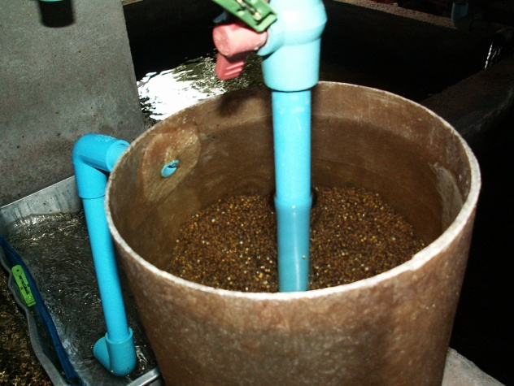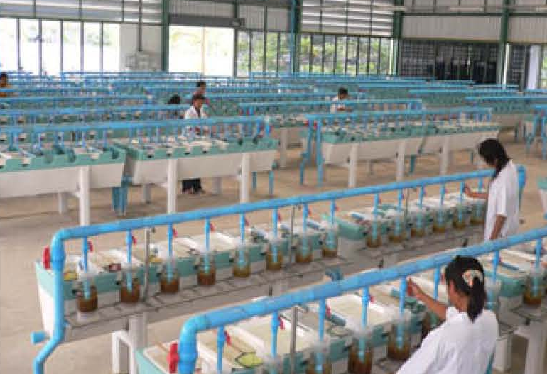
Fig. 1 Tilapia egg incubation jar made of fiberglass (left); and a series of incubators (right) in well-designed large tilapia hatchery in Thailand.
Shallow aluminum or plastic (Fig. 2) trays are use for the rearing of yolk-sac fry after they hatch. A large number of fry (up to 40,000 fry) can be accommodated in a tray with shallow water oxygenated by its gentle movement. Several trials studied the effects of factors such as fry density and water flow on the fry survival, showed higher densities are even better.
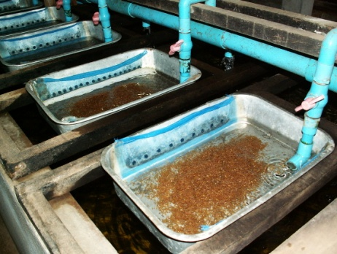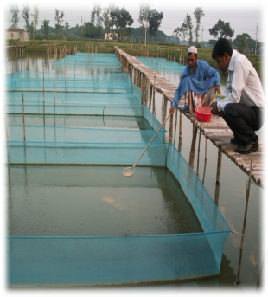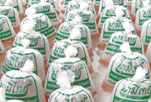
Fig. 2 Larval rearing in aluminum tray (left), feeding hormone mixed feed (middle, in Bangladesh) and fry packed in plastic bags (right) ready for transport.
Attempts were also made to maintain high survival and increase percentage of males in the fry populations. These included determining the optimum dose of methyl-testosterone in feed, frequency and length of feeding period and so on. As a result high percent of males (100% or close to) have been consistently achieved. As demand for fry is seasonal, a method of advanced nursing (Little et al., 2003) has also been developed which can be applied when they needed to keep longer period.
With a gradual improvement in each step of the whole process, a complete package of mass-scale fry production technology has been developed. Research is still on-going especially to make it more adaptable to the environmental conditions and for the manipulation of fry production and supply demand (e.g. Bhujel et al., 2001; 2007). Many research projects secured/launched, and also the student research, were either only on tilapia or in combination with other species. More than 100 student theses (M.Sc. and PhD) have been produced related to tilapia. Research areas covered varies. Initially, tilapia was used as means for waste recycling (AIT, 1994; Edwards and Pullin, 1990), its fry as feed to other species e.g. snakehead (Kaewpaitoon, 1992) and dominant species with others in polyculture e.g. carps, catfish and prawn/shrimp from semi to intensive production systems (Little, 1998). Over 150 peer reviewed journal articles have been published in tilapia alone (Bart, 2004). Significant numbers of popular articles have also been appeared in several magazines and newsletters. They served as main information outlets to the outside world and have contributed significantly to the adoption, culture tilapia technologies and overall development of aquaculture in Asia and beyond (Bhujel, 2009). For an example, Brazilian aquaculture has grown significantly as a result of Chitralada broodstock and the technology they took from Thailand.
  - Technology Dissemination
Any technology package after its development, it has to be disseminated. A variety of ways can be applied depending upon the local contexts keeping the benefit of end-users or farmers in mind. Some of the means applied or occurred in Thailand (Fig. 1) and around the globe are briefly discussed in this section.
  - Education and Training
Tilapia culture and breeding techniques were well incorporated into the post-graduate curriculum in both in theory and practicum, at AIT. In the course, all the students are assigned to conduct tilapia breeding and grow-out trials. Many of these students are lecturers at the Universities in their home countries. They do the same when they go back to teaching. Emphasis on tilapia farming is reflected in their curricula as well as. More importantly, after acquiring knowledge and skills many graduates or alumni and staff are directly or indirectly involved in tilapia farming and its promotion. Many of them are successfully running tilapia hatcheries and farms by themselves in Thailand while few others in other countries e.g. Bangladesh, Ghana and so on.
Successful launching of aquaculture program and its activities in the region increased demand not only for formal education but also created the interest in short-term, need-based skill development training. As a result, AIT has trained over 1,000 personnel so far from about 30 countries. ‘Techniques for Mass Fry Production and Grow-out’ was one of the most attractive courses. Interestingly, the course on tilapia attracted more participants than by Integrated Aquaculture probably because it was completely different and about new techniques developed as compared to the traditional techniques of aquaculture dominated by carps. This training course has a significant role in promoting tilapia not only in Asia but also in Africa and Americas. In addition there were several participants for hands-on work experience in tilapia hatchery. One of the remarkable examples is that some private companies (e.g. Chareon Pokhaphand) sent their staff for training and they have established tilapia hatcheries. It served as the base for the company’s tilapia business that also involves fillet export to US now. In a decade’s time (1989-1999), out of 843 people trained, 26% were from Bangladesh, 22% from Vietnam and 12% Cambodia; mostly for tilapia only or in combination with other species. Many officials of the governments, research institutions have also got this training where they have established and run tilapia hatcheries in their countries, specifically e.g. Bangladesh, Thailand and Vietnam.
  - Demonstration and outreach

AIT has been keeping a prototype hatchery and runs as a commercial unit within the not-for-profit organization. Many visitors from abroad and students of Thai Universities, colleges visit tilapia hatchery. It has been an interesting place also for distinguished guests of AIT e.g. Thai Princess Mahachakri Sirindhorn, and the King of Sweden in 2003. When there are visits graciously paid by Royal families, the hatchery technology is additionally highlighted including live TV coverage. Many farmers also come with pick-up trucks to AIT directly to purchase fry also to farmers. In doing so, they see the system and spread the words from mouth to mouth. Interestingly, Thai fisheries stations use tilapia hatcheries as a means to generate income unlike distributing fry at free of cost in many countries. Using the funds generated further research and technology dissemination is done in the long-run. AIT engaged farmers as part of research team for field testing also called participatory research. They feel proud being a part of the scientific research. AIT continued to focus on the production of quality mixed sex tilapia in the early 1990s even when AIT was commercializing the monosex approach. This was because it was perceived that even though there was a rapidly increasing demand in the commercial sector for monosex, poor rural households needed quality tilapia to be available locally and centralized commercial monosex operations were unlikely to meet their needs in the short to medium term. Hence, AIT also focused studying on decentralized seed production resulting in large impacts in some marginal agricultural areas such as in Bangladesh. Benoy Barman’s work for PhD at AIT, showed fry could be produced cheaply in rice-fish fields. There was number of research work in this aspect on-campus funded by DFID and then through various mechanisms e.g. DFID’s support in Bangladesh and subsequently supports from SIDA/DANIDA in Vietnam and elsewhere in Indochina.

Aqua outreach played a considerable role in building regional institutional capacity in aquaculture and aquatic resources management and related fields through innovative approaches. It established a network of partners which included vocational colleges, research institutes, universities and department of fisheries (provincial or national levels) under the ministries. AARM assisted to establish tilapia hatcheries under outreach activities. For example, Department of Fisheries in Udonthani Province of Thailand, a tilapia hatchery was established with a view to supplying fry to the farmers of the province. Similarly, a hatchery in an Agricultural college, which is managed by one of the AIT graduates, also serves the same purpose. More interestingly, various non-profit organizations in the same province and also in Chiang Mai established and have run tilapia hatcheries e.g. Udonpatana Foundation, as a means to serve the poor families providing an evidence for earlier the notion that tilapia is poor men’s fish. Table 1 is a list of hatcheries in Thailand established with direct and indirect assistance of AIT and its partners.

Learning lessons from the promotion of tilapia culture in SE Asia, similar activities have been expanded to Nepal. A project called “Women in Aquaculture” has been launched jointly with the Institute of Agriculture and Animal Sciences (IAAS), Nepal. Tilapia culture was tested or compared with carps at the beginning. After getting positive responses, tilapia has been promoted among ethnic groups and also attempts have been made to expand further with a view to solving the problem of protein malnutrition in the rural areas (Bhujel et al., 2008).
  - Private-Public Partnership (P-PP)
A number of attempts were made to disseminate the technology through public / government organization with the aim of supplying large number of high quality mono-sex tilapia fry. However, the success was not up the expectation and shortage of high quality fry was still at large. It was probably due to the lack of realization on the potential of tilapia farming by those organizations and their aims were to serve as extension agents rather than doing business by themselves. However, the most obvious reason has been the lack of performance based incentives or rewards for and control over the staff in public organization. Fortunately, these problems were identified well in advance and attempts were also made to quickly shift to partnership with private sector. Unique contractual agreements were made realizing the importance of strict imposition of technological procedures or protocol was necessary in the production of high quality tilapia fry production at every step of the process that involves careful management of brood stocks, collection of eggs, artificial incubation of delicate fry and hormonal sex-reversal. A breakthrough occurred when a private company picked-up the technology in supplying large number of quality seed was possibly. Although, the technology was thought to be cumbersome but private sector adopted quickly due to its profitability and increasing demand. More importantly, after the successes in the private sector, public sector has re-focused on this technology. As a result, tilapia became number one species in Thailand in mid-90s due mainly to these reasons. Sooner or later tilapia industry may take off other countries too. Bangladesh, Malaysia and Vietnam, governments are aggressively promoting tilapia. Tilapia has been officially allowed to culture in commercial scale.
CP Food Co. Ltd., which runs five tilapia hatcheries using the AIT technology, has also played a significant role in promoting tilapia further especially red variety. The company created demand by giving “Thapthim” as a brand name which means “ruby” giving the impression to the common people that it is something special and completely different food item. The company promoted it by producing and distributing an attractive picture of a food item of red-tilapia to almost all the restaurants in Thailand in order to boost domestic demand. The company now has several tilapia growers in groups in various pocket areas under contract farming. Under the agreement, farmers get a complete package of technology, inputs such as fingerlings and feed. They also buy back the fish so that farmers would not need to worry about market. This is a very good lesson strategy to learn from CP, while promoting any new species like tilapia.
Other companies e.g. GenoMar, a Norwegian company has also made remarkable contribution hiring a consultant who was successful in establishing tilapia farming in Brazil after bringing a group of farmers to study the system and purchase broodfish in Thailand. He was initially hired by GenoMar for setting up AIT style hatcheries in the Philippines and subsequently China as well as Latin America. GenoMar also has established a hatchery in Singapore. In early 80s, David Little, who was the main researcher behind developing the technology, has worked with Regal Springs when they first started tilapia production in Java to introduce the AIT approach. More recently, many groups from Bangladesh have been supported by AIT. A large hatchery plan has also been implemented with a company in India for the transfer of tilapia farming technology in bio-secure way, where previously tilapias were not officially approved for culture. Many groups from various countries have showed interests for the establishment of AIT style hatcheries and quality control/certification systems.
  - Aqua Internship: on-the-job work experience
AIT and its partners in Thailand as well as in other countries offer internship programs to students from within the same country or abroad to provide on-the-job work experience at the tilapia hatchery alone so far in the past. Students, normally enrolled in their universities in their countries do not need any aquaculture background to join internship. Biology background would be sufficient as it is more in hands on work with hatchery staff and learn by doing the work as regular staff. Tilapia hatcheries have been considered as one of the best internship placements where students spend 2-3 months and understand the real field situation and also identify problems faced by the industry which can be research areas for their thesis with the aim of solving those problems faced by the industry. These hatcheries also provide opportunities to students to carry out their research afterwards and even employ in some cases. Internship program runs on cost-sharing basis. Interns or their Universities provide airfares, interns bear food costs by themselves and Asian partner institutions provide free or accommodation or with discounted fees either in their student dormitories/hostels, guest houses or arrangement to live with staff families in communities.
Fig 1. Technology dissemination pathways in Thailand (Belton et al., 2009)
  - CONCLUSIONS

Realization of the potential of tilapia as a candidate species, because of its benefits over others, identification of shortage of quality fry as the main constraint of its expansion and continuous research carried out to find the solutions served as foundation for developing a practical technology package, for the transfer of knowledge and technology. Incorporation of the hatchery technique and its farming in post-graduate education, short-term training courses, outreach and internship programs accelerate in the promotion of tilapia culture.

Several individuals who were formally educated from, trained by and/or exposed to AIT have contributed tremendously in promoting the tilapia farming technology developed at AIT. However, the major breakthrough occurred when private sector took up the technology, successfully implemented it and success story started to spread through various means. Countries wanting to promote tilapia may need to think about establishing such hatchery either their own or encouraging and facilitating the private sector. Results have showed that five large hatcheries managed using the set of guidelines or protocol developed could easily produce over a billion high quality fry within 3-5 years period. Further promotion and expansion can be augmented through education, training, farm visits and other media means where the demand is such high e.g. PR China.

Several individuals and groups from abroad were attracted to see the operation and understand it in-depth. Many of them started by themselves and many others established their farms by making contractual arrangements. As a result, several hatcheries emerged in Thailand followed by Bangladesh where most people rely on fish for protein. Again, global expansion has occurred due mainly to the up-take of the technology by the private sector. A lot of adaptations in the technology, modifications and/or improvements have been made in different parts of the world by various groups depending upon the availability of materials and equipment. Nevertheless, ideas of several individuals have contributed in further advancing the technology. Due to which millions of people have and going to have direct or indirect benefits from tilapia research and technology transfer.

Aquaculture program of AIT has established itself in international arena because of these activities carried out over two decades. It has contributed significantly in the improvement of indigenous capacity for education, research and development in the region and beyond. Therefore, approaches/strategies used and role played by AIT in the promotion of tilapia should serve as a model for other organizations which have similar goal of contributing to food security and poverty reduction. However, there is always a room for improvement. No technology can be 100% perfect. More research is still necessary to improve the technology as well as strain itself. For examples, improvement in survival of fry, development of cold and salinity tolerance in various strains, solution to heat stress during summer and its drastic drop in egg production in some cases, various new and emerging diseases, and minimization of cost of production. One of the researchable issues has been always raised is the impacts of MT (methyl-testosterone), a steroid hormone, on the health of technicians who handle the MT on daily basis while preparing feed and feeding the fry, and the impacts on the environment.
  - REFERENCES
AIT, 1994, Partners in Development: The Promotion of Sustainable Aquaculture. Asian Institute of Technology, Bangkok, Thailand, 98 p.
Belton, B., Turongruang, D. Bhujel, R. and Little, D.C. 2009. The History, status, and future prospects of mono-sex tilapia culture in Thailand. Aquaculture Asia Magazine April-June 2009, 16-19 pages.
Bhujel, R.C. 2000. A review of strategies for the management of Nile tilapia (Oreochromis niloticus) broodfish in seed production systems, especially hapa-based systems. Aquaculture 181:37-59.
Bhujel, R.C., W.A. Turner, A. Yakupitiyage, D.C. Little, 2001. Impacts of environmental manipulation on the reproductive performance of Nile tilapia (Oreochromis niloticus). Journal of Aquaculture in the Tropics 16(3): 197-209.
Bhujel, R. and J. Stewart, 2007. Sustainable tilapia culture in Thailand. Fish Farmer, Nov./Dec. 2007, pages 38-39.
Bhujel, R.C., D.C. Little, A. Hossain, 2007. Reproductive performance and the growth of stunted and normal Nile tilapia (Oreochromis niloticus) broodfish at varying feeding rates. Aquaculture 273:71-79.
Bhujel, R.C., M.K Shrestha, J. Pant, S. Buranrom, 2008. Ethnic Women in Aquaculture in Nepal. Development, 51: 259-264.
Bhujel, R.C. 2009. Artificial incubation, hormonal sex-reversal promoted tilapia boom. Global Advocate, Sept/Oct 2009: 73-75.
Bart, A. 2004. Contribution of Aquaculture and Aquatic Resources Management (AARM) program of the Asian Institute of Technology (AIT) to tilapia research. Proceedings of ISTA6, Sept 12-16, 2004, the Philippines. Pages 711-722.
Edwards, P. and R.S.V. Pullin, (eds.), 1990. Wastewater-fed Aquaculture. Proceedings of the International Seminar on Wastewater Reclamation and Reuse for Aquaculture, Calcutta, India, December 6-9, 1988. Asian Institute of Technology, Bangkok, Thailand. 296 pages.
Macintosh D.J. and D.C. Little, 1995. Nile tilapia (Oreochromis niloticus) In Broodstock management and egg and larval quality, N. R. Bromage and R.J. Roberts (eds). Blackwell Science, 424 p.
Kaewpaitoon, K. 1992. Utilization of septage-raised tilapia (Oreochromis niloticus) as feed for snakehead (Channa striata). Dissertation AE 92-2. Asian Institute of Technology, Bangkok, Thailand.
Little, D.C. 1989. An evaluation of strategies for production of Nile tilapia (Oreochromis niloticus) egg and fry suitable for hormonal treatment. PhD thesis. Institute of Aquaculture, University of Stirling, Scotland, UK.
Little, D. 1998. Options in the development of the aquatic chicken. Fish Farmer, July/August 1998, pages 35-37.
Little, D.C., D. Sikawa, and J. Juntana, 1994. Commercial production and marketing of Nile tilapia (Oreochromis niloticus) fry in Chonburi and Chachoengsao Provinces, Thailand. The NAGA ICLARM Quarterly, April 1994, pages 14-17.
Little, D.C. W.A. Turner and R.C. Bhujel, 1997. Commercialization of a hatchery process to produce MT-treated Nile tilapia in Thailand. p. 108-118. In D.E. Alston, B.W. Green and H.C. Clifford (Eds.), IV Symposium on aquaculture in Central America: focusing on shrimp and tilapia, 22-24 April 1997, Tegucigalpa, Honduras, Asociacion Nacional de Acucultores de Honduras and the Latin American Chapter of World Aquaculture Society, 237 p.
Little, D.C., R.C. Bhujel, and T.A. Pham, 2003. Advanced nursing of mixed sex and MT-treated tilapia (Oreochromis niloticus) fry, and its impact on subsequent growth in fertilized ponds. Aquaculture, 221 (1-4): 265-276.
Pullin, R.S.V. 1988. Tilapia genetic resources for Aquaculture. Proceedings of the Workshop on Tilapia genetic resources for aquaculture March 23-24, 1987. ICLARM. 108 pages.

