DEVELOPMENT OF SUSTAINABLE AQUACULTURE PRACTICES IN TABASCO, MEXICO USING NOVEL IAA TECHNOLOGY

Rafael Martínez- García¹, María Fernanda Cifuentes-Alonso¹, Maximiano Antonio Estrada Botello², Abel Santiago Lopez¹ Torres, María de Jesús Contreras-García¹, Alejandro Macdonal-Vera¹, Estuardo González-Arévalo¹, Wilfrido Miguel Contreras-Sánchez¹, Kevin Fitzsimmons³

¹Laboratorio de Acuicultura Tropical, División Académica de Ciencias Biológicas, Universidad Juárez Autónoma de Tabasco, México
²Division Académica de Ciencias Agropecuarias, Universidad Juárez Autónoma de Tabasco, México
³University of Arizona, 2601 E. Airport Drive, Tucson, Arizona 85706, USA

Abstract
The treatment and discharge of aquaculture effluent and resulting negative impacts on the environment remains a critical issue that is threatening the sustainable growth of the aquaculture industry. Three optimal sites has been selected to carry out IAA systems in order to deplete eutrophication, two indigenous communities, one from the highlands and other one from the wetlands were selected to produce agro and aqua products with the same amount of energy, also a demonstration system is building at UJAT. Part of our progress so far is: two workshops; the first one on integrated systems and the second one on bioflocs systems with more than 60 attendants among farmers, students and technicians. In Caridad Guerrero the highland indigenous community we have a 90% progress for the setting up phase, habanero pepper will be growth with Tilapia water effluents. In the wetland community there is a progress of 40% the group is already organize and training is given, the demonstration system at UJAT has a 30% progress, materials and instruments have been already purchased and the design was made. In overall the project suffered a delayed due to major flooding events in the region.

Introduction
The treatment and discharge of aquaculture effluent and resulting negative impacts on the environment remains a critical issue that is threatening the sustainable growth of the aquaculture industry. Even the discharge of effluent that has been treated to levels acceptable under limitation guidelines (ELGs) through the use of dilutions, may pose long-term environmental risks. The resulting negative impacts will continue to intensify in the future if sustainable practices are not developed in commercial scale.
The first phase of a two phase project focused on the development and testing of sustainable aquaculture systems—specifically, the development of technology that combined agriculture and aquaculture technology. Such systems are often referred to as aquaponic systems as the water in which the fish are living in is used as a nutrient rich water source to stimulate plant growth. The technologies in the current research program were a novel variation from existing concepts, however, as they were developed as re-circulating systems and the plants were imbedded in soil and supplied with irrigation water from surface drip systems. Subsequently, the water migrates through the soil profile, collects in sub-surface collecting drainage canals built at negative slopes, and migrates down the canals and collects in a terminal basin. From this basin, the water is pumped back into the aquaculture tanks. Alternatively, plants in many aquaponic systems are grown in styrofoam trays that float on top of a water medium. Roots from the plants are allowed to grow submerged in the water which is infused with the nutrient rich aquaculture effluent, thus eliminating the need for using soil mediums. While hydroponic and aquaponic technologies have proven to be highly productive and efficient in commercial scale, the technologies developed in phase I of this program allow for a more diverse number of crops to be generated. Moreover, these systems are relatively simple and were developed with the goal of implementation in Tabasco, Mexico. Because more plants can be grown in soil based mediums compared to hydroponics systems, RIAA technology offers the advantage of diversifying the product for improved income as well as providing a more diverse diet to local communities.

Approach
The approach towards implementing novel agriculture technology in Tabasco is being carried out, through the training of local farmers, demonstration of concept through development and support, and longer term monitoring. The project team was formed through an existing strong partnership between the University of Arizona’s College of Agriculture and Life Sciences (CALS) and the Universidad Juarez Autonoma de Tabasco (UJAT). Business management practices were also supported by Arizona’s Eller College of Business Management.
Firstly, our student led team held a training program at UJAT for rural and commercial farmers in the nearby regions. This training seminar was given by Dr. Kevin Fitzsimmons, Dr. Dennis McIntosh and Dr. Rafael Martinez-Garcia, which were designed to engage nearby farmers and to describe to them the techniques and practices of RIAA systems including technical aspects, animal and plant management, and essential simplified business practices. The second component of this project was to build demonstration systems in two small indigenous communities in Tabasco. Along with the demonstrations, our student led team will provide workshops in the indigenous languages (with collaboration with the Universidad Intercultural del Estado de Tabasco; an Indigenous University) (Fig. 1) describing the benefits of the integrated farms and how best to manage the farm to increase income and reduce chemical costs.

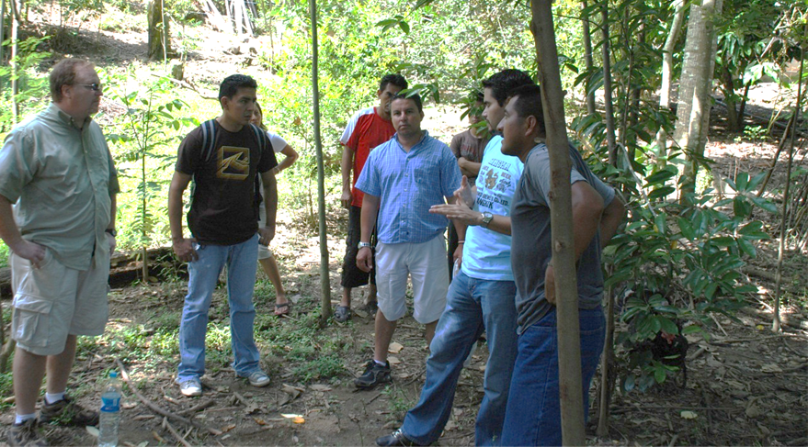
Figure 1. Training on site of IAAS systems and hands on practical activities
Summary of Findings:
The project suffered a major delay in its development due to severe flooding events that impact the three selected sites. Fig. 2.
a)
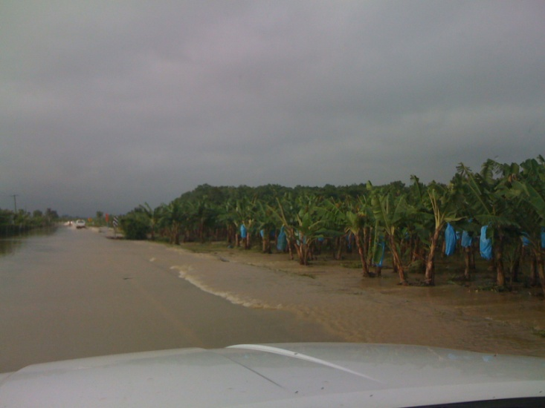
b)
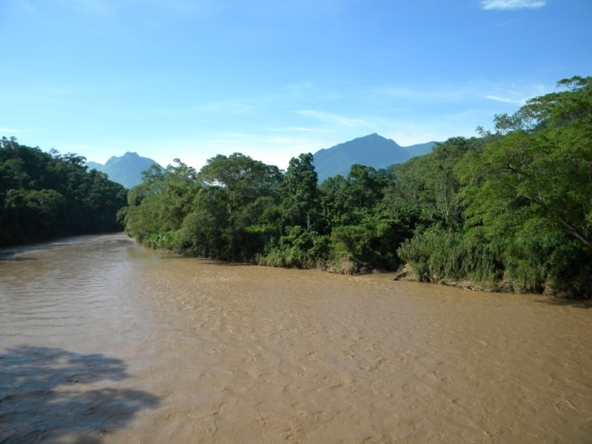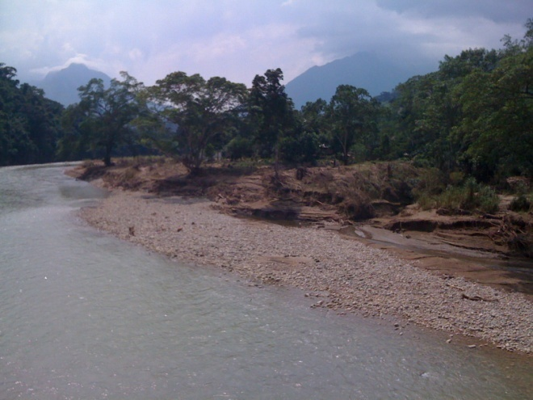

Figure 2. A) Flooded State highway Villahermosa-Teapa. B) Before and after flooding event, massive erosion and damage

All the progress in Caridad Guerrero site suffered severe impacts. Agricultural beds were destroyed with heavy sediments and water erosion, the whole project had to be rebuild. The other two sites also suffered flooding impacts for more than three months. The Villages were abandoned and people stayed in emergency shelters. All the activities programmed at these sites were delayed; at UJAT a portion of land was filled with sand to raise the land level. We have rescheduled our activities in both sides for January 2011.

Workshop 1: Integrated Agriculture-Aquaculture
From August 12 - 19, students from the P3 award team along with Drs. Dennis McIntosh, Kevin Fitzsimmons and Rafael Martinez from the Universities of Delaware and Arizona respectively, presented an overview of integrated agriculture aquaculture systems (IAAS) at the Universidad Juárez Autónoma de Tabasco (UJAT) to 34 participants. This workshop provided an opportunity to introduce project group members to other members of the University, to indigenous community farmers, extension agents, Professors and also participating members of nearby farming cooperatives attending the workshop. In conjunction with educational training, the workshop included several visits to nearby communities where development of small-scale integrated farming operations were either being planned or currently being developed.

Workshop 2: Bio-Floc
From September 6 – 10, a second workshop was held at UJAT to discuss the many aspects of maintaining bio-floc in integrated systems. Several of these more advanced themes attracted approximately 30 participants each, representing farmers, hatchery staff, professors and students. Maintaining bio-floc material in aquaculture systems is appropriate in regions like Tabasco, Mexico where high protein diets may be prohibitively expensive, but power for aeration is subsidized and reliable. Bio-flocs are characterized by a mixture of nitrifying , autotrophic and heterotrophic bacteria along with several kinds of algae, and have been shown to be a very nutritious for several kinds of filter feeding juvenile fish (such as those used in our proposed technology) as well as crustaceans including shrimp. Originally, a large component of this workshop was dedicated to visiting a number of aquaculture facilities in nearby rural regions, where on-the-ground training would occur. Unfortunately, our group was unable to make these visits due to massive flooding caused by substantial rainfall and high intensity storms.

Support visit 1: Kelly Green
From March 18 – 28, 2011, support visit was held in order to support P3 projects, Kelly Green designated from the Farmer to Farmer program to collaborate in the duties of the project. The first part of the collaboration was to visit the site project in Tacotalpa, where Kelly help with sampling activities, she stayed for over 3 days in the Tacotalpa area and could observed the situation of the population. After this she visited the second work site in a Chontal indigenous community in Nacajuca municipality, where he had a training talk and a water sampling activity. The rest of her visit she expended collaborating in other Aquafish CRSP projects.

Early Phase IAA Implementation.
The P3 project has identified several regions with indigenous communities that have connections to the University Juarez de Tabasco in collaboration with an Indigenous University ( Universidad Intercultural del Estado de Tabasco). The P3 team has already begun to implement the integrated agriculture-aquaculture technology in (Caridad Guerrero) Lacandon village in Tacolapla, (Fig. 3A) where a farmer’s cooperative has already formed and there is existing aquaculture infrastructure (Fig. 3B). The farmers have identified a suitable location (Fig. 4A) where they would like to produce vegetables, though currently do not have the knowledge to set-up an integrated agriculture-aquaculture system (IAAS). The intent is to produce a variety of crops both for their own use, but also for generating income, in this phase they will grow habanero pepper, which has a very high demand and price. The proposed site needed to be selectively cleared to make planting space for the IAAS; however, most of the larger trees were retained.
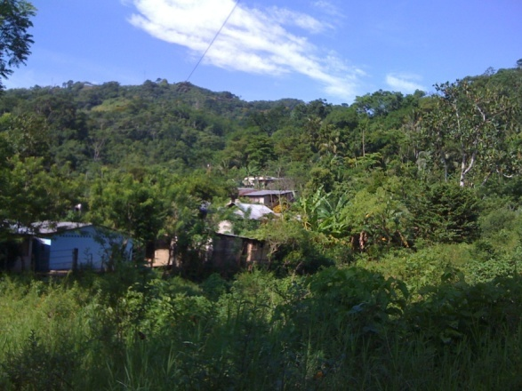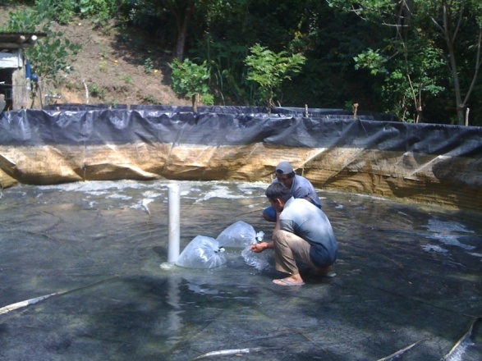
Figure 3. A) Lacadon village in the Mexican state of Tabasco. B) And an aquaculture tank in use by the farmer’s cooperative to grow tilapia.

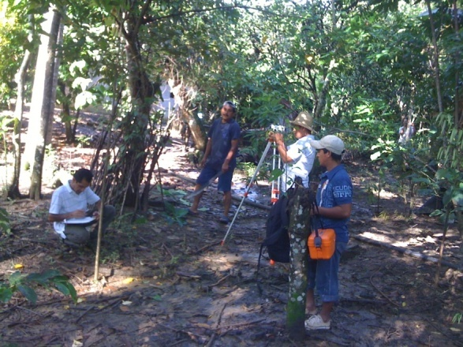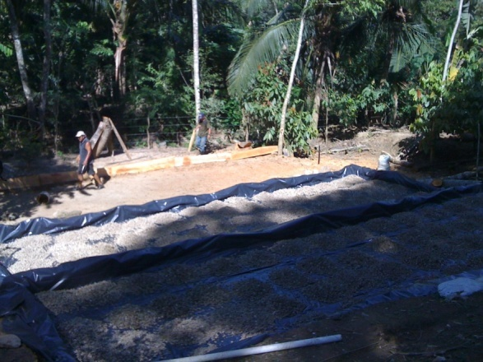
Figure 4. A) Personnel measuring levees and levels in the selected site. B) View of the three agriculture beds part of the IAAS system
Following the evaluation of the supply of water quality and quantity, aquaculture system set-up, proposed site, and listening to the farmers’ expectations, our team proposed to utilize a series of flood irrigated raised growing beds (Fig. 4B). These beds are currently being developed with an expected completion by the end of 2010 (Fig. 5) There was a delay in the bed construction due to major flooding events in September, the beds were destroyed and reconstruction was needed. One of the principal construction goals is to develop a simplified surface irrigation system by which the aquaculture effluent or ‘waste water’ is delivered to the plants (Fig. 5) .
One challenge the team has had to overcome in this regard is managing the timing of the irrigation without automated pumps. The aquaculture tanks require frequent water replacement to avoid the accumulation of suspended solids and both organic and inorganic nutrients. These water outflows are greater than plant demands. The solution identified is to build a settling basin in which to collect the aquaculture outflows and to distribute the water to a variety of plant production beds. The excess treated aquaculture effluent in the settling tank will be discharge back into the stream.

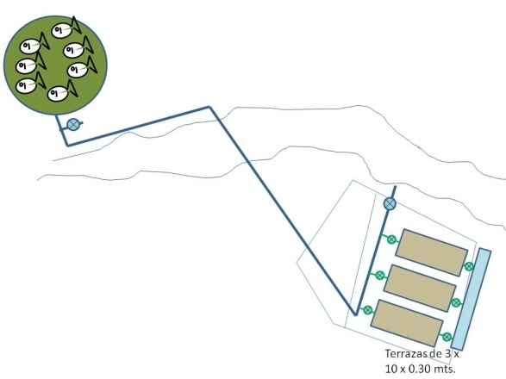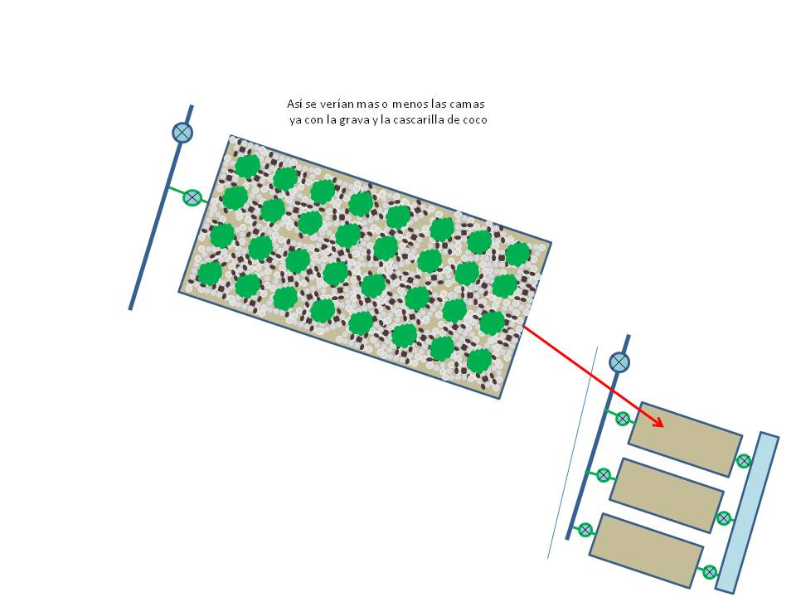

Figure 5. IAAS design in Caridad Guerrero, Tacotalpa

Continued Future Work
Development of the integrated aquaculture-agriculture technology is being developed to suit the needs of the indigenous communities and farmers cooperatives in the Lacandon village in Tacotalpa. This work is expected to be completed and operational by early 2011. Additional nearby communities have also been identified and have expressed interest to work with our P3 team to develop and implement similar technologies. These are expected to occur by May 2011.
Following the implementation of the integrated agriculture-aquaculture technology, the student team will continue to work with community representatives to manage the operations using simplified business practices. For example, our team is working with the farmers to keep track of harvest quantities, market prices, and profits made. The goal of communicating these management tools, is that the communities will not only become self reliant but also use the information to make investment decisions to maximize their supplemental incomes. Academic products will result of this project, two undergraduate students are working on their thesis, the first one is evaluating the feasibility of the IAAS system (Tilapia and habanero growth) as long with agriculture parameters, the other thesis is focusing in the socioeconomic impact of the project in the community and in the surrounding communities.

Conclusions:
At this moment we are ready to transplant habanero peppers and start the IAAS system, organization and training phase on the other two sites is done, and we will begin setting up IAAS system in the rest of the sites. The P3 project, aimed at the development of Sustainable Aquaculture Practices in Tabasco, Mexico Using Novel RIAA Technology, has thus far been met with promising results. Our team has identified that success of this project is dependent upon satisfying the economic, environmental as well as social equity benefits. The social components of this project have thus far been the most critical. Students from the team have worked with indigenous community leaders as well as farmers from local communities to better understand their needs and to modify the technologies developed in the early phases of this project to maximize the economics and environmental benefits. In less than a year from the start of the project, the team has helped educate and train more than 200 participants, technologies to enhance the livelihood of local level farmers are being developed in one site with anticipation of development in two additional sites, and critical relationships have been developed which will extend the life of the project beyond the completion of the P3 component. Utilization of the technologies will have low impact on the environment, generate sufficient revenues to cover both long and short terms costs, and the communities are being supplied with the knowledge and tools to administer farming production effectively. Thus, the farming technologies implemented through this project are expected to remain operationally sustainable beyond the life of the P3 project.

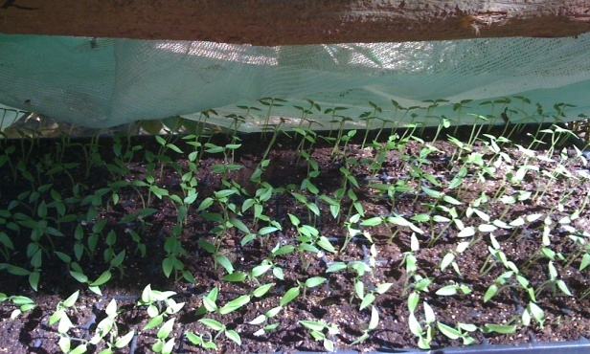 Figure 6. Habanero pepper plants ready for transplant

