USE OF GONADOTROPIN RELEASING HORMONE ANALOGS ON THE INDUCED REPRODUCTION OF CHAME Dormitator latifrons

Gustavo A. Rodriguez M. de O.^{1*}, Eva A. Medina H¹., Jeniffer Velazquez S¹., Vanesa Lopez L¹., Cristobal Roman R¹., Konrad Dabrowski², Eladio Gaxiola Camacho¹, Maria C. Haws³.
¹Facultad de Ciencias del Mar, Universidad Autónoma de Sinaloa, AP 187 Mazatlán, Sin México CP 82000
²School of Environment and Natural Resources, Ohio State University, Columbus OH
³Pacific Aquaculture and Coastal Resources Center, University of Hawaii at Hilo, Hilo, Hawaii, USA
*Corresponding author: garm73@gmail.com

Abstract
Chame (Pacific Fat Sleeper) is considered a relevant upcoming fish species for aquaculture; particularly in Ecuador and some preliminary trials in Mexico. Nevertheless, the reported production for the last 15 to 20 years in culture has been dependant of wild-caught juveniles. Thus, we are conducting research focused on the achievement of controlled reproduction and larvae production as well as to get relevant information on the reproductive biology of the fish. At this moment we have successfully induced gamete release in both genders using the following procedures: An experiment was conducted with 16 females divided into the following groups: control group (0.5 ml/kg 0.9% saline solution), Desgly10-Ala6 LHRHa injected at 40 µg/kg (priming dosage) and 80 µg/kg (resolving dose), 2 injections of Ovaprim® at 0.5 ml/kg or a single implant 75 µg (Ovaplant®). Spawning results showed 100% success within 24h and 48h for the Ovaplant group, and 25% for the LHRHa treatment but 0% for Ovaprim group within 48-72h. Only one natural spawn was observed. Obtained data establishes oocyte size as 300 µm and a relative fecundity of 80,000 to 100,000 cells per gram. All delivery treatments were effective to induce spermiation in volumes from 0.5 to 10 ml per male (LHRHa injected at 40 µg/kg, Ovaprim® at 0.5 ml/kg or a single implant 75 µg (Ovaplant®); however several males released sperm naturally up to 1 ml throughout the reproductive season. Obtained data indicates that sperm activation time is close to 4 minutes, and overall concentration is within the range of 1 to 2X109 cells per milliliter. Increased sperm motility is achieved after predilution on a 1:10-1:40 ratio in Ringer´s solution. As optimal salinity values, both for fertilization and egg incubation, our results indicate that there is no sperm activation above 5‰ of salinity; similar data were recorded for optimal incubation salinity as no hatching was observed above 5‰ salinity. These findings are relevant due to the differences with other spawning protocols previously used, given that other trials reported the need of repeated injections of Human chorionic gonadotropin (HcG) up to 10,000 UI per fish. Another difference with previous studies was the observance of only partial spawns. We conclude that these protocols allow to successfully obtaining viable gametes for chame larvae production.
Introduction
At present, medium-scale commercial aquaculture in Ecuador, as well as initial experiences of chame culture in Mexico, are conducted with wild caught juvenile fish. There is also interest in this fish in Nicaragua, where freshwater fishes such as tilapia are currently fetching higher prices than cultured shrimp. Therefore, the goal of this work is the production of juveniles under laboratory conditions and minimize the dependency on wild fish supply. Available information indicates that in Ecuador, chame aquaculture has continuously decreased over the last eight years due to the shortage of juvenile fish since controlled propagation has not been achieved. Research in this area was largely abandoned over ten years ago. For Mexico, there is a steadily demand on the central and the southern Pacific Coast. Also, as surveyed by the authors, there are already fish farmers interested in acquiring laboratory produced juveniles for commercial aquaculture in Oaxaca State. In addition, the species is not considered for protection under Mexican laws, and controlled juvenile production will provide a considerable benefit for the diversification of fish culture in Mexico. The main goals of this proposal are the following: 1) attempt hormonally induced reproduction by outlining the viability of the utilization of newer spawning techniques; 2) fertilization and egg incubation at different salinities to evaluate hatching success; 3) a series of trials with larvae offered live and dry food as exogenous starter diets have been conducted at a preliminary stage. This manuscripts details the first trails with hormone induced spawning and spermation in chame.

Materials and methods
Broodstock fish were collected in a 100 km radius of Mazatlán, Sinaloa Mexico and later transported and acclimated to FACIMAR-UAS (23°12´57” N; 106°25´31” W). Fish were fed with a combination of 60% floating pellets (32% protein 8% lipids) and 40% sinking pellets (35% protein 10% lipid). Fish of both genders were tagged using PIT-Tags (Passive Integrated Transponder tag, Biomark®) and potential breeders with visible signs of gonad maturation such as swollen abdomen, significant individual weight gain and changes in coloration on males and females, both in the papilla and the abdomen (Bonifaz et al, 1985; Estuardo Campoverde, pers. comm.), were separated and monitored, however gonad biopsies were not possible due to the significantly reduced size of the pore at the papilla. An. experiment was conducted with 12 females divided into the following groups: control group (0.5 ml/kg 0.9% saline solution), Desgly¹⁰-Ala⁶ LHRHa (sigma®) injected at 40 µg/kg as priming dosage and 80 µg/kg as resolving dose, 2 injections of Ovaprim® at 0.5 ml/kg or a single implant 75 µg (Ovaplant®) (Syndel®). Number of spawners 24 and 48 h after hormone treatments, number of oocytes per gram (relative fecundity) and oocyte diameter was measured in spawned fish per treatment.
For males, an experiment with twelve fish was carried out to induce spermiation with the following treatments: control group (0.5 ml/kg 0.9% saline solution), desgly10-Ala6 LHRHa injected at 40 µg/kg, Ovaprim® at 0.5 ml/kg or a single implant 75 µg (Ovaplant®). Sperm quality as motility, activation time and sperm concentration were evaluated in spermiating fish per treatment.
An alternative protocol for sperm activation and fertilization as well as hatching success in terms of water salinity was conducted as follows: sperm samples were pre-diluted in ringer´s solution at several dilution ratios (1:1-1:40) (Arias-Rodriguez L. UJAT-Tabasco, per. comm.) as sperm viscosity was too high to allow effective activation with direct dilution in activation media (10 µm filtered, UV sterilized water). Once pre-dilution was completed, again 50-100 µl of Ringer´s diluted sperm samples were activated in 900 µl of activation media (0, 5, 15, 25, 35, 45, 55 and 65 ‰) to establish best activation conditions as water salinity value.
Also, once spawns were achieved, water salinity incubation conditions were estimated by placing 1000-1500 fertilized eggs in 1 l containers with 10 µm filtered, UV sterilized water at 0, 5, 15, 25, 35, 45, 55 and 65 ‰ with three replicas per salinity. Survival (%) per salinity and total length and morphological characteristics of larvae at hatching and thereafter were observed using digital image analysis with Motic Image Plus 2.0 software (Fig. 1).
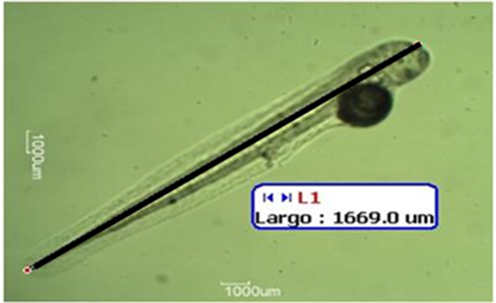
Figure 1. Computer digital analysis for measurement of day-2 larvae using Motic Image Plus 2.0 software

Result and discussions

The use of gonadotropin releasing hormones is a useful technique for the induced reproduction of chame. For females, spawning results showed 100% success within 24h and 48h for the Ovaplant group, and 25% for the LHRHa treatment but 0% for Ovaprim group within 48-72h after injections or implantations (Fig. 2). Ovaplant females released oocytes both 24 or 48 h after implantation; as extra information in overall a total of 29 spawns were achieved on this first attempt to produce viable oocytes for larvae production of chame using implantation delivery techniques for synthetic analogs of GnRHa (Ovaplant®) at a 75 µg single implant; other inducing spawning treatments were not as effective as implants, nevertheless still LHRHa showed some interesting results to be verified in a follow-up experiment during chame next reproductive season in Mexico (Sept-Oct).
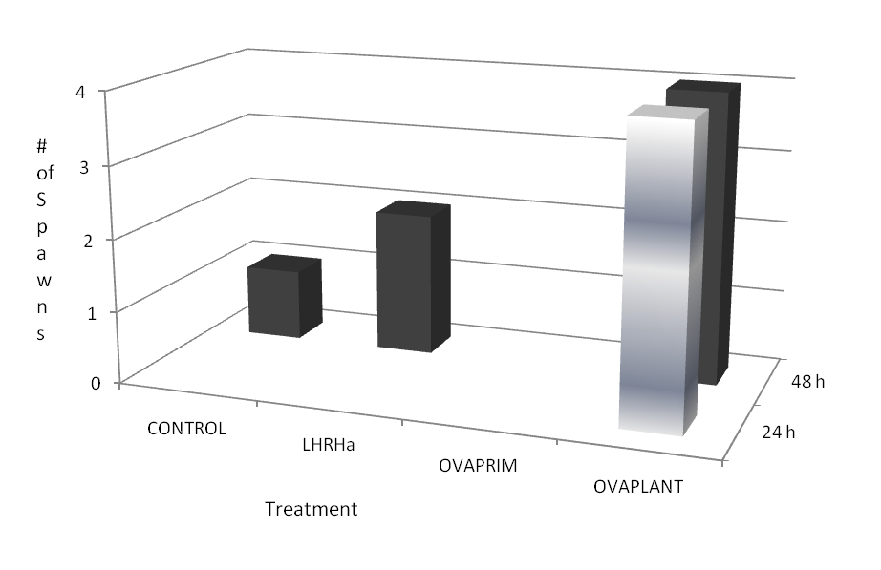
Figure 2. Spawning success of females per treatment (n=4) within 24 and 48 h after injection or implantation.

Only one natural spawn was observed for all females either within the experiment and for all collected fish. As extra information, we estimated that mean oocyte diameter is 300 µm and fish showed a relative fecundity of 80,000 to 100,000 cells per gram (Table 1) Apparently, only partial spawns were recorded for all observed spawns. Thus, we were able to validate GnRH analogs as valuable tools to achieve controlled spawning of chame, in a similar fashion to bullseye puffer Sphoeroides annulatus (Duncan et al., 2003) and with better results that previous trials in Ecuador (several per comm.) were large amounts of HcG had to be injected (up to 10,000 UI) to obtain viable oocytes or no spawn achieved as tested with fatsleeper Dormitator maculatus using HcG, LHRHa and Ovaprim (Gaude et al, 2010).
Table 1. Estimated values of spawning females for all experimental treatmens within the experiment.
Variable | Control |  | LHRHa | Ovaprim |  |  | Ovaplant
Weight (g) |  | 393.3±185.1 | 486.15±205.2 |  | 388.9±151.6 | 388.6±216.1
% of spawning fish |  | 25% | 50% |  | 0% | 100%*
Relative fecundity (cell g⁻¹) |  | 83000 | 59000 |  | n/a | 50000±10000**
Oocyte diameter (µm) |  | 392.6±51.8 | 327.7±18.5 |  | n/a | 353.8±106.6**
*n=4 **Pooled from 4 females

For males, sperm quality issues are noticeable given that in most cases, milt collected can show very low sperm motility; either after hormone injection or with testicle removal and maceration from fish (Estuardo Campoverde, pers. comm.). We were able to induce spermiation in all hormone treatments with minimal changes in estimated sperm quality variables (Table 2). As main difference, both and Ovaprim and Ovaplant groups released as significantly higher amount of milt, with noticeable sperm fluid mixed with sperm fluid; however it did not affect motility or sperm concentration (Table 2). LHRHa was an effective spermiation inducing agent as proved with many other fish such as bullseye puffer Sphoeroides annulatus (Rodriguez, 2001). Several males released sperm naturally up to 1 ml throughout the reproductive season as observed in this experiment. Obtained data indicates that sperm activation time is close to 4 minutes, and overall concentration is within the range of 1 to 2X10⁹ cells per milliliter (table 2). No spermatocrit values were recorded as chame sperm viscosity probed to high in undiluted sperm. Therefore, GnRHa can be used to induce sperm release in chame, result that in our knowledge is the first report of similar findings.
Predilution of sperm in Ringer´s solution on a 1:10 ratio was determined to be the most favorable ratio, both for sperm activation and fertilization. As optimal salinity values, both for fertilization and egg incubation, our results indicate that there is no sperm activation above 5‰ of salinity; similar data were recorded for optimal incubation salinity as no hatching was observed above the same salinity value. Therefore all fertilization and incubation trials were conducted in 1 µm filtered, UV sterilized fresh water.
Table 2. Estimated values of sperm quality for all experimental treatments
Variable | Control | LHRHa | Ovaprim | Ovaplant
Weight (g) | 622.7±54.7 | 434.7±139.4 | 538.75±187.4 | 540.6±202.1
# of spermiating fish | 3 | 4 | 3 | 4
Mean volume ml | 0.5 | 2.3 | 4.3 | 8.2
Motility (%) | 93.3±11.5 | 83.3±11.5 | 80.0±26.4 | 93.3±5.77
Activation time (Min) | 4:24±0:22 | 4:57±1:91 | 2:47±1:37 | 2:90±1:02
Concentration (cell ml⁻¹) | 1.96E+09±  1.29E+09 | 2.29E+09±  7.8E+08 | 1.26E+09±  2.37E+08 | 2.31E+09±  7.84E+08
Eggs are demersal and have an adhesive layer, transparent and spherical with a 300 µm average diameter (Fig. 3a). Hatching occurs at 14-17 hours at 26°C, larvae length is close to 1288.2±137.2 µm, yolk sack diameter is around 171.2±10.6 µm with a single lipid droplet, no eyes or mouth are visible and show a vertical floating position with no active movement (Fig. 3b). At 24 h (1 day posthatching DPH), yolk sack diameter reduces to 137.1±8.3 µm, eyes are perceptible, with no pigmentation and digestive tract is noticeable (Fig. 3c). Mouth opening occurs at 2 DPH, ayes are well pigmented and digestive tract structures become more discernable (intestine, vestigial anus); yolk sack diameters is significantly smaller 93.8±10.7 µm (Fig. 3d). At 3 DPH, yolk sack is fully consumed and oral movements are perceptible and digestive tract has an evident circumvolution and pigmentation (Fig. 3e). Anus fully opens at 4 DPH, and some other internal structures are visible (i.e. liver) and body pigmentation increases considerably.

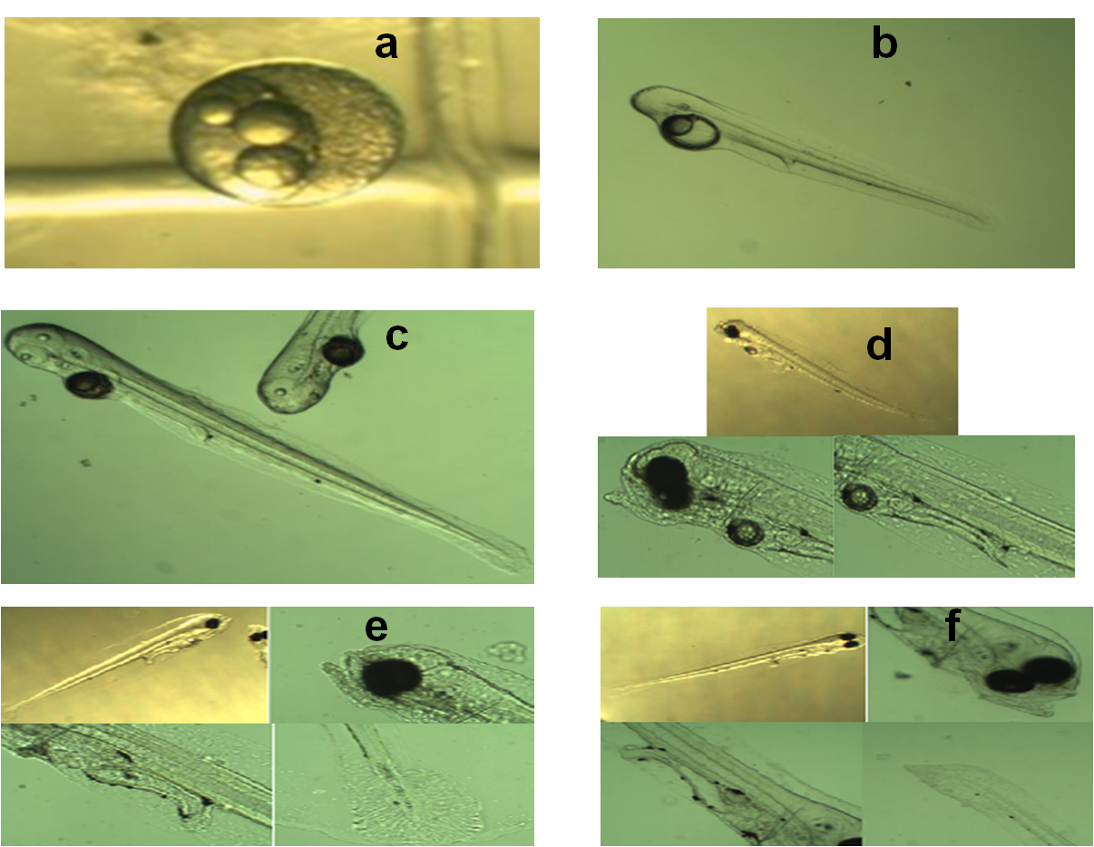
Figure 3. Early morphological development of chame larvae at 26°C.
Acknowledgments:
This project was funded in part by the United States Agency for International Development (USAID) under CA/LWA No. EPP-A -00-06-00012-00 and by participating US and Host Country institutions such as DGIP- PROFAPI 2009/151 research project funded by Universidad Autonoma de Sinaloa, Mexico .
REFERENCES:
Duncan, Neil J, G. A. Rodriguez M de O, D. Alok, Y. Zohar. 2003. Effects of controlled delivery and acute injections of LHRHa on bullseye puffer fish (Sphoeroides annulatus) spawning. Aquaculture 218, 625-635.
Gaudé, A., Brown, C., Green, C. 2010. Awakening the sleeper: bringing Dormitator maculatus into full market potential as a premier marine bait for Louisiana. Abstract Aquaculture 2010. San Diego Californa, USA.
Rodriguez Montes de Oca, G.A. 2001. Evaluación de la calidad del esperma del botete Diana Sphoeroides annulatus (Jenyns, 1834) en condiciones de cautiverio y bajo inducción hormonal con LHRHa. Masters degree Thesis. CIAD, A.C. Mazatlán Sin.

