CHAPTER 1
Total RNA Isolation

Overview

Isolation of total RNA. Total RNA can be isolated using a variety of procedures, depending on species, organ, and tissue types. We have provided information concerning the most basic and simple method of RNA isolation using Trizol, followed by RNA cleanup using RNeasy mini column. We have found this combination of methods works very well for many different tissue types, producing very clean total RNA without inhibitory contaminants. It is also very flexible, that the procedures can be modified to accommodate the differing requirements of specific tissues. For example, if you are working with tissues which contain large quantities of starch or other polysaccharides, such as maize endosperm or maize root tips, the protocol requires modification to remove polysaccharides which would interfere with target production. This can be achieved by dissolving the pellet containing the RNA and the polysaccharide in a larger volume of DEPC treated water or TE buffer than described in the protocol (increasing the volume from 0.1 to 0.5 mL at step 14), and incubating the solution on ice for a few hours. This step precipitates most of the dissolved starch from the RNA solution, and it can be removed by centrifugation. If necessary this step can be repeated once or twice more. We strongly recommend RNA cleanup using RNeasy mini-elute columns before proceeding to RNA amplification, since traces of phenol contamination can strongly inhibit the future steps it is important to purify the total RNA.
The Trizol reagent was developed from the single-step RNA isolation method described by Chomczynski and Sacchi (Analyt. Biochem. 162:156-159, 1987). Trizol is a monophasic mixture of phenol and guanidine isothiocyanate, which during sample homogenization, maintains RNA integrity whilst solubilizing and/or precipitating other cellular components. For smaller samples, homogenization can be done using a glass-in-glass homogenizer. Phase separation is facilitated by addition of chloroform, and the aqueous phase, containing the RNA, DNA and polysaccharides, is recovered. The nucleic acids (and the polysaccharides) are then precipitated using isopropanol. For general RNA methods, see Farrell (RNA Methodologies: a laboratory guide for isolation and characterization (3rd. edition), Elsevier Academic Press, 2005).

Materials and Methods

Total RNA Isolation

Materials

TRIzol® Reagent (Invitrogen; 15596-026)
RNAase-free mortar and pestle: cover the mortar and pestle with aluminum foil and bake overnight at 180ºC.
RNAase-free 1.5 mL microfuge tubes.
Liquid nitrogen.
Refrigerated microfuge.
RNAase-free pipette tips.
Isopropanol.
DEPC-treated H₂O.
3M Na acetate (pH 5.3), RNAase-free: prepare the 3 M Na acetate in DEPC treated H₂O in an RNAase-free container ; adjust the pH with acetic acid and autoclave before using.

Methods

- Homogenize 200mg of tissue in liquid nitrogen.
  - Chill mortar with ~100 mL of liquid nitrogen.
  - Add tissue after nitrogen has evaporated to one-half of its original volume.
  - Grind tissue quickly but carefully.
  - When liquid has fully evaporated, grind faster to produce a fine talc-like powder.
- Add 1 mL Trizol per 100 mg of tissue and continue to mix. If frozen stiff, wait to thaw slightly and continue
- When mixed thoroughly, wait until the homogenate melts into a liquid, and transfer to RNAase-free tubes.
  - Cover the mortar with foil while waiting (~5 –10 min)
  - RNAase-free microfuge tubes are optimal for this purpose (1 mL liquid per tube).
- Incubate for 5 min at room temperature (RT).
- Add 0.2 mL chloroform for each 1 mL of Trizol, and vortex for 15 sec.
- Incubate for 1 min at RT.
- Centrifuge at 15,000xg for 10 min @ 4°C.
- Transfer the aqueous phase to fresh RNAase-free tubes, and put on ice.
  - You should see two layers. Remove the top layer, starting from the very top and side of tube, leaving a broad zone separating the lower layer.
  - Put tubes on ice as soon as the liquid has been transferred.
- Precipitate by adding an equal volume of isopropanol.
  - Mix by inverting twice.
  - Incubate for 15-30 min on ice.
- Centrifuge at 15,000xg for 10 min at 4°C.
  - A small pellet should be visible.
- Wash pellet with 1.0 mL 75% ethanol prepared using RNAase-free water (Be careful; the pellet may be loose).
- Dry the pellet for 5 min by inverting onto a Kimwipe. Caution: Do not let it dry for longer than 5 min, since the pellet will become very difficult to re-suspend.
- Add 100-500 μL DEPC treated water.
  - Resuspend by pipetting (breaking the pellet helps to speed up the dissolving).
  - After breaking the pellet thoroughly, incubate the tubes on ice for at least 1 h, with occasional resuspension.
- Spin at 20,000xg for 20 min at 4°C to remove the debris.
- Transfer supernatant to a clean RNAase-free tube.
  - Note: You will not always get a clear distinction between the supernatant and the unwanted debris layer at the bottom of the tube.
  - To avoid transferring debris, pipette slowly from the surface of the supernatant.
- Repeat precipitation with 10% volume 3M sodium acetate and an equal volume of 100% isopropanol.
  - Precipitate on ice for 1 h or overnight at –20°C.
- Spin at 20,000xg for 20 min at 4°C (14,000 rpm in a table top microcentrifuge).
- Repeat steps 11-12.
- Dissolve in 100 μL RNAase-free water for 1 h on ice (steps 17-20 are optional).
- Determine the concentration and purity of the RNA using spectrophotometry.
- Run gel to check the RNA integrity and quality.
  - Prepare 1% agarose gel in 1X TBE or TAE in a RNAase-free gel box.
  - Load 2 μL sample and 1 μL dye.

Optional DNAase treatment (steps 22-26)

- Add 5 μL of 10 x RQ1 DNAase buffer and Add 20 μL of RQ1 DNAase (1U/μL) (Promega Cat # M6101A), make up the total volume to 50 μL with DEPC H₂O and incubate at 37ºC for 30 min.
- Add 50 μL of RNAase-free water to bring total volume to 100 μL.
- Add 100 μL of phenol/chloroform (pH 4.0) and shake to mix well. Spin tube for 2 min at max speed (20,000xg) to separate phases.
- Transfer the upper phase to fresh tube (~85 μL), and add 9.0 μL of RNAase-free 3M sodium acetate, and 250 μL of ethanol. Mix by inversion.
- Place at -20⁰ C for 10-20 min to precipitate the RNA.
- Wash with 75% ethanol, dry briefly and dissolve the total RNA in 20 μL of DEPC H₂O on ice for 1-2 h.
- Store the RNA at –80° C until needed.

RNA Quality Control and Quantification

Overview

RNA quality is a critical factor which determines the quality of hybridization. RNA that is of poor quality (i.e. degraded or contaminated) cannot be efficiently labeled, and consequently will not give good hybridization signals. Macromolecular (and other) contamination not only adversely affects RNA labeling but also interferes with RNA quantification. As a general rule: Good RNA = Good Hybridization.

RNA quantification can be done using UV absorbance at 260 nm, or by treating the RNA with the RNA-specific dye Ribogreen and measuring the fluorescence. Although the Ribogreen binding method is more sensitive than UV absorbance, the latter is the most widely used. In this method, the absorbance values are converted into RNA quantity using the Beer-Lambert equation:
A = E * b * c
Where A is the absorbance represented in absorbance units (A), E is the wavelength-dependent molar absorptivity coefficient (or extinction coefficient) with units of liter/mol-cm, b is the path length in cm, and c is the analyte concentration in moles/liter or molarity (M).

For nucleic acid quantification, the Beer-Lambert equation is manipulated to give:
c = (A * e)/b
Where c is the nucleic acid concentration in ng/microliter, A is the absorbance in AU, e is the wavelength-dependent extinction coefficient in ng-cm/microliter, and b is the path length in cm. The generally accepted extinction coefficients for nucleic acids are:

- Double-stranded DNA: 50
- Single-stranded DNA: 33
- RNA: 40

Methods

RNA Quantification using the NanoDrop.

NanoDrop spectrophotometer, which directly measures the RNA concentration of a sample without dilution, requiring only ~1 - 2 μL of sample without dilution.

- Place 1.5 μL of ddH₂O on the lower pedestal of the NanoDrop, lower the upper pedestal into position, then initialize the instrument.
- After the initialization is completed, select the Nucleic Acid Measurement window from the Menu Options.
- Wipe the pedestals clean using a Kimwipe, and apply fresh 1.5 μL of ddH₂O onto the lower pedestal. Replace the upper pedestal, and take the blank reading (setting the base line).
- Wipe the pedestals thoroughly with a Kimwipe.
- Apply 1.5 μL of the RNA sample, replace the upper pedestal, and take the measurement.
- Wipe the pedestals, apply fresh ddH₂O, and take the final (control) measurement.
- Clean the pedestals, and exit the program.

Note:- RNA concentration can also be measured using conventional spectrophotometer at 260 NM, by dilution the RNA sample 1:50 with DEPC treated water. To achieve accurate measurement it is essential to estimate the RNA concentration in atleat two different dilutions.

RNA Quality Analysis.

Agarose Gel Electrophoresis.

1. Preparation of agarose gel for RNA analysis.

  - For quick RNA quality check, use a 1% agarose gel prepared in TBE buffer.
  - Melt 1.0 g agarose in 100 mL 1X TBE buffer (prepared in twice-autoclaved ddH₂O), and cast the gel within a RNAase free gel box. It is good practice to keep a gel box separately for RNA use only; after each run, it should be cleaned by rinsing with DEPC-treated water). Note: Please follow standard denaturing gel electrophoresis if you are planning to do Northern analysis.

10 X TBE Buffer

ddH₂O 800 mL
Tris base 108.0 g
Boric acid 55.0 g
EDTA 9.3 g
Adjust volume to 1L with ddH₂O
- Run agarose gel to check RNA integrity.
  - 1% Agarose gel in 1X TBE in an RNAase free gel box.
  - Load 5μL sample and 2μL dye.
  - Run at 100V until the dye reaches the end of the gel (~30 min).
  - Observe the RNA gel using a UV gel box
- Store remaining RNA at –80°C.
- You also will be using the Bioanalyzer for RNA electrophoresis, in which case you should follow the manufacturer’s instructions.

Figure. Image typical of total RNA analyzed using agarose gel electrophoresis. This RNA is suitable for target preparation. Critical is the non-smeared appearance of the major bands, which correspond to ribosomal RNA. The mRNA is not visible, being a collection of molecules of different lengths.

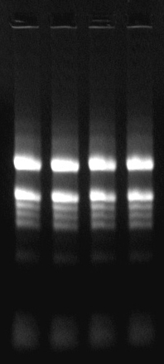

Target Preparation I: Total RNA Cleanup

Materials:

RNeasy MinElute Column (Qiagen Cat #74204)
Agilent RNA 6000 Nano LabChip Kit
Refrigerated microcentrifuge
RNAase-free microfuge tubes and tips
100% Ethanol
DEPC-treated H₂O

Methods:

It is necessary to remove any phenol that may have been carried over from the Trizol and other contaminants before proceeding to next step. In this lab, we are using Qiagen RNeasy MinElute Columns for RNA cleanup. A maximum of 45 µg RNA in a maximum starting volume of 200 μL can be used. This amount of RNA represents the binding capacity of the columns. Further details concerning the columns can be found in the Qiagen RNeasyMini Handbook.

- Put on gloves! RNA is very labile. Keep RNA solutions on ice.
- Adjust sample (10-20 μg total RNA) to a volume of 100 μL with RNAase-free water, add 350 μL RLT buffer (provided in the RNeasy kit), and mix thoroughly. At this point, the RNA samples are maintained at room temperature.

- Add 250 μL of 100% ethanol to the diluted RNA, and mix thoroughly by pipetting. Do not centrifuge; continue immediately to the next step.

- Add 700 μL of the sample to an RNeasy MinElute Spin Column in a 2 mL collection tube. Close the tube gently, and centrifuge for 15 sec at 8,000xg. Discard the flow-through.

- Transfer the spin column into a new 2 mL collection tube. Pipet 500 μL RPE buffer (provided in the kit) onto the spin column. Close the tube gently, and centrifuge for 15 sec at 8,000xg to wash the column. Discard the flow-through.

- Note: Buffer RPE is supplied by the manufacturer as a concentrate. If you buy the kit yourself, ensure that you add ethanol prior to use of this buffer. For this lab exercise, we have already added the ethanol.

- Add 500 μL of 80% ethanol to the RNeasy MinElute Spin Column. Close the tube gently, and centrifuge for 2 min at 8,000xg to dry the silica-gel membrane. Discard the flow-through.

- Transfer the RNeasy MinElute Spin Column into a new microfuge collection tube. Open the cap of the spin column, and centrifuge in a microcentrifuge at full speed for 5 min. Discard the flow-through and collection tube.

- To elute, transfer the spin column to a new microfuge tube. Pipet 20 μL of DEPC H₂O pre heated to 55 C (from Qiagen kit) directly onto the center of the silica-gel membrane. Close the tube gently, incubate at RT for 2 min, and centrifuge for 1 min at maximum speed to elute. Repeat the elution one more time with additional 20 μL warm DEPC H₂O (55 C).

- Measure the RNA concentration and proceed to the next step. Note: do not discard the spin column until you have verified the RNA recovery. You may need to re-extract with more water (50 μL). We expect about 80% RNA recovery. Keep RNA solutions on ice after elution.

Measure the RNA amount using Nanodrop and use the Bioanalyzer to verify the quality of the total RNA.

Total RNA Analysis using the Bioanalyzer.

Total RNA quality can be analyzed either by Agarose gel electrophoresis in TBE buffer or using Bioanalyzer (Agilent technologies) or Experion (BioRad). The Bioanalyzer or Experion requires very small quantity of RNA (50-150 ng) for analysis where as Agarose gel electrophoresis requires 1-2 ug.

Figure 1. Total RNA from Arabidopsis leaf tissue was analyzed using the Bioanalyzer.

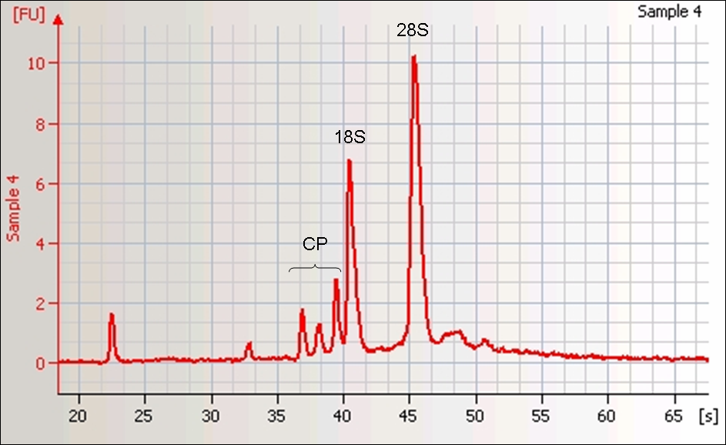
Figure 2. Image file output from the Bioanalyzer. Sample 12 is the unpurified total RNA, and lanes 1-11 the cleaned-up RNA samples from Arabidopsis leaf tissues.

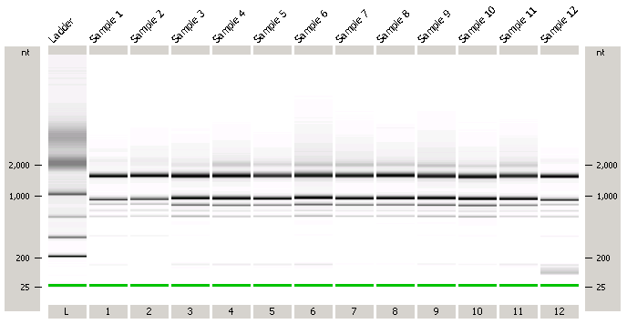

CHAPTER 2
RNA amplification and aRNA hybridization

Overview

A typical microarray experiment requires 30-50 μg of total RNA, corresponding to about 1μg of polyA⁺ RNA. Therefore, RNA amplification techniques become essential for experiments involving limited amounts of starting materials, for example microarray analysis involving rare tissues such as, in plants, the female gametophyte, the developing embryo, and other dissected tissues and cell types. Most RNA amplification techniques are based on the method of Eberwine (van Gelder et al., 1990), employing double stranded cDNA synthesis using oligo dT primers incorporating one of the T3 or T7 viral promoters, followed by in vitro transcription as a means to linearly increase the concentration of messenger RNA. The optimized Eberwine method is capable of amplification of mRNA up to ~10³ fold for one round of amplification, and up to ~10⁵ fold for two rounds of amplification (Wang et al., 2000; Baugh et al., 2001). Employing two rounds of RNA amplification, one can successfully perform a microarray experiment using as little as 10 ng of starting RNA, i.e. corresponding to the content of a few isolated cells. However, use of two rounds of RNA amplification reduces the number of detectable genes up to 20% , due to truncation of the 5’ complexity of the RNA population (Luzzi et al., 2003).

A variety of alternatives to Eberwine-based methods have been described (Iscove et al., 2002; Aoyagi et al., 2003; Ginsberg and Che, 2002; Brabdt et al., 2002; Seth et al., 2003). The major advantage of the Eberwine RNA amplification method over other methods is attributed to its linear mode of amplification, which helps preserve the relationships between the abundances of different transcripts. Xiang et al. (2003) indicate that this linear relationship can be maintained over five cycles of RNA amplification.

In terms of the two major types of microarray platforms available, having cDNA amplicon and oligonucleotide array elements respectively, certain constraints are placed on the methods of amplification that can be employed. Amplicon-based microarrays are particularly flexible in terms of the targets that can be hybridized, since either strand of the cDNA can be fluorescently labeled. In contrast, hybridization to oligonucleotide-based microarrays is restricted to the use of negative–strand targets. Since the Eberwine-based RNA amplification methods generate only negative strands, targets can be directly produced by labeling of the (amplified RNA) aRNA. Alternatively, a second round of amplification can be used to generate RNA corresponding to the positive-strand of the gene, which can then be reverse-transcribed to generate labeled target. Either method has advantages and disadvantages: directly labeling aRNA forces use of riboprobe hybridization methods, which can be challenging under certain conditions; using two rounds of amplification is time consuming and may cause truncation. We consequently recommend use of direct labeling of aRNA, rather than second round amplification, unless the extra level of amplification is required. New methods have been recently described for linear aRNA amplification which are specific to the positive strand of the gene (BD Biosciences). In our experience, total RNA isolated using the Qiagen RNeasy kit performs very well in RNA amplification, and without a requirement for further purification. However tissues containing large amounts of polysaccharide (such as plant root and endosperm tissues) present challenges for the RNeasy kit. For these tissues, we have found that Trizol extraction followed by polyA⁺ RNA purification provides RNA suitable for amplification.

Target Preparation III: Setting up the First Strand cDNA Synthesis

Materials:

Aminoallyl Message Amp II kit (Ambion Cat# 1753)
RNAase-free tips, tubes
Refrigerated Microcentrifuge
DEPC-treated H₂O
Thermocycler or incubators set at 42ºC
100% ethanol

Methods:

Preparation of aRNA Wash Buffer

Add 22.4 mL ACS grade 100% ethanol (ACS grade or better) to the bottle labeled aRNA Wash Buffer. Mix well and mark the label to indicate that the ethanol has been added.

First Strand cDNA Synthesis

- Place up to 1 μg of total RNA (typically 100 - 500 ng is sufficient) into a RNAase-free microfuge tube.
- Add 1 μL of T7 Oligo(dT) Primer. **Note this is NOT the same as the Oligo(dT) primer used for total RNA target labeling**.
- Add Nuclease-free Water to a final volume of 12 μL.
- Incubate 5 min at 70°C in a thermocycler.
- Remove the RNA samples from the 70°C incubator and centrifuge briefly (~5 sec) to collect sample at bottom of tube and immediately transfer to ice.

Assemble the Reverse Transcription Master Mix at room temperature, then place on ice.
(To reduce pipetting, prepare enough Reverse Transcription Master Mix to synthesize first strand cDNA for all RNA samples in the experiment. It is prudent to include 5% overage to cover pipetting errors. The following recipe is for a single reaction)

Amount Component

2 μL 10X First Strand Buffer
1 μL Ribonuclease Inhibitor
4 μL dNTP Mix
1 μL Reverse Transcriptase

- Mix well by gently pipetting up and down or flicking the tube a few times. Centrifuge briefly (~5 sec) to collect this master mix at the bottom of tube and place on ice.
- Transfer 8 μL of Reverse Transcription Master Mix to each RNA sample from step 5, mix thoroughly by gently pipetting up and down or flicking the tube a few times, and place the tubes in a 42°C incubator. We generally use a PCR machine with the lid temperature set at 48°C.

After the 2 h incubation at 42°C, centrifuge the tubes briefly (~5 sec) to collect the reaction at the bottom of the tube. Place the tubes on ice, and proceed to Second Strand cDNA synthesis.

Target Preparation IV. Second Strand cDNA Synthesis, and Setting Up for aRNA Synthesis

Materials

Aminoallyl Message Amp II kit (Ambion Cat# 1753)
RNAase-free tips, tubes
Refrigerated Microfuge centrifuge
DEPC-treated H₂O
Thermocycler incubators set at 16º C and 37C

Method

1. On ice, add the second strand cDNA synthesis reagents in the order listed to each sample from steps 5 above.

Amount Component

20 μL cDNA sample (from step f above)
63 μL Nuclease-free Water
10 μL 10X Second Strand Buffer
4 μL dNTP Mix
2 μL DNA Polymerase
1 μL RNase H

2. Gently mix by pipetting up and down or by flicking the tube a few times, then centrifuge the tubes briefly (~5 sec) to collect the reaction at the bottom of tube.

2A. When processing more than one sample, it is a good idea to make a Master Mix of the second strand cDNA synthesis reagents listed above; include ~5% overage to cover pipetting error.

If using this Master Mix, add 80 μL Master Mix to 20 μL cDNA sample. Gently mix by pipetting up and down or by flicking the tube a few times, then centrifuge the tubes briefly (~5 sec) to collect the reaction at the bottom of tube.

Incubate the tubes at 16ºC for 2 h, (use either a water bath in a cold room or a Thermal cycler; do NOT use a heat block in a 4°C refrigerator because the temperature will fluctuate too much).

After the 2 h incubation at 16°C, proceed to cDNA Purification (below), or immediately freeze reactions at –20°C. Do not leave the reactions on ice for long periods of time.

Target Preparation V: cDNA Purification

Use the cDNA purification kit supplied with the messageamp-II kit or you can also use other PCR purification kits like Qiaquick.

Before beginning the cDNA purification, preheat the 10 mL bottle of Nuclease-free Water to 55°C for at least 10 min.

- Check that the cDNA filter cartridge is firmly seated in a 2 mL wash tube and pipet 50 μL cDNA binding buffer onto the filter in the cDNA filter cartridge.
- Incubate at room temperature for 5 min. (DO NOT spin the cDNA binding buffer through the cDNA filter cartridge).
- Add 250 μL of cDNA binding buffer to each cDNA sample from the second strand cDNA synthesis and mix thoroughly by repeated pipetting.
- Pipet the cDNA sample/cDNA Binding Buffer onto the center of an equilibrated cDNA Filter Cartridge.
- Centrifuge for ~1 min at 10,000xg, or until the mixture has passed through the filter.
- Discard the flow-through and replace the cDNA filter cartridge in the 2 mL wash tube. Make sure that the ethanol has been added to the bottle of cDNA Wash Buffer before using it.
- Apply 500 μL cDNA wash buffer to each cDNA filter cartridge. Centrifuge for ~1 min at 10,000xg, or until all the cDNA wash buffer is through the filter.
- Discard the flow-through and spin the cDNA filter cartridge for an additional minute to remove trace amounts of ethanol.
- Transfer cDNA Filter Cartridge to a cDNA Elution Tube. To the center of the filter in the cDNA Filter Cartridge, apply 10 μL of nuclease free water that is preheated to 55°C. Leave at room temperature for 2 min and then centrifuge for ~1.5 min at 10,000xg, or until all the nuclease-free water is through the filter.
- Repeat the previous step with additional 10 μL of 55 C pre-heated nuclease-free water. The double-stranded cDNA will now be in the eluate (~18 μL).
- Discard the cDNA Filter Cartridge.

Target Preparation VI: In Vitro Transcription for aRNA synthesis

The oligo microarrays, being printed with positive-strand DNA elements, require labeled negative-strand targets for hybridization. Since the first round of amplified aRNAs represents the negative–strand, it is recommended to label the aRNA itself. aRNA labeling can be done using two methods: (a). direct incorporation of Cy-dye modified UTP during the process of in vitro transcription, or (b). indirect labeling, by incorporating aminoallyl modified UTPs during in vitro transcription, followed by monoreactive cy-dye coupling. Since the cy-dye modified nucleotides used for direct labeling are extremely expensive, we recommend the second approach.

Aminoallyl UTP (aaUTP) does not contain a bulky side chain modification, which means that one can replace 100% of the UTP with aaUTP during RNA synthesis without loss of incorporation. We recommend using a 1:3 ratio of UTP to aaUTP.

1. Make the reaction mix by adding the reagents in the following order:

16 μL double-stranded cDNA
3 μL aaUTP Solution (50 mM)
12 μL ATP, CTP, GTP Mix (25 mM)
1 μL UTP Solution (50 mM)
4 μL T7 10X Reaction Buffer
4 μL T7 Enzyme Mix

2. Mix well with pipette, centrifuge at 3,000xg for 30 sec, then incubate the tube at 37ºC in a PCR machine (the lid temperature should be set at 40ºC).

2A. If you are working with more than one sample, it is recommended to make a Master Mix; include 5% overage to account for pipetting errors). If using the Master Mix, add 24 μL to 16 μL double-stranded cDNA sample. Mix well with pipette, centrifuge at 3,000xg for 30 sec, then incubate the tube at 37ºC in a PCR machine (the lid temperature should be set at 40ºC).

The minimum recommended incubation time is 4 h, and the maximum is 14 h. Stop the reaction by adding 60 μL nuclease-free water to each aRNA sample to bring the final volume to 100 μL. Mix thoroughly by gentle vortexing, and proceed to the aRNA purification step (next page).

Target Preparation VII: aRNA Purification, Quantification, and Dye Coupling

Materials

Aminoallyl Message Amp II kit (Ambion Cat# 1753)
RNAase free tips, tubes
Refrigerated Microfuge centrifuge
100% EtOH
Cy3 Monoreactive dye (Amersham Pharmacia; Cat# PA23001)
Cy5 Monoreactive dye (Amersham Pharmacia; Cat# PA25001)
DMSO (Sigma; Cat#D8418)
Hydroxylamine (Sigma Cat#159417)
Sodium Carbonate
Sodium Bicarbonate
DEPC-treated H₂O

aRNA Purification

Before proceeding to the dye coupling, it is important to remove all the unincorporated nucleotides from the aRNA. Check to make sure that each IVT (In Vitro Transcription) reaction was brought to 100 μL with nuclease-free water.

- Add 350 μL of aRNA binding buffer to each aRNA sample, then proceed to the next step immediately.
- Add 250 μL of ACS grade 100% ethanol to each aRNA sample, and mix by pipetting the mixture up and down three times. Do NOT vortex to mix and do NOT centrifuge.
- Proceed immediately to the next step as soon as you have mixed the ethanol into each sample. Any delay in proceeding could result in loss of aRNA because once the ethanol is added, the aRNA will be in a semi-precipitated state.
- Pipet each sample mixture from step 2 onto the center of the filter in the aRNA filter cartridge, centrifuge for ~1 min at 10,000xg, or continue until the mixture has passed through the filter.
- Discard the flow-through, and replace the aRNA filter cartridge back into the aRNA collection tube.
- Apply 650 μL wash buffer to each aRNA filter cartridge, centrifuge for ~1 min at 10,000xg, or until all the wash buffer is through the filter.
- Discard the flow-through, and spin the aRNA filter cartridge for an additional ~3 min to remove trace amounts of wash buffer.
- Transfer filter cartridge(s) to a fresh aRNA collection tube. To the center of the filter, add 100 μL nuclease-free water (pre-heated to 55º C).
- Leave at room temp for 2 min and then centrifuge for ~1.5 min at 10,000xg, or until the nuclease-free water is through the filter.
- The aRNA will now be in the aRNA collection tube in ~100 μL of nuclease-free water.

Determine the concentration of RNA using either the Nanodrop or a conventional spectrophotometer. Aliquot 4 μg of aRNA (if aRNA is limited, any where from 1-4 ug should be enough) and completely dry it using a Speedvac centrifuge set at 45ºC or lower. Store the remaining aRNAs at -80ºC for further use.

Make an aliquot for the Bioanalyzer (5 μL of 150-200 ng/μL).

aRNA Analysis using the Bioanalyzer.

Follow the procedure recommended by the manufacturer for analysis of the RNA samples. In general, 1 μL of RNA sample (100-200 ng/μL) is sufficient for analysis using a Nano chip.

Figure 2. Typical results of aRNA Analysis using the Bioanalyzer

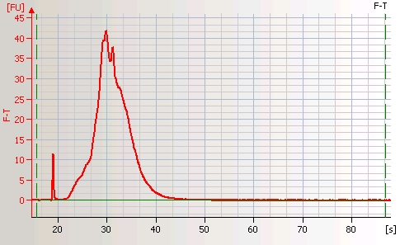
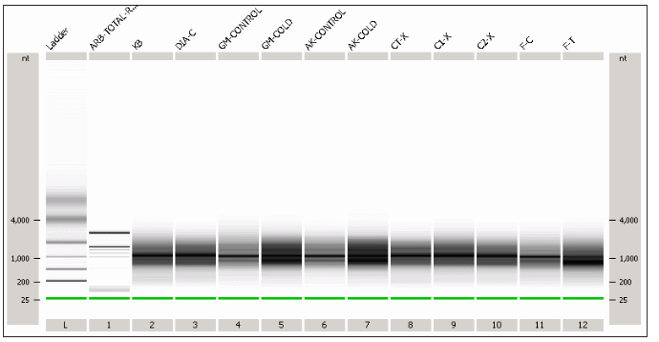
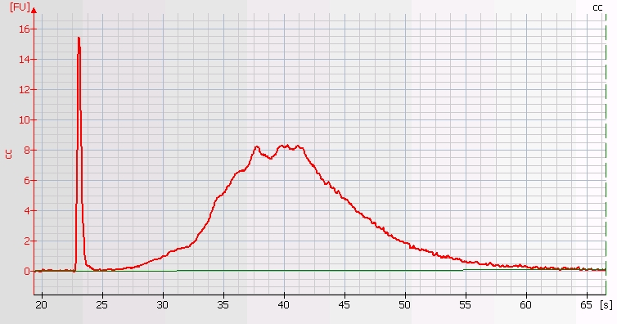

Target Preparation VIII: Coupling AA-cRNA to the Cy Dye Ester

Preparation of 0.2 M sodium carbonate buffer: pH 9.0.
Solution I. Dissolve 0.84g NaHCO₃ in 50 mL of DEPC H₂O in a disposable sterile Falcon tube.
Solution II. Dissolve 1.05g Na₂CO₃, in 50 ml of DEPC H₂O in a disposable sterile Falcon tube.
Mix 45 ml of solution I and 2.75 ml of Solution II in a disposable sterile Falcon tube, which should result a 0.2 M Sodium Carbonate buffer with pH 9.0. Check the pH by aliquoting 5 ml in to a new 15 ml Falcon tube, if needed adjust the PH by adding appropriate amount of Sol-I or Sol-II, never check the PH directly in the stock solution that may cause RNase contamination. Aliquot 0.2mL into RNAase-free tubes, store at -20ºC. Use one tube at a time, discarding the tube after use.
Preparation of Cy3 and Cy5 monoreactive dye. These dyes are supplied as five aliquots; the contents of each tube is sufficient for at least four labeling reactions. Dissolve the entire contents of a single tube in 22 μL DMSO by flicking the tube several times, and leaving at RT for at least 30 min protected from light. Centrifuge at 1,000xg for 30 sec to collect the dye at the bottom of the tube. The dye is now ready for use, but can be stored at -20ºC for up to one month. Always protect the dye from light by wrapping with aluminum foil.

- Dissolve the dried aRNA with 5 μL of 0.2 M NaHCO₃ buffer (see previous chapter) by flicking the tube several times and leaving the tube at RT for at least 20 min.
- Add 5 μL of Cy3 or Cy5 (in DMSO) to each tube, and mix them thoroughly by flicking the tube several times.
- Spin the tube at 1,000xg for 30 sec.
- Incubate the dye and aRNA mix in the tube at RT for 2 h while covered in aluminum foil.

Target Preparation IX: aRNA Purification (Post Dye-Coupling)
Materials required
RNeasy MinElute column (Qiagen Cat# 74204)
RNAse free tips and tubes
Refrigerated centrifuge
Hydroxylamine (Sigma Cat#159417)
Quenching Reaction. This optional step involves quenching any unreacted Cy dye by adding an excess of primary amines.
- Add 4.5 μL 4M hydroxylamine.
- Incubate for 15 min in the dark at RT.
Removal of Unincorporated Dye.
The Qiagen RNeasy MinElute column is used for this purpose.
- Adjust sample to a volume of 100 μL with RNAase-free water. Add 350 μL of RLT (kit) buffer, and mix thoroughly.
- Add 250 μL of 96–100% ethanol to the diluted RNA, and mix thoroughly by pipetting. Do not centrifuge, continue immediately with step 3.
- Apply 700 μL of the sample to an RNeasy MinElute Spin Column in a 2 mL collection tube (supplied). Close the tube gently, centrifuge for 15 s at 8,000xg, and discard the flow-through.
- Transfer the spin column into a new 2 ml collection tube. Pipet 500 μL RPE (kit) buffer onto the spin column. Close the tube gently, and centrifuge for 15 s at 8,000xg to wash the column. Discard the flow-through (reuse the collection tube in step 5).
Note: RPE buffer is supplied as a concentrate; ensure that ethanol is added before use.

- Add 500 μL of 80% ethanol to the RNeasy MinElute Spin Column. Close the tube gently, and centrifuge for 2 min at 8,000xg to dry the silica-gel membrane. Discard the flow-through and collection tube.
- Transfer the RNeasy MinElute Spin Column into a new 2 mL collection tube (supplied). Open the cap of the spin column, and centrifuge in a microcentrifuge at 12,000xg for 5 min. Discard the flow-through and collection tube.
- To elute, transfer the spin column to a new microfuge tube. Pipet 20 μL warm DEPC water (55 C) and leave at RT for 2 min. Close the tube gently, and centrifuge at 12,000xg for 1 min.
- Repeat step 7 with an additional 20 μL of warm DEPC water (55 C).

Measure the amount of dye incorporated into aRNA using a NanoDrop or conventional spectrophotometer.

Measurement of Dye Incorporation
General
The Beer-Lambert equation is used to correlate the calculated absorbance with concentration:
A = E * b * c
Where A is the absorbance represented in absorbance units (A), E is the wavelength-dependent molar absorptivity coefficient (or extinction coefficient) with units of liter/mol-cm, b is the path length in cm, and c is the analyte concentration in moles/liter or molarity (M).

Dye Incorporation

Follow the table below to estimate the amount of dye incorporation. The Nanodrop instrument contains built-in software (the Microarray Concentration module) that uses the general form of the Beer-Lambert equation to automatically calculate the fluorescent dye concentrations.

Dye Type | Extinction Coefficient (liter/mol-cm) | Measurement Wavelength (nm)
Cy3 | 150000 | 550
Cy5 | 250000 | 650
Alexa Fluor 488 | 71000 | 495
Alexa Fluor 546 | 104000 | 556
Alexa Fluor 555 | 150000 | 555
Alexa Fluor 594 | 73000 | 590
Alexa Fluor 647 | 239000 | 650
Alexa Fluor 660 | 132000 | 663
Cy3.5 | 150000 | 581
Cy5.5 | 250000 | 675

Table of extinction coefficients for dyes used in microarray experiments.

Figure 3. Nanodrop estimation of Cy3 and Cy5 incorporation into target.

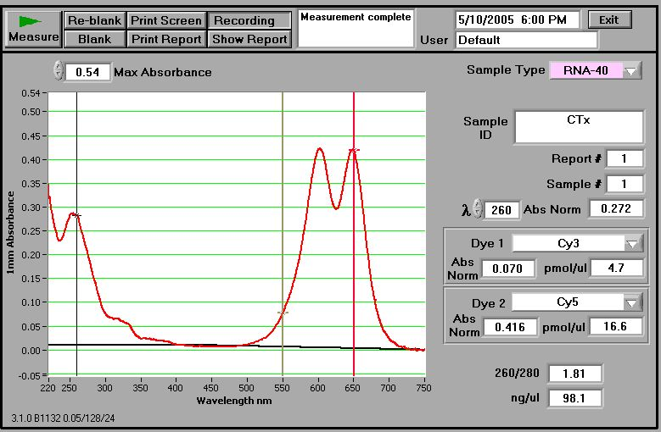
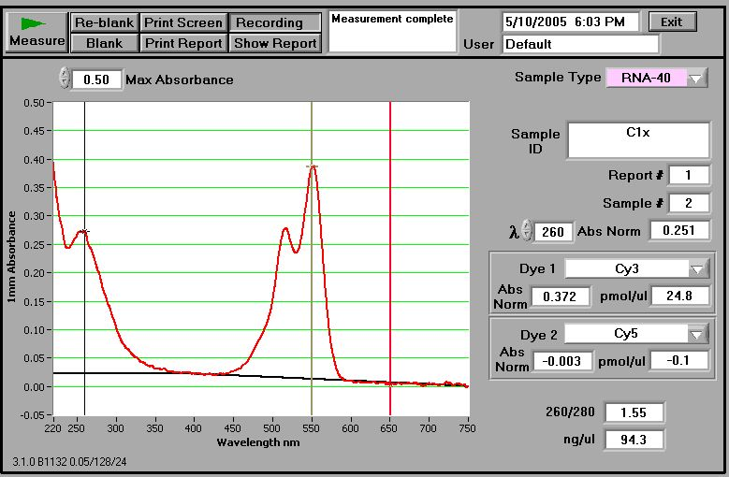

Note:- If NanoDrop is not available, use spectrophotometer to measure the dye incorporation. Incorporation for Cy5 is measured as its absorption at 650 nm, and incorporation of Cy3 at 550 nm. To calculate the amount of dye incorporated in your sample please use following web links.

http://www.pangloss.com/seidel/Protocols/percent_inc.html

http://www.prontosystems.com/technical_support/calculator/#ResultsView

Microarray Hybridization

Materials

Wash glasses
Microscope slide holders
10 mL disposable pipette
50 mL tubes
Sterile measuring cylinder
Extra-deep Hybridization Cassette (Telechem International Cat# AHCXD)
LifterSlip (Erie Scientific Company Cat#24X601-2-4733)
Incubator set to 55°C
Liquid Blocking Reagent (Amersham; Cat # RPN3601)
2% SDS
20XSSC
DEPC treated H₂O

Method

DNA probe immobilization:

This can be done at any time prior to hybridization.
- Re-hydrate slide over a 50°C water bath for 10 sec.
  - Hold slide with the label side down over the water vapor.
  - Watch spots carefully so that they do not over-hydrate and begin to merge together.
- Snap dry the slide on a 65°C heating block for 5 sec.
  - Place slide label side up on heating block.
  - Allow slide to cool for 1 min.
- Repeat steps 1-3 for a total of four times.
(The re-hydration step is important to obtain uniform spot without doughnut effect, however if you feel uncomfortable with re-hydration step, proceed directly to UV cross linking)

- UV cross-link the slides by exposing them in batches, label side up, to 180mJ in a commercial cross-linker (we employ a Stratalinker).
- Wash the slide in 1% SDS (prepared in sterile DDH₂O) for 5 min at RT on a shaker or agitate by hand.
- Remove SDS by dipping the slides ten times into sterile DDH₂O.
- Immediately transfer the slides to 100% ethanol, dip five times, then incubate for three min with shaking.
- Spin dry slide in centrifuge at no more than 200 x g for 2-4 min.

  - Pack bottom of 50 mL centrifuge tube with Kimwipes.
  - Using forceps carefully place slide into tube with label at the bottom.
  - Repeat spin if any liquid is remaining on the slide surface.

- Repeat ethanol wash if any visible streaks remain after spin dry.
- Store slide in a lint-free light-proof box at RT with low humidity.

Note: If you have centrifuge equipped with microplate centrifugation, use an mBox (Erie scientific, cat# BX-IM-20ERIE) to dry the slides. The mBox helps speed up the process, and also facilitates drying the slides uniformly.

Hybridization setup:

Hybridization mix

- Mix the following in a microfuge tube:

20X SSC 6.0μL
Liquid Block 3.6μL
2% SDS 2.4μL
Both Labeled Targets --- μL
H₂O to 60 μL

Note:- We recommend using 48 pmol of Cy5 labeled targets and 48 pmol of Cy3 labeled targets in a 60 μL hybridization volume, but this amount should be optimized empirically. We have used up to 100 pmol target with Arabidopsis. However, it is important not to add too high an amount of labeled targets in to the hybridization mix, since eventually this results in Cy-dye precipitation, leading to a very high background.

- Denature labeled target by incubating tube at 65º C for 5 min.
- Transfer tube to ice immediately or apply on to the slides directly.
- Rinse ArrayIt™ Hybridization Cassette with distilled water and dry thoroughly.
- Make sure flexible rubber gasket is seated evenly in gasket channel.
- Add 15 μL water to the lower groove inside the cassette chamber.
- Insert the microarray (1" x 3" or 25mm x 75mm slide) into cassette chamber, DNA side up.
- Place the lifter slip over the microarray slide (make sure the white stripe of the lifterslip is at the lower side)
- Apply the PRE-HEATED sample slowly to the one end of the lifterslip and let it disperse.
- Quickly place the clear plastic cassette lid on top of the cassette chamber.
- Apply downward pressure and manually tighten (clockwise) the four sealing screws.
- Check all four screws again to confirm a tight seal.
- Place the cassette into a hybridization oven set at 55ºC.
- Allow the hybridization reaction to proceed for 8-12 h.
- After hybridization, remove cassette, manually loosen the four sealing screws (counterclockwise) and remove lid.
- Remove the microarray slide from the cassette chamber using forceps and place the slides into the washing buffer.

Note:- Our recipe (SSC buffer, SDS, and Liquid Block) provides a low background, high sensitivity, and highly-reproducible results. Commercially-available hybridization buffers containing 50% formamide can also be used, in which case hybridization should be done at 42 ºC instead of 55 ºC.

Microarray Washing

- Wash slide in the following solutions for 5 min each:
2x SSC, 0.5% SDS @ 55°C
0.5x SSC @ RT
0.05x SSC @ RT

- Washing is done by immersing the slides in a glass slide-staining jar containing the appropriate volume of wash buffer, followed by placing it on a belly shaker at 60 rpm. Pre-heat the first wash solution, and make sure the slides are completely immersed in wash buffer.

- After completion of the washes, spin dry the slide in centrifuge at no more than 1,000 rpm for 2-4 min.

  - Pack bottom of 50 mL plastic disposable centrifuge tube with Kimwipes.
  - Using forceps, carefully place slide into tube with label at the bottom.
  - Repeat spin if any liquid remains on the slide.

Note: If you have centrifuge equipped with microplate centrifugation, use an mBox (Erie scientific, cat# BX-IM-20ERIE) to dry the slides.

- Scan slide immediately, or store in a light-tight box at room temperature under dry conditions.

- Immediate scanning is recommended. However, we have observed that properly stored slides (light protected, dry, RT) retain fluorescent signals for up to a month. Note: Some reports indicate environmental pollutants (ozone) can drastically affect fluorescence, particularly that of Cy5.
- Examine the scanned images immediately to determine the number of elements that are near zero or are saturated (for a 16-bit scanner, that represents a value of 65,400). The proportion of these elements should be acceptably low, since information is lost in either case.
- It is much more preferable to rescan with altered gain settings on the scanner than to proceed with analysis of images containing large proportions of zero or saturated elements. We have found that, even though the absolute value of the spots may be reduced by scanning a second or third time, the relative fluorescence distribution is preserved, so the information is not lost.
- Scanning a second time at higher PMT/laser values can also be done to move low intensity elements higher within the dynamic range. The two intensity distributions (at low and high PMT/laser values) can then be merged to provide an increased combined dynamic range.
- Save the image as a .TIFF file.

Microarray Feature Extraction.

Introduction

Feature extraction is a critical step which must be done carefully and thoughtfully, as it greatly influences the outcome of your microarray experiment! Feature extraction is carried out by spot-finding programs, which convert the digital scanned images to numerical values representing the signal intensities of each spot. There are a number of commercial spot-finding programs available, at various prices. Almost all modern microarray scanners come bundled with these programs, and the Axon/Molecular Devices gal file is largely accepted as a standard.

Feature extraction using GenePix Pro 6.0

- Load the .TIFF image file into the GenePix program.
- Load the .gal file using “open gene list”.
- Use auto adjust function F8 to find array, find features, and adjust the features .
- Spend time going through the entire slide twice: once to look for mismatches in the grid, and the second time to manually flag obvious problems. Look for: smears, streaks, or dust where the spot is obviously the same intensity or lighter than the smear it is sitting in, individual spots that are misplaced with respect to the grid (even if nothing is there, chances are the position is being dictated by a small noisy area, visible or not), spots that have bled into adjacent spots, and anything else that looks suspicious. We would like to keep as much data as possible, but dealing with an unbalanced statistical design is preferable to allowing outliers into the data set.
- Extract the data.
- Save the data as GPR files.

