BACTERIAL CAUSES OF SKIN ULCERS AFFECTION IN Tilapia nilotica (Orechromis niloticus) WITH SPECIAL REFERANCES TO ITS CONTROL

Mohamed E. Abou El-Atta and Mohamed M. El.Tantawy

Central Laboratory For Aquaculture Research

Abbassa Abou Hammad Sharkia Egypt

Fish Health Department.

Abstract
This work applied on Tilapia nilotica to investigate some bacterial causes of skin ulcer affection. The naturally infected fish showed dullness, sluggish movements, and loss of balance, spiral swimming near the surface, lethargic, erratic and loss of appetite. Dark pigmented and hemorrhagic skin, roughness easily detached scales, and sometimes-lossed leaving ulcers, hemorrhage at the base of the fins, and sometimes fin and tail rot, unilateral or bilateral exophthalmia (Pop eye) with or without opaqueness of the eyes, hemorrhage and abdominal distention. The hemorrhagic edematous ulcerated skin and anorexia affected the vital activities. Internally the infected fish showed general septicemia revealed by congestion of the gills, hepatosplenomegaly, and distended gall bladder with bile. In some cases, the surface of the liver has some hemorrhagic spots, enlarged, and sometimes become pale in color, congestion of the kidney that sometimes enlarged in addition, accumulation of bloody tinged exudates in the abdominal cavity. Bacteriological examination revealed isolation of Aeromonas hydrophila by 43.77%, Pseudomonas fluorescence by 29.63 % and Streptococcus faecium by 17.51 %. Histopathological examination to the infected skin showed focal sloughing of the epidermis with hyperplasia of alarm substance and mucous cells, Congested and hemorrhagic dermis with excessive aggregation of lymphocytes and melanomacrophage cells (MMC) with hyaline degeneration, also of epidermal basement membrane, the presence of melanomacrophage in different layers of the skin and underling muscles of most infected fish. The gills showed extensive fusion and obliteration of the secondary gill filaments, necrosis of the epithelial lining, hyperplasia of goblet cells and leukocytic infiltration. Antibiogram sensitivity test to the isolated bacteria revealed that, A. hydrophila was sensitive to Ciprofloxacin, Nalidixic acid, Tetracycline and chloramphenicol and was resist to Ampicillin, while P. fluorescens was sensitive to Nalidixic acid, chloramphenicol, Ciprofloxacin, Streptomycin and was resist to Amoxicillin and Ampicillin and St. faecium was sensitive to Ciprofloxacin, Ampicillin Nalidixic acid, and Amoxicillin.
Key words: Fish – bacteria - skin affection - ulcer.

Introduction
Aquaculture has an important role in the development and meeting the increase demand for aquatic animal production, Haylor and Bland (2001). Aquaculture industry gradually developed in the world as well as in Egypt. The health keeping of fish depended on the relationship between fish, environment and pathogens. The commercial rearing of fish by stocking them at relatively high densities in intensive fish farms, hatcheries and fish cages give rise to problems due to stress that predispose for diseases. Skin acts as a mirror to the health state of the fish aquaculture, since some pathogens attack the skin not only due to surface contamination from aquaria but also due to invasion by pathogenic microorganisms. Some of these pathogens that isolated from the skin and the internal organs of Tilapia nilotica were Aeromonas Sp., Pseudomonas Sp., Streptococcus Sp., Abd El-Latif and Adawy, (2004), Laila et al., (2004), El-Refaee (2005), Attia (2004). Some of these pathogens could transmit to man (who eat fish meat or deal with fish and fish products, as Aeromonas Sp., Streptococcus iniae, Goncalves et al., (1992), Weinstein et al., (1997) and Zlotkin et al., (2003). The prevalence of A. hydrophila, as causative agent of MAS was 37% among the diseased cultured O. niloticus, El-Ashram (2002), Aeromonas sp. and Pseudomonas sp. isolated from O. niloticus and from cat fish by 35.96% and 16.88% respectively, Abou El-Atta (2003), A. hydrophila, A. Sobria, and A. Caviae isolated by the following ratio (50%), (12.4%), (16.7%) and (11.9%) respectively. O. niloticus suffered from congestions and hemorrhages on the skin and fins, Abd El-Latif and adawy, (2004) and the affected fish suffered from excessive slime on skin, scale loss, ulceration, fin and tail rot, pale gills and exophthalmia, mouth sore, eye opacity, dislodged eye ball and sluggishness, Yambot(1998), petechial hemorrhages all over the body surface, congestion and enlargement of the internal organs (liver, spleen, and kidney), abdominal ascites by bloody tinged fluid, enlargement of liver and spleen and marked distended gall bladder, Badran and Essa (1991), Abou El-Atta (2003). Post mortem lesions were ascites, congestion, hemorrhages in the gills, petechial hemorrhages on the wall of muscles, peritoneum and intestine, dark red enlarged congested kidney, spleen and gall bladder was distended with bile, Abou El-Atta (2003), The histopathological changes in skin showed intercellular and intracellular edema, other epidermal cells revealed ballooning degeneration while some ruptured resulted in skin erosions, El-Gamal (1995).The gills showed extensive fusion and obliteration of the secondary gill filaments with necrosis of the epithelial lining, hyperplasia of goblet cells and leukocytic infiltration were recorded, Gamal et al., (2002). Pseudomonas was widely distributed in ecosystem and was recognized as one of the primary cause of bacterial hemorrhagic septicemia in fish, pseudomonas septicemia, usually is associated with environmentally stressful conditions such as overcrowding, low temperature, injuries, Aly (1994), Allen et al., (1983), It may be a secondary invader of damaged fish tissue, Roberts and Horne (1978).P. fluorescens considered the causative agent of red spot disease attack all kinds of cultured fishes where the disease raised in running water ponds, Austin and Austin (1993), stagnant water ponds as well as in cages Angko and Lioe, (1982), the disease favored by stressor as low temperature, injuries and recorded that the incidence of pseudomonas septicemia was 11%, Aly (1994) and 6.7%, Eissa et al., (1996), of affected tilapia. The infected fish showed dark body coloration, exophthalmia with corneal opacity and hemorrhage in the eyes, loss of balance, frayed and torn tail and fins, scale detachment and skin discoloration with scattered hemorrhages all over the body surface with slight ascites, petechial hemorrhages were seen on the ventral abdominal wall and the base of the fins, Badran (1993)Miyazaki et al., (1984), El-Attar and Moustafa (1996), The postmortem examination revealed congestion of spleen, kidney, ovaries and liver with distended gall bladder, presence of few amount of yellowish sanguineous fluid in the abdominal cavity, Badran and Essa (1991), and in the intestinal canal, Ahmed and shorett (2001). Histopathology, the skin revealed marked spongiosis and ballooning degeneration in the epidermis exhibited extensive, edema and focal hemorrhages, Gills sowed edema, congestion, hemorrhages and mononuclear leukocytic infiltration in the secondary lamellae was commonly seen, El Gamal (1995). The first case of Streptococcus SP. infection involved tilapia recorded by Wu (1970). Streptococcus iniae was the cause of meningo-encephalitis and mortality in cultured fish species and soft-tissue infection in humans, Fuller et al., (2002).The observed clinical signs occurred on the tilapia infected by streptococcosis, as anorexia, darkening of the skin, unilateral or bilateral corneal turbidity that developed into exophthalmia, abnormal swimming behavior, whirling, extreme leaping or simple activity. Infected fish were swam close to the water surface, lethargic, showed loss of balance and hyperventilated. Some developed ascites and petechial hemorrhages, especially around the anal zone, Bunch and Bejerano (1997).It was found that streptococcus infection detected in high prevalence among cultured fresh water fishes in Egypt, especially during summer seasons. The most common signs of streptococcosis in fish was septicemia, skin ulcers, uni or bilateral exophthalmia, hemorrhages of the eye, in some cases changed cloudy and destructed [pop –eye] and hemorrhages on the skin especially in the base of fins and tail, incidence of infection were in O. niloticus 17.2% and were identified as St. faecium 42.90%, St. faecalis 29.48%, and un typed species of streptococcus (Sp.1,Sp.2,and Sp.3) by 11.57%, 8.96% and 7.09% respectively, El-Refae (2005).
The present study aimed to isolate and identify the most predominant causes of skin ulcer lesions, clinical and postmortem examination, experimental infection, histopathological studies and antibiogram sensitivity to control of such microorganisms.

Materials and Methods
Fish
One Hundred naturally infected O. niloticus showed skin infection collected from aquaculture fish farm of Central Laboratory for Aquaculture Research (CLAR) Abou Hammad - Sharkia – Egypt during winter season from November to February,2007-2008 clinical examination
Clinical signs and postmortem examination carried out as described by Schäperclaus et al. (1992) to determine the clinical alteration due to bacterial infection. Examination include skin alterations as body color, presence of opaque films, exophthalmia, raised and detached scales, eroded opercula, reddening, ulcers, body swellings, clubbed and abraded gills, fins and tail.
Bacteriological examination
Samples includes swabs were collected under aseptic condition from ulcers, erosions, tail, fin, gills, muscles, liver, spleen, kidney, eye, and ascetic fluids. Swabs for bacteriological examination were inoculated into Nutrient broth, Tryptic soy broth and Brain heart infusion broth and incubated at 25-28Co for 24 - 48 hrs then streaked over Nutrient agar, Tryptic soy agar and Brain heart infusion agar and incubated at 25-28oC for 48 hrs. The suspected purified colonies picked up and streaked over specific medium for further purification, pure colonies transferred into nutrient agar slant for further identification. pure colonies streaked on to Rimler’s - Shotts medium (R.S. medium), Aeromonas selective agar base with Ampicillin supplement, pseudomonas selective agar base, blood agar and nutrient agar, tryptic soy agar and incubated at 25 Co for 24 hrs. Colonies picked up by sterile loop and subculture on blood agar plate and incubated at 25Co for 24 hrs for detection the hemolytic activity, a loop full of pure culture inoculated on nutrient agar slant for further identification, another loop full inoculated on semisolid nutrient agar for testing the motility and preservation. Identification of the isolates carried out according to Schäperclaus et al, (1992) Bergey, (1994) and Elemar et al, (1997) using the routine study of the morphological character and biochemical reactions as shown in Table 1, 2, 3.
Histopathological examination
Parts of skin (ulcer – hemorrhages – blisters), fins, gills were taken as samples then fixed in buffer formalin solution. Gills were soaked in E.D.T.A. for softening of cartilage then dehydrated through a second grades of Alcohol and cleared in xylol, after that the organs embedded in paraffin wax and cut into thin section of 5-7 mµ and stained with H & E.

Experimental infection with isolated strains
Forty of apparently healthy fish of equal size of O. niloticus used for experimental infection, and divided into eight groups, each group contains (5) five fishes, six groups for test and experimentally infected by one / or two types of isolates, and (2) two groups for control and injected by sterile broth to make the same stress of infection by injection. Eight glass aquaria of (140 x 70 x 50 cm) dimensions were used, the aquaria supplied with sufficient chlorine free tap water, aeration was carried by electric aerator and temperature adjusted by electric heater at 26±2Cº. As shown in Table 5.
Antibiogram sensitivity
Antibiogram sensitivity were done according to the limit given by Schäperclaus et al, (1992) using the disc diffusion method on Muller Hinton agar medium and the interpretations of the zones of inhibition estimated as shown in Table 4.

Results and Discussion
►Results of clinical examination: the naturally infected fish showed dullness, loss of balance, loss of appetite, sluggish movements, swimming near the surface water, lethargic, erratic and spiral swimming. Roughness and easily detached scales, dark pigmented skin, hemorrhage at the base of the fins, and sometimes losing of scales leaving ulcers, unilateral or bilateral exophthalmia, opaqueness of the eyes with hemorrhage and abdominal distention. Loss of balance could attribute to lesions in the labyrinth, which was associated with maintenance of equilibrium, the sluggish movement was probably due to the result of frayed tail and fins besides hemorrhagic edematous and ulcerated skin in addition to anorexia that affected the vital activities. Skin erosions and cutaneous grayish patches beside the slight hemorrhage at the base of the fins primarily induced by the release of powerful bacterial proteolytic enzymes that lead to electrolyte and protein loss together with disturbed circulation. Photo 1, 2, 3 and 4, Similar results were reported by El-Ashram, 2002, Gamal et al, 2002, Abou El-Atta, 2003, Abd El-Latif et al, 2004, and El-Refaee, 2005.
►Results of postmortem examination of naturally infected fish: These results showed general septicemia revealed by congestion of the gills, hepatosplenomegaly, congestion of the kidney that sometimes enlarged, distended gall bladder with bile, accumulation of bloody tinged exudates in the abdominal cavity. In some cases, the surface of the liver has some hemorrhagic spots, enlarged, and sometimes become pale in color. Photo 5, similar results were recoded by Ringo and Gatesoupe, (1998), Romalde and Toranzo, (1999), and El-Refaee, (2005), congestion of the liver, kidney and spleen was a septicemic lesion, Congestion and edema seem to play a role in the enlargement of kidney and spleen this agree with Amlacher, (1970) and Stoskopf, (1993). The over distended gallbladder could be attributed to enteritis or to the encountered constriction of the common bile duct. Variation in the color of the affected gills from pale to congestion was due to the coating of the gills by necrotic debris and secondary mycosis Plumb, 1994. Some infected fish showing unilateral or bilateral exophthalmia with corneal opacity may attributed to local inflammatory edema, Cataract may developed as a result of pathological degenerative changes in the lens, these results reported also by Plumb et al., (1974), Kitao ,(1993), Chang and Plumb ,(1996).
►Results of bacteriological examination: it showed that A. hydrophila, P .fluorescens and St. faecium were the main causative agents of high morbidity and mortalities among tilapia. High prevalence of A. hydrophila could be attributed to its presence as apart of the intestinal flora of the healthy freshwater and marine water fishes and its ability to its rapid growth rate in the living fish body, Newman and Natnarich, (1982). Moreover, the morphology of the bacterial cell is straight, motile rods 0.3 x 1.0-3.5 m µ, non-fastidious, its rapid growth rate colonies was formed within 24 hrs at 22-28ċ help its ubiquity, Robert, 1989. While P. fluorescence, which is a motile rod relatively long 0.8 x 2.0-3.0 mµ. The relatively low infection rate of St. faecium infection may be due to it was adapted to salinity levels in various ecosystems and that they were generally less virulent when found in an ecosystem that differs from their origin. Tilapia in water with 18-30 ppt. salinity at 25-30Cº was more susceptible to Streptococcus than when in fresh water at the same temperature, Chang and plumb, 1996. Okaem, (1989) and El-Bouhy, (1995), previously obtained similar results that they isolate A. hydrophila, P. fluorescens as single infection or mixed infection with St. feacium.
►Results of histopathological examination: mostly inflammatory reaction (leukocytic infiltration) represents a host reaction against the bacteria and /or toxins produced by bacteria. The skin and fins showed focal sloughing of the epidermis with hyperplasia of alarm substance and mucous cells. congested and hemorrhagic dermis with excessive aggregation of lymphocytes and melanomacrophage cells(MMC) with hyaline also of epidermal basement membrane, the presence of melanomacrophage in different layers of the skin and underling muscles of most infected fish may have served as a limiting factor for the disease since melanomacrophage constitute apart of the fish defense mechanism. These finding attributed to the production of the infective bacteria for extra cellular enzymes that have a hemolytic and proteolytic activities, reported by Austin and Austin, (1987). Such enzymes had a toxic effect, the toxic media produced by the bacteria played an important role in causing exudation, hemorrhage, degeneration, and necrosis of the tissues. The toxic effect on the epithelial cells leads to irritation and subsequent hyperplasia of alarm substance cells and mucous cells as defense mechanisms against the hazards of the toxins. Also, it affect the endothelial lining of subcutaneous blood vessels leads to escape of R.B.Cs. and leukocytes to the surrounding tissues as well as escape of the plasma protein that causes edema, congestion and hemorrhage at the site of infection. Excessive aggregation of EGC, MMC are the main item of defense mechanism and the MMC dark coloration was attributed, these finding agree with Easa et al, (1985) and Ventura and Grizzle, 1988. The gills showed congestion of branchial blood vessel of telangiectasis some cases showed moderate to severe focal epithelial hyperplasia of secondary lamellae while other cases showed complete sloughing of secondary lamellae with desquamation of epithelial cell covering of primary lamellae. Wakabayashi and Iwado, (1985), suggested that the bacteria produce an extra cellular hyperplasia-inducing factor that can produce typical BGD (bacterial gill disease) lesions as hydropic degeneration, exfoliation of the epithelial cells with associated spongiosis and epithelial hyperplasia associated with lamellar fusion. While telangiectasis produced as a response to the branchial injury, in which there is breakdown of vascular integrity due to rupture of pillar cells and pooling of blood, Ferguson (1989).Similar picture described by Marzouk and Bakeer(1991). The gills arch showed edema, hemorrhage and dilatation of blood vessels with leukocytic infiltration and increase number of EGC there lesions may be due to process of acute inflammation was initiated by the action of the released vasoactive amines on the microcirculation of the area and the release of cell breakdown products, Robert (1978).
►Results of experimental infection to Tilapia nilotica by the isolated strains. It showed that A .hydrophila give 100% mortality, this result was accepted with Gatti and Nigrelli (1984), while P. fluorescens cause 80% mortality, these result recorded by El-Gamal1995, and St. faecium cause 40% mortality these result similar to that recorded El-Refaee (2005) , while the mixed infection with A .hydrophila and P. fluorescens give 100% mortality, but A .hydrophila and St. faecium give 100% mortality, while mixed infection of P. fluorescens and St. faecium give 80% mortality as shown in Table 5.
►Results of antibiogram sensitivity test to the isolated bacteria: it was found that A. hydrophila was sensitive to Ciprofloxacin, Nalidixic acid, Tetracycline and chloramphenicol and was resist to Ampicillin, while P. fluorescens was sensitive to Nalidixic acid, chloramphenicol, Ciprofloxacin, Streptomycin and was resist to Amoxicillin and Ampicillin and St. faecium was sensitive to Ciprofloxacin, Ampicillin Nalidixic acid, and Amoxicillin as shown in Table 4. These results accepted with Attia, (2004). St. faecium was sensitive to Streptomycin, Ciprofloxacin, Ampicillin, Nalidixic acid and Amoxicillin, the antibacterial sensitivity to St. faecium agree with that recorded by El-Refae, (2005).
Table 1. Result of morphological and biochemical characteries of suspected Aeromonas
Test | Reaction | Test | Reaction
Motiliy | + | Nitrate reduction | +
Gram staining | - | Citrate utilization | +
Gelatin liquefaction | + | Arginin hydrolysis | +
Oxidase | + | Fermentation of sugar
O / F | F | Glucose | +
Growth on 5% Na Cl | - | Sucrose | +
Indol | + | Lactose | -
V.P | + | Maltose | +
Methyl red | + | Galactose | +
H2s production | - | Fructose | +
Catalase | + | Trehalose | +
Table 2. Result of morphological and biochemical characteries of suspected pseudomonas
Test | Reaction | Test | Reaction
Motility | + | Nitrate reduction | +
Gram staining | - | Citrate utilization | +
Gelatin liquefaction | + | Argenin hydrolysis | +
Oxidase | + | Fermentation of sugar
O / F | O | Glucose | +
Growth on 5% Na Cl | + | Sucrose | -
Indole | - | Lactose | -
V.P. | - | Maltose | -
Methyl red | - | Galactose | +
H2s production | - | Arabinose | +
Catalase | +
Table 3. Result of morphological and biochemical characteries of suspected streptococcus

Test | Reaction | Test | Reaction
Gram stain | +ve cocci  pairs and  short chain | Aregnin dihydrolase | +
 | - | Esculin hydrolysis | +
Motility | + | Hippurate hydrolysis | -
Growth on tryptic soy broth | - | Aceton(Voges perskauer) | +
Growth on MacConkey agar | - | Indole production test | -
Catalase | - | Acid production from sugars
Oxidase | + | Arbinose | +
Growth at 10oC | + | Mannitol | +
Growth at 45oC | V. | Sucrose | +
Growth at 6.5% Na Cl | α | Lactose | +
Hemolysis on blood agar | + | Trehelose | +
Bile esculin | - | Raffinose | +
CAMP test | S | Gelatin liquefaction | -
Sensitivity to Nalidixic acid | R | Glycogen | -
Sensitivity to SXT | F | Citrate utilization | -
Table 4. Results of Antibioiogrames sensitivity test for the isolated strains.
Antibiotic | Disc code | Concentration | Diameter of inhibition  zone (mm) |  |  | A. hydrophila | P. fluorescens | St.faecium
Antibiotic | Disc code | Concentration | R | I | S | A. hydrophila | P. fluorescens | St.faecium
Amoxicillin | AMX | 25µg | ≤22 | 23-30 | ≥31 | + | - | +++
Ciprofloxacin | CIP | 5µg | ≤15 | 16-20 | ≥21 | ++++ | +++ | ++++
Tetracyclin | T | 30µg | ≤14 | 15-18 | ≥19 | +++ | ++ | ++
Chloramphenicol | C | 30µg | ≤12 | 13-17 | ≥18 | ++ | +++ | +
Nalidixic acid | NA | 30µg | ≤13 | 14-18 | ≥19 | +++ | ++++ | +++
Ampicillin | A | 10µg | ≤22 | 23-30 | ≥31 | - | - | +++
Streptomycin | S | 10µg | ≤11 | 12-14 | ≥15 | + | ++ | ++
Trimethoprim  +  sulfamethoxazol | SXT | 1.25µg  +  23.75µg | ≤10 | 11-15 | ≥16 | + | ++ | +

Table 5. Design of experimental infection in Tilapia nilotica with isolated bacteria.

Group NO. | No. of fish per group | Injected material | Route of infection | Dose per fish | Total No. of death | Mortality %
1 | 10 | A. hydrophila | I / P | 0.5 ml 2 x 10⁶ | 10 | 100
2 | 10 | P. fluorescens | I / P | 0.5 ml 4 x 10⁶ | 8 | 80
3 | 10 | St. faecium | I /M | 0.5 ml 5 x 10⁶ | 4 | 40
4 | 10 | A.hydrophila  +  P.fluorescens | I / P | 0.25 ml 2 x 10⁶  +  0.25 ml 4 x 10⁶ | 10 | 100
5 | 10 | A. hydrophila  +  St. faecium | I /M | 0.25 ml 2 x 10⁶  +  0.5 ml 5 x 10⁶ | 10 | 100
6 | 10 | P. fluorescens  +  St. faecium | I /M | 0.25 ml 4 x 10⁶  +  0.25 ml 5 x 10⁶ | 8 | 80
7 | 10 | Sterile broth | I / P | 0.5ml | 0 | 0
8 | 10 | Sterile broth | I /M | 0.5ml | 0 | 0
N.B:
1- all the broth cultures are incubated for 24 hr before injection.
2-temperature adjusted at 26 ± 2 º C

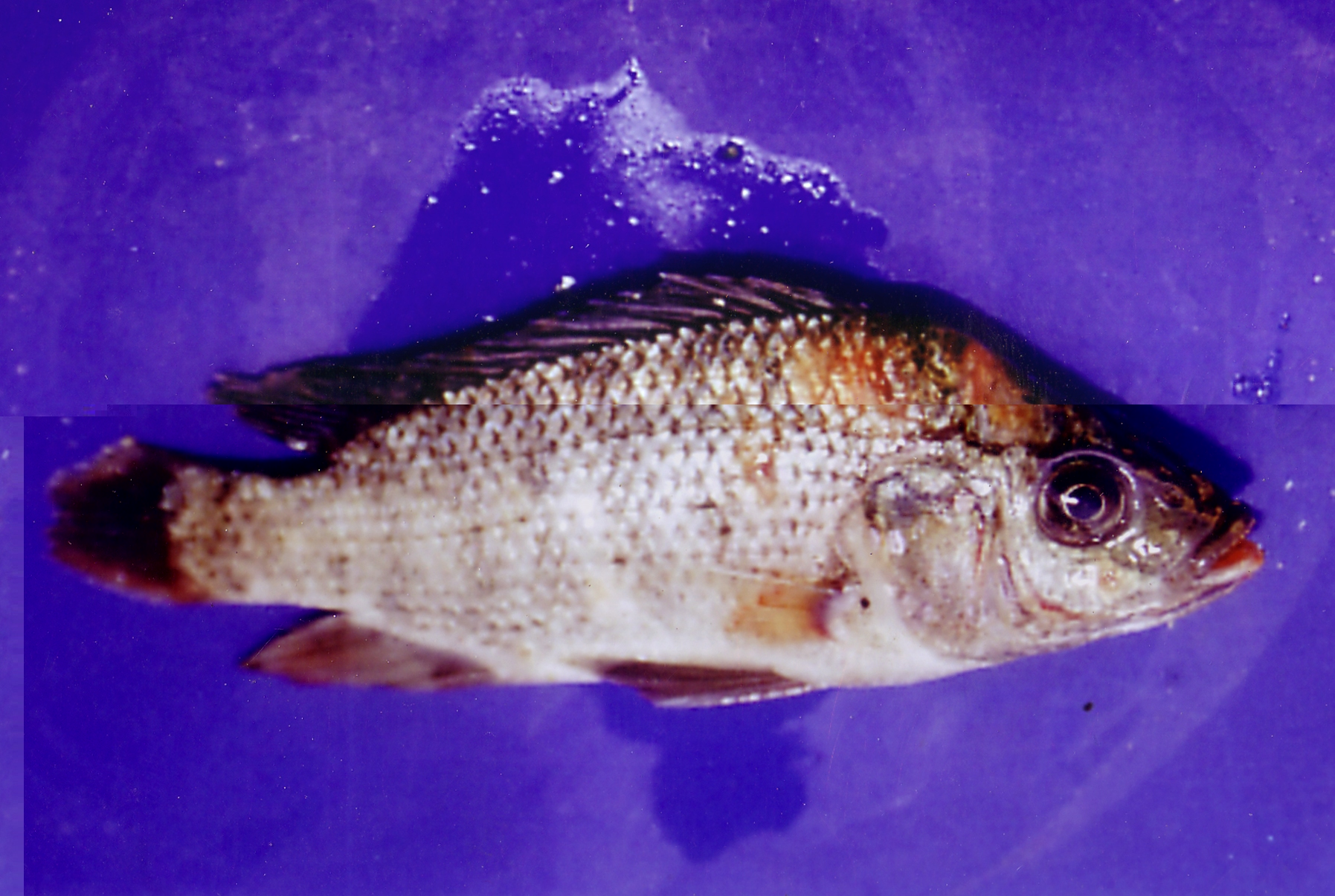  Photo ( 2 ) | 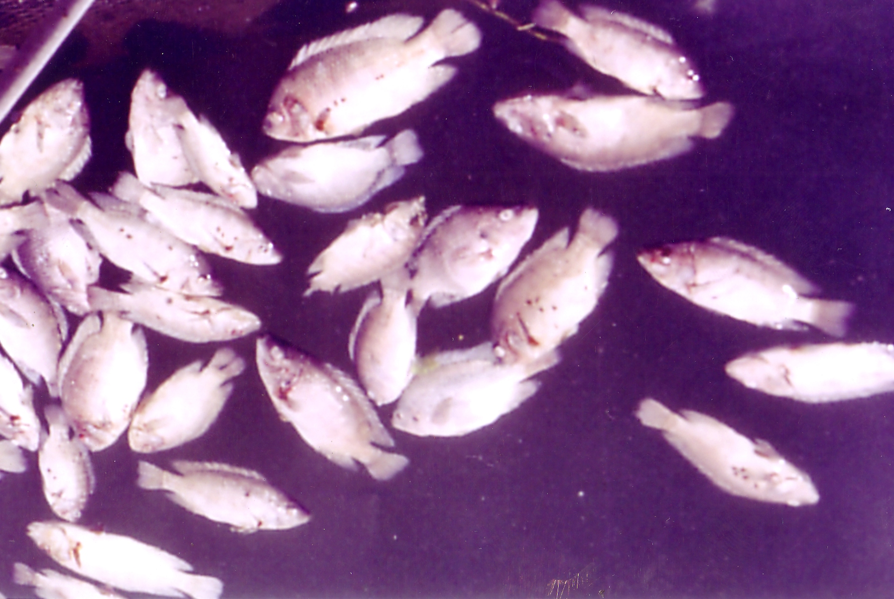  Photo ( 1 )
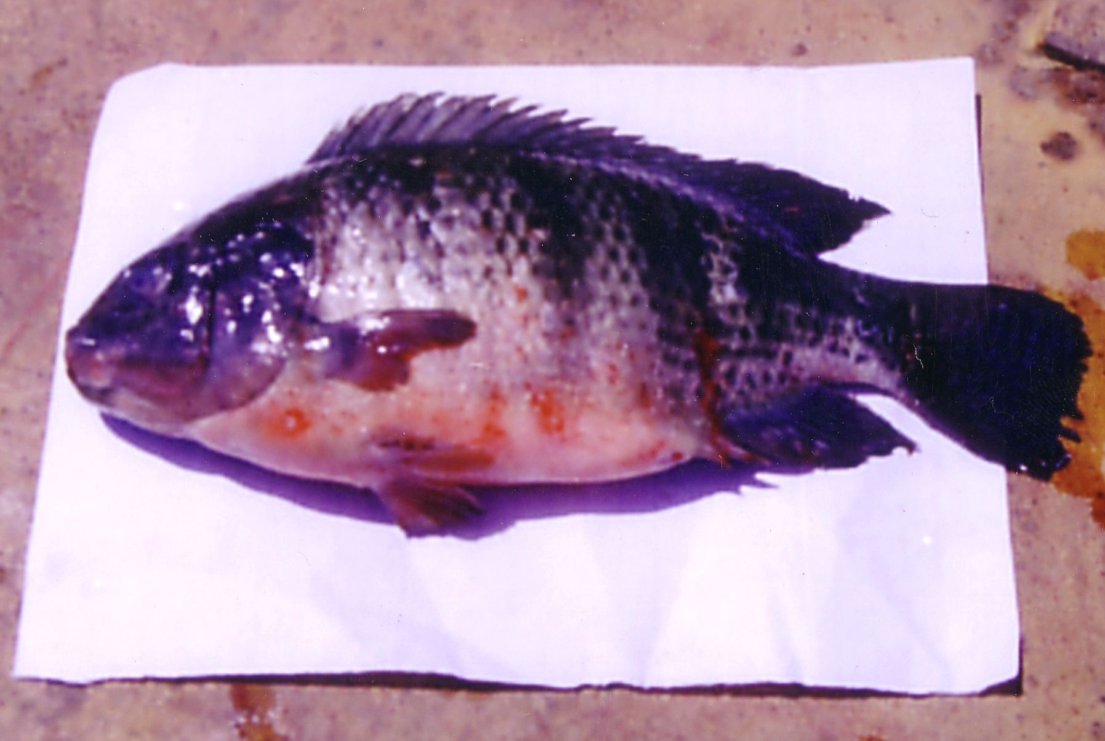  Photo ( 4 ) | 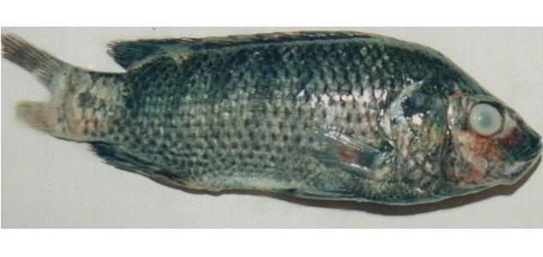  Photo ( 3 )
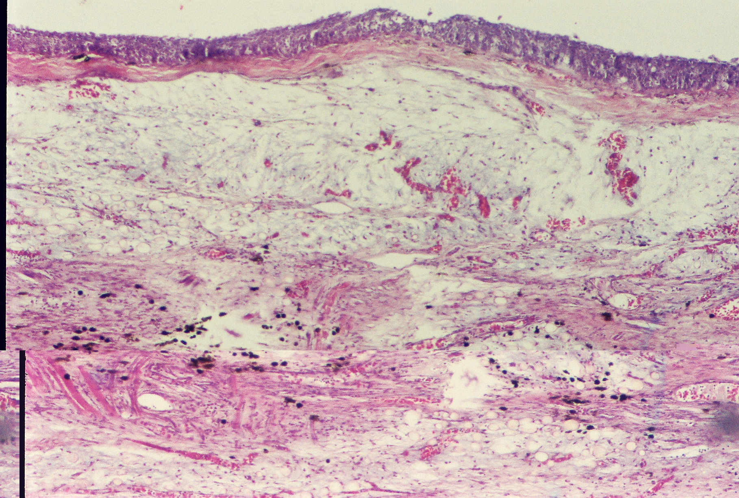 Photo ( 6 ) | 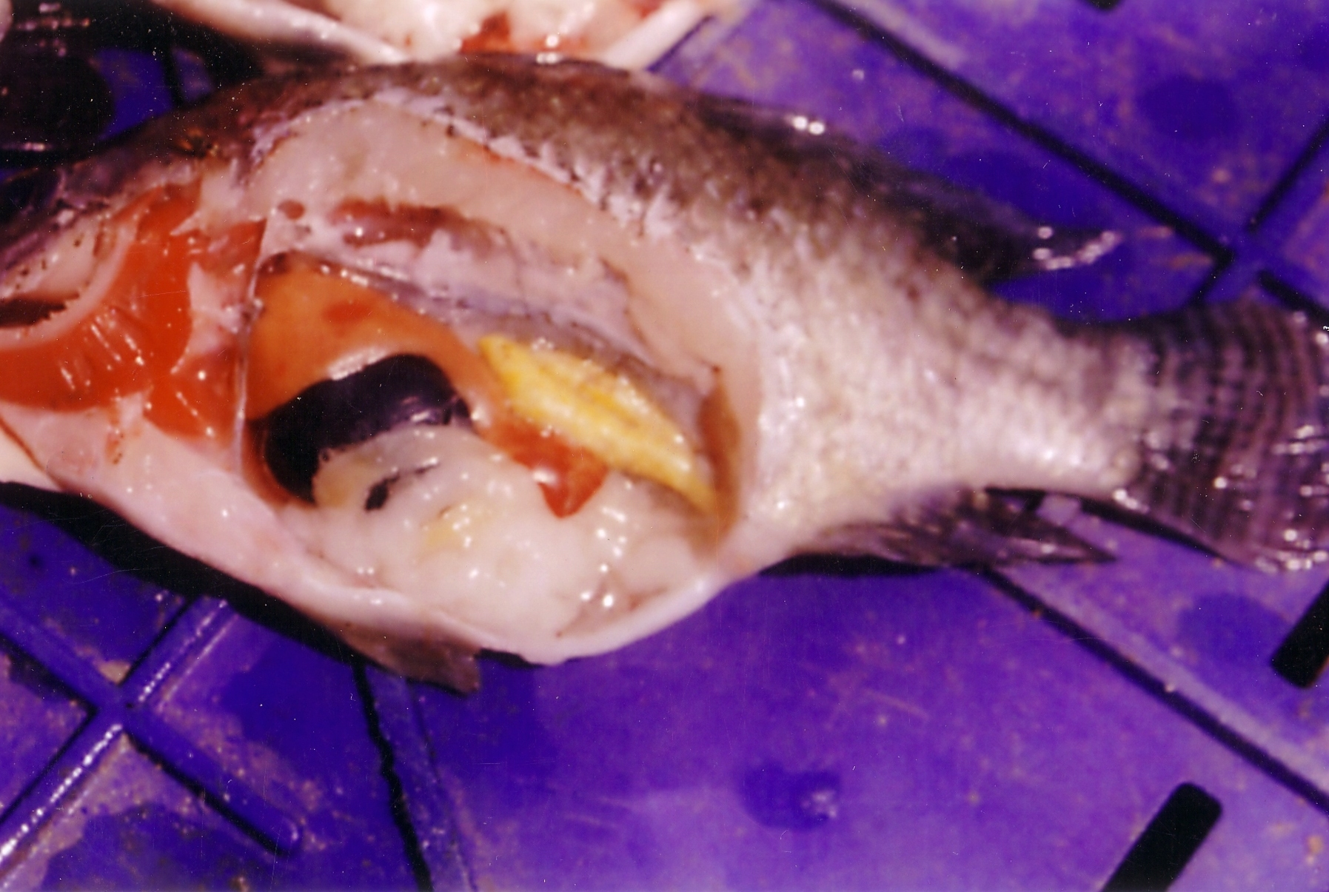  Photo ( 5 )
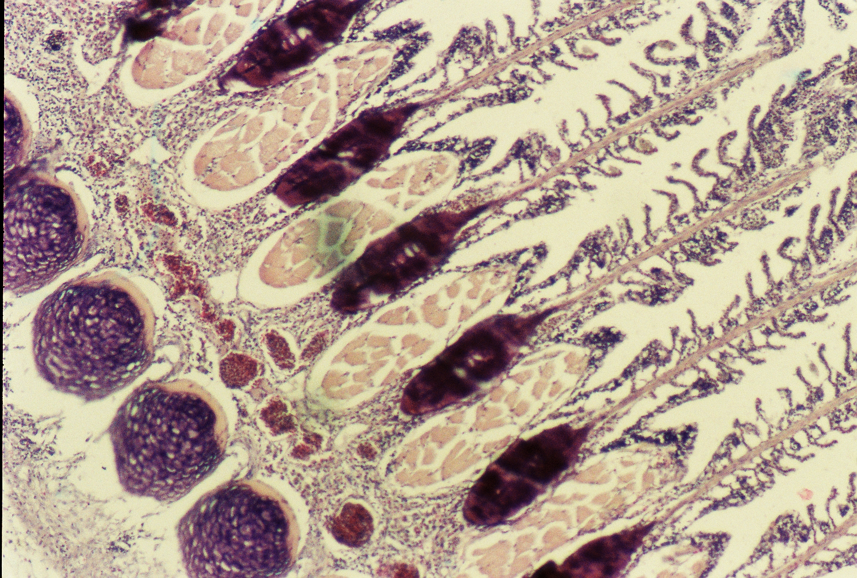  Photo ( 8 ) | 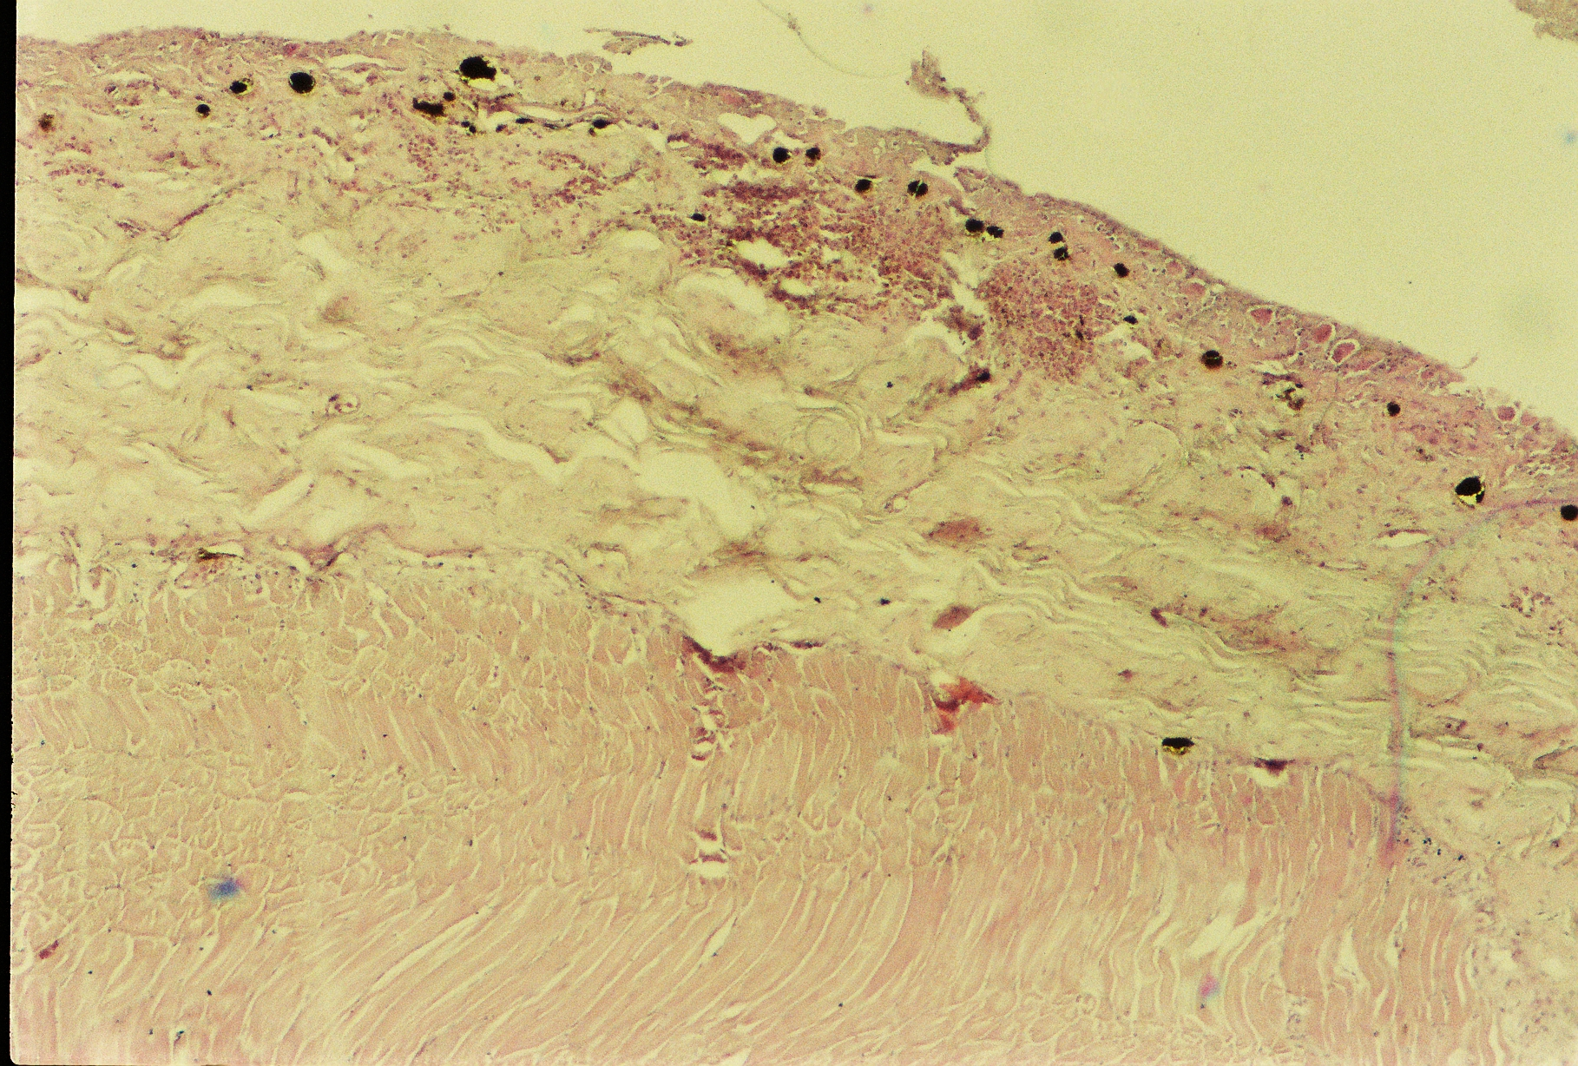  Photo ( 7 )
Photo (1) Showed high mortalities of naturally infected tilapia.
Photo (2) Naturally infected tilapia showed tail &fin rot, hemorrhage on different parts of the body, redness of the mouth with unilateral exophthalmia.
Photo (3) Naturally infected tilapia showed darkness of the body with bilateral cloudiness of the eye.
Photo (4) Naturally infected tilapia showed sever hemorrhage and abdominal dropsy.
Photo (5) Naturally infected tilapia internally showed congested gills, kidney, and enlarged liver with distended gallbladder.
Photo (6) & (7) Skin of naturally infected tilapia showed hyperplasia of alarm substance and mucous cells of the epidermis and congested and hemorrhagic dermis with excessive aggregation of lymphocytes and melanomacrophage cells with hyaline degeneration.
Photo (8) Gills of naturally infected tilapia showed congestion of branchial blood vessel of telangiectasis, complete sloughing of secondary lamellae with desquamation of epithelial cell covering of primary lamellae.
REFERANCES
- Abd El-Latif, M.M. and R.S.M. Adawy. 2004. Studies on Oreochromis niloticus in Manzala Lake, Suez Canal Vet.Med.J.V 11 (2) 403-410.
- Abou El-Atta. M. E. 2003. Efficiency of polymerase chain Reaction (P.C.R.) in diagnosis of some bacterial fish pathogens. Ph.D.Thesis in Vet. Sci (Bacteriology, immunology and mycology) 44-63. Suez Canal University.
- Ahmed, Sh., M., and A. M. Shorett. 2001). "Bacterial hemorrhagic septicemia in Oreochromis niloticus at Aswan fish hatcheries". Assiut Vet. Med. J. Vol. 45 No. 89, April 2001.
- Allen D.A., Austin B. and R.R. Colwell. 1983. Numerical taxonomy of bacterial isolates associated with of freshwater fishery. J. of general microbiology, 129, 2043 - 2062.
- Aly, S.E.M. 1994. Pathological studies on some fish in Suez Canal area. Ph. D.thesis (pathology) Fact. of Vet. Med. Suez. Canal University.
- Amlacher, E. 1970. "Textbook of Fish Diseases". T.F.S. publication, New Jersy, USA, 117-135.
- Angka, S.L and k. G. Lioe. 1982. Control of bacterial hemorrhagic septicemia in cultured fish. Bul. Perel Inst. Pertan Bogor 3 (3) pp 13-14 (In Bahasa Indonesia).
- Attia, Y. M. A. 2004. Studies on problems affecting gills of cultured fishes Ph.D. thesis Vet. Sci. Fish Disease Department. Fact. of Vet. Zagazig University.
- Austin, A. and D.A. Austin. 1993. "Bacterial fish pathogens", "second edition" pseudomonadaceae representatives' pp, 253.
- Badran, A.F., and I. A. Eissa. 1991. Studies on bacterial diseases among cultured fresh water fish (Oreochromis niloticus) in relation to the incidence of bacterial pathogens at Ismailia Governorate J. of Egypt. Vet Med. Association, 51 (4), PP 837 - 847.
- Badran, A.F. 1993. Studies on pseudomonas septicemia outbreak among intensively cultured fresh water fishes with special reference to its control. Zag. Vet. J. (21) 4, 737 - 746.
- Bergey, D. H. 1994. Bergey's Manual of Determinative Bacteriology, ed. R. E. Buchaman & N. E. Gibbons, 9lh ed. Baltimore: Williams and Wilkins.
- Bunch, E. C. and I. Bejerano. 1997. The effect of environmental factors on the susceptibility of hybrid tilapia Oreochromis niloticus X O. aureus to streptococcosis. The Israeli Journal of Aquaculture-Bamidgeh 94(2), 67-76.
- Chang, P. H, and J. A. Plumb. 1996. Histopathology of experimental Streptococcus sp. Infection in tilapia Oreochromis niloticus (L.). and channel catfish Ictaluru spunctatus.Journal Fish Diseases. 19, 235-241.
- Easa, M.E., Akeula, M.A. and M.M. El-Nimr. 1985. Enzootic of fin rot among Carp fingerlings in Egyptian fishponds. J. Egypt. Vet. Med. Assoc., 45 (1): 83-93.
- Eissa, I.A.M., A.F. Badran, A.S. Diab and A.M. Abdel-Rahman. 1996. "Some studies on prevailing bacterial diseases among cultured tilapias in Abbassa fish farms". Proceedings of the 3rd Vet. Med. Congress, Zag, 8-10 October 1996, Zagazig University, Egypt, pp. 185-202.
- El- Ashram, A.M.M. 2002. On Aeromonas hydrophila infection among cultured Tilapias: Abiological, Histophathological and management study. Egypt. J. Aquat. Biol & fish, 6, 3: 181 - 202 (ISSN 1110 - 6131).
- El-Altar, A.A and M. Moustafa. 1996. Some studies on tail and fin rot disease among cultured Tilapia fishes. Assiut Vet. Med. J, 35, 70, 155 - 159.
- El-Bouhy, Z. M. 1995. "Studies on the fin and tail rot disease in some commercial cultures in Sharkia province, J.Egypt.Vet. Med. Ass. No. 1, 2:123-140.
- Elemar, W. K., D. A. Stephen, M. J. William, C. S. Paul and C. w. Jr. Washington. 1997. Color Atlas and Textbook of Diagnostic Microbiology.5th Ed. Lippincott. Philadelphia. New York.
- El-Gamal, R.M. 1995. Bacterial causes of fin rot in some freshwater fishes M.V. Sc. Thesis (Microbiology) Fact of Vet. Med. Suez Canal Univ.
- Ferguson W.H. 1989. "Gills and pseudobranchs". In: Systemic Pathology of Fish. A texand Atlas of Comparative Tissue Responses in Diseases of Teleosts.
- Gamal A. Mohamed, M.S. Moustafa Fouda and S. Hussein Hussein 2002. "Aeromonas hydrophila infection in male mono sex Oreochromis niloticus fish reared in floating cages". 6th Vet. Med. Zag. Conference (7-9 Sept. 2002), Hurgada, Egypt.
- El-Refaee, A., M.E. 2005. Streptococcus infection in fresh water fish Ph.D. Thesis submitted to Faculty of Vet. Med., (Microbiology). Alex. University, Egypt.
- Fuller, I..D., A. C. Camus, C. L. Duncan, V. Nizet, D. J. Bast, R. L. Thune, D. E. Low and J. C. S. de Azavedo. 2002. Identification of a Streptolysin S-Associated Gene Cluster and its Role in the Pathogenesis of Streptococcus iniae, Disease Infection and Immunity, October 2002, p.5730-5739, Vol. 70, No. 10.
- Gatti R. and D.A. Nigreli. 1984. Hemorrhagic septicemia in Catfish, pathogenicity of strains isolated and reproductively of the disease, objectivie Documenti veterinari, 5 (6) p, 61 - 63.
- Goncalves, J.R., G. Braum, A. Fernandes, Biscaia, I., M.J.S. and J. Bastardo. 1992. Aeromonas hydrophila fulminate pneumonia in a fit young man Tborax 47, 482-483.
- Haylor, G., and S.A. Bland. 2001. Integrating aquaculture into rural development in coastal and inland areas. In Aquaculture in the third millennium PP 73 -81.
- Kitao, T. 1993. Streptococcal infections. Bacterial Diseases of Fish. (ed. ByV. Inglis, R. J. Roberts and N. R. Bromage), 196-210. Blackwell Scientific Publications, Oxford.
- Laila, A.M., F.R. El-Seedy, M.A. Abdel- Aziz, and W.S. Soliman. 2004. "Aerobic Bacteria Isolated from Freshwater Fishes in Egypt". The First International Conference of the Veterinary Research Division, National Research Centre, 15-17 February 2004, pp. 117.
- Marzouk, M. S. M. and A. Bakeer. 1991. Effect of water Ph. on Flexibacter columnaris infection in Nile Tilapia, Egypt, J. Comp. Path. Vol.4, No.1March 227-235.
- Miyazaki, T., S. S. Kubota, N. kaige and T. Miyashita. 1984. A histopathological study of streptococcal disease in tilapia. Fish Pathology 19:167-172.
- Miyazaki T., S.S. Kubotas. and T. Miyashita. 1984. Histopathological study and Pseudomonas fiuorescens infection in tilapia.Fish pathology 19 (3) 161 - 166.
- Newman,S.G. and J.J. Natnarich. 1982. Direct immersion vaccination of juvenile Rain Bow trout, salmo gairdnen, and juvenile Coho salmon, Oncorhymchus kisutch, with a Yarisina ruckeri bacterin J. of fish disease 5:338-341.
- Okaeme, A.N. 1989. Bacteria associated with mortality in tilapias (Heterobronchus bidorsalis) and (Clarias lazera) in indoor hatcheries and out door ponds. J.of Aqu.Trop4 (2)143-146.
- Plumb, J. A. 1994. Health maintenance of cultured fishes principal microbial diseases. C.R.C. Press Boca Raton, FL. USA. .
- Ringo E. and F. J. Gatesoupe. 1998. Lactic acid bacteria in fish: a review. Aquaculture 160:177-203.
- Roberts R.J. and M.T. Horne. 1978. Bacterial meningitis in farmed rainbow trout salmogarirdneri Richrdson, affected with chronic pancreatic necrosis J. of fish diseases 1, 157-164.
- Robert, RJ, 1989. The aquatic environment. In Fish Pathology". 2nd ed., Ed Roland J, Robert, Bailliere Tindall, London, Philadelphia, Sydney, Tokyo Toronto. P. 4-5.
- Robert, R.J. 1978. "Fish Pathology" Baillier Tindal, London, 194-195.
- Schäperclaus, W., H. Kulow and K. Schreckenbach. 1992a. Infections abdominal dropsy. In: Schäperclaus W. (Ed.) fish disease, Vol 1. Akademie- Verlag, Berlin, PP 401- 458.
- Schäperclaus, W., H. Kulow and K. Schreckenbach. 1992b. Fish Diseases, Vol. I. A.A. Balkema /Rotterdam, septicemia of fish, Fish disease leaflet 68(1- 24).
- Romalde, J. L., B. Magarinos, C. Villar, J. L. Barja and A. E. Toranzo. 1999. Genetic analysis of turbot pathogenic Streptococcus parauberis strains by ribotyping and random amplified polymorphic DNA. F.E.M.S. Microbiol. Lett. 15, 179(2):297-304
- Stoskopf, M. K. 1993. Fish Medicine. W.B.Sauder CO.882 pp.Vet.Med.J. Giza 45 (1) 87-99.
- Ventura, M. T. and J. M. Grizzle. 1988. Lesions associated with natural and experimental infections of Aeromonas hydrophila in channel catfish Ictalurus punctatus (Rafinesque). J. of fish diseases, 11: 397 - 407.
- Weinstein, M. R., M. Litt, D. A. Kertesz, P. Wyper, D. Rose, M. Coulter, A. McGeer, R. Facklam, C. Ostach, B. M. Willey, A. Borczyk, and D. E. Low. 1997. Invasive infections due to a fish pathogen, Streptococcus iniae. N. Engl. J. Med. 337:589-594.
- Wu, S. Y. 1970. New bacterial disease of Tilapia. Fish Culture Bulletin, v.23, p.3-40.
- Yambot A.V. 1998. "Isolation of Aeromonas hydrophila from Oreochromis niloticus during fish disease outbreaks in the Philippines." Asian Fisheries Science 10 (1998): 347-354. Asian Fisheries Society, Manila, Philippines.
- Zlotkin, A., S. Chilmonczyk, M. Eyngor, A. Hurvitz, C. Ghittino and A. 2003. Trojan horse effect: phagocyte-mediated Streptococcus iniae infection of fish. Infect Immun.71 (5):2318-2325.

