**The effects of plankton on Tilapia growth using organic and inorganic fertilizers and what causes phytoplankton bloom to “crash”**

# Contents

**Topic Pages**

Abstract 3

Introduction 4-5

Literature review 6-16

Objective of experiment 17

Materials 18

Procedure 19

References 20

Annexes 21-22

**Abstract**

Plankton is also one of the main sources of food for fish. They are the most common prey for all fish larvae. Plankton has its place in the lower regions of the food chain and is the basic source of food for small aquatic animals like fish larvae. During the early stage of their life cycle fish rely on their yolk sac for nutrition. They also rely on plankton to survive during its development stage. And if the number of plankton decreases, the population of fishes will be greatly affected. This cycle clearly demonstrates the impact of plankton upon pond life. Fish farmers have increased fish yields in ponds by using inorganic or chemical fertilizers and organic fertilizers or "manures." (Bocek, 2009)

When ponds are fertilized with organic and inorganic fertilizers, nutrients stimulate the growth of microscopic plants in the water (phytoplankton). Phytoplankton is food for other organisms (zooplankton and larger animals) that are eaten by fish. Abundant growth of these microscopic plants gives water a turbid, greenish color (called a “bloom”) that can prevent light from reaching the pond bottom and reduce the growth of rooted aquatic weeds. Fish farmers and recreational farm pond owners fertilize ponds to increase fish. Aquaculture ponds are fertilized to increase the available natural food (phytoplankton and zooplankton) for fry or larval fish, or for species that are efficient filter feeders.

Some ponds have very dense algae blooms dominated by one or two species. For reasons that are not well understood, these blooms are subject to spectacular collapse, often called a “crash,” where all the algae suddenly die. This research would highlight the effects of plankton on Tilapia growth using organic and inorganic fertilizers and the causes of phytoplankton blooms to “crashes.”

It was found that when organic fertilizers are used there is a higher phytoplankton bloom and higher oxygen level in the tanks where as when inorganic fertilizers are used there is a greater zooplankton population.

When organic and inorganic fertilizers are combined it provides food for fishes and the fishes in the combined tank had the highest weight gained.

*Brachionuspala* and *Daphnia pulex* which are plankton-feeding animals, will decrease the numbers of the phytoplanktonvery rapidlywhenpresent in high numbers.

**Introduction**

A fishpond is a unique environment created by man. It must be managed properly to achieve good fish production. For centuries fish farmers have increased fish yields in ponds by using inorganic or chemical fertilizers and organic fertilizers or "manures." (Bocek, 2009)

The major objective of applying fertilizers in fishponds is to enhance the primary productivity of the fish ponds i.e. to assure abundance of different fish food organisms (mainly phytoplankton, benthos and periphyton) in the aquatic environment. This encourages growth and production of fishes which feed on these organisms. Improved primary productivity in a fish pond requires adequate space, moisture, light, nutrients, favorable pH, temperature and absence of toxic substances. Of these, considerable importance has been laid on the influence of nutrient concentrations of pond environment on primary productivity. Other factors remaining favorable, nutrient concentrations determine the magnitude of phytoplankton growth, which relates to total fish production. Hence for obtaining maximum fish production, it is necessary to maintain the nutrient status of the pond to an optimum range. (Brunson et al, 1999).

A well-managed fertilized recreational pond can produce 200 to 400 pounds of fish per acre annually. This is three to four times the fish production that can be obtained without fertilization.

Phytoplanktons are free-floating microscopic algae. Photosynthetic activity by large plankton populations can produce enough oxygen to cause oxygen super saturation of water during mid-afternoon on bright sunlit days.

Phytoplankton growth is stimulated by addition of nitrogen, phosphorous and potassium. Populations may "bloom" 7 to 10 days after large inputs of nutrients, or "crash" when nutrients are depleted, or if toxic chemicals are added to the water. Phytoplankton respiration may be nearly 80% of oxygen consumption in water, and respiration by large phytoplankton populations may deplete oxygen in ponds during sustained periods of cloudy weather or at night.

There are two main sources of algal species used in aquaculture. These are: (1) natural populations of phytoplankton, either as they are found in nature or from cultures enriched by adding nutrients and (2) unialgal cultures. Unialgal cultures are essential when a high quality feed source with known nutritional properties is required.

Most species are unicellular or filamentous freshwater forms. The best known algae, such as Chlorella, Chlamydomonas, Dunaliella and Haematococcus, belong to this group. Some species accumulate high concentrations of carotenoids under certain culture conditions.

Chlorella is spherical in shape, about 2 to 10 [μm](http://en.wikipedia.org/wiki/Micrometre) in diameter, and is without [flagella](http://en.wikipedia.org/wiki/Flagella). *Chlorella* contains the green photosynthetic pigments [chlorophyll](http://en.wikipedia.org/wiki/Chlorophyll)-a and -b in its [chloroplast](http://en.wikipedia.org/wiki/Chloroplast). Through [photosynthesis](http://en.wikipedia.org/wiki/Photosynthesis) it multiplies rapidly requiring only [carbon dioxide](http://en.wikipedia.org/wiki/Carbon_dioxide), [water](http://en.wikipedia.org/wiki/Water), [sunlight](http://en.wikipedia.org/wiki/Sunlight), and a small amount of [minerals](http://en.wikipedia.org/wiki/Mineral) to reproduce.

**Literature review**

The natural productivity of a fish culture system depends largely on the availability of natural food organisms and on favorable environmental conditions for the fish.

Phytoplankton, the floating microscopic plants that give water its green color, are the first step in the food chain of fish ponds. Other organisms also feed on them and multiply, increasing the availability of natural food for fish stocked in the pond. In addition to carbon dioxide (C02) , water and sunlight for carbohydrate synthesis, phytoplankton need mineral elements including nitrogen, phosphorus, potassium, calcium, sulfur, iron, manganese, copper and zinc for their growth and nutrition. To promote phytoplankton growth and maintain the optimum natural productivity of ponds, the water must contain adequate amounts of these nutrients.

**What are Fertilizers?**

Fertilizers are natural or synthetic substances that are used in ponds to increase *the production of the natural food organisms* to be eaten by the fish. These organisms include *phytoplankton, zooplankton* and insects they are all part of a complex *food web* converging toward fish production. By increasing the availability of major nutrients, *fertilizers promote the development of plank tonic algae, which provide food for many fish*. Fertilization also leads to the development of animals which feed on algae, including some fish such as the Chinese silver carp and the Nile tilapia. **(See Annex I)**

When a fertilizer is added to a fish pond, *the chemicals* it contains dissolve in the water, where a portion is usually rapidly *taken up by the phytoplankton* present, either *to be stored*, sometimes in quite large proportions, or *to be assimilated* and used for growth, reproduction, etc.;

Another portion is *attracted by and becomes attached to* the organic and mineral particles present, both in the pond water and in the upper layers of the bottom mud or soil.

This second portion may also assist the development of *bacteria*, responsible for the decomposition of organic matter. The decomposition of organic matter may in turn release more nutrients back into the mud or water. The chemicals attached to soil particles may also later be *released back into the water slowly*, over a long period of time. They may also migrate deeper into mud and soil, where they will no longer affect the water body, unless the pond bottom is dried or ploughed.

Most of these phenomena are linked with and controlled by *water quality* and in particular temperature, pH, alkalinity and dissolved oxygen level. (Brunson et al, 1999)

**Types of Fertilizers**

Brunson, (1999) indicated that pond fertilizers form two distinct groups: *mineral or inorganic fertilizers*, which contain only mineral nutrients and no organic matter; they are manufactured industrially to be used in agriculture for improving crop production and they can be obtained from specialized suppliers.

*Organic fertilizers*, contains a mixture of organic matter and mineral nutrients; which are produced locally, for example as wastes from farm animals or as agricultural wastes.

The formulation of a fertilizer tells the percent by weight of nitrogen (N), phosphorus (as P2O5), and potassium (as K2O) in the fertilizer. For example, an 11-37-0 fertilizer contains 11 percent nitrogen, 37 percent phosphorus (as P2O5), and 0 percent potassium (as K2O). Phosphorus is the most important nutrient in ponds, but nitrogen and potassium may be needed occasionally. In new ponds, some nitrogen may be beneficial, while potassium is rarely, if ever, needed.

Organic materials are not recommended for fertilizing recreational farm ponds, as excessive amounts may lower dissolved oxygen to a critical level, possibly killing fish. The fertilizers can promote the growth of undesirable filamentous algae (commonly known as “Blue green algae”, “pond moss” or “pond scum”). Fertilizers are available through any farm supply dealer and are formulated specifically for ponds, but any fertilizer formulation with the appropriate nutrient levels can be used unless the product contains other ingredients that may be harmful to fish or other aquatic organisms. For example, do not Use fertilizers intended for lawn or turf application that contain either herbicides or insecticides. (Brunson et al, 1999)

**WHY FERTILIZE PONDS?**

Microscopic green plants called algae or "phytoplankton" form the base of the food chain for fish. All green plants need proper temperature, light, and nutrients for growth. If sufficient light and proper temperature are present, the nutrients in chemical fertilizers (nitrogen, phosphorous and potassium) are readily assimilated by phytoplankton and their abundance increases. Manure contains the same nutrients which are released and become available to phytoplankton during and after decomposition. As phytoplankton assimilate fertilizer nutrients and reproduce to form dense communities’ pond water turns a greenish or brownish color. This is called a phytoplankton bloom.

Sudden death of phytoplankton or algal bloom, "bloom crash**"**, may result from insufficient light (e.g. cloud cover) for photosynthesis, inadequate pond nutrients (a bloom too dense to be supported by available nutrients and oxygen) and/or bloom senescence (the plant cell line becomes too old to continue reproduction). Oxygen is consumed or depleted when dead phytoplankton/algae decay. During the nighttime hours, a dense phytoplankton bloom can remove all oxygen from the water for respiration (to breathe) alone. When a bloom crash occurs, the water appears to have become "black" or clear overnight.

Another phenomenon is where the culture gradually loses the colour over a couple of days, whereby something is eating all the phytoplankton; under close inspection there is a burgeoning population of rotifers and cladoceras.

As phytoplankton multiply they are eaten directly by some fish or by other mostly microscopic aquatic animals called "zooplankton." Phytoplankton and zooplankton (collectively called "plankton") also serve as food for larger aquatic organisms. Through a complexed chain of interactions, fertilizers increase production of natural food organisms eaten by fish. Different fish may have different food preferences. Some can filter plankton, others eat aquatic insects and others may feed on decomposing material. **See figure 1.** (Bocek, 2009)

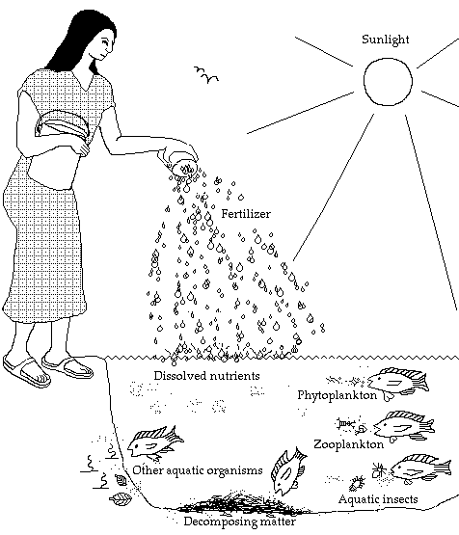

**Figure 1. Showing how fertilization increases the abundance of natural fish food.**

**(Bocek, 2009)**

**DIFFERENCES BETWEEN CHEMICAL FERTILIZERS AND MANURES**

Chemical fertilizers are concentrated nutrients for green plants. they can be stored for a long time, and 2) relatively little is needed since the nutrients are in a concentrated form. These are important advantages over manures since labor and transportation are costly. The disadvantages of chemical fertilizers, especially if the farm is isolated and operates on a limited budget, are that they are expensive and available only from commercial suppliers. **See Annex 2**

Chemical fertilizers might also be a potential for being wasted. Adding chemical fertilizer to a pond stimulates phytoplankton growth. However, if too much is added the plankton can become so dense that sunlight penetration through the water is restricted. When this occurs algae cells may have more than enough nitrogen and phosphorus available in the water, but they do not receive sufficient sunlight and no additional plankton will be produced. Keeping phytoplankton abundance within the limits suggested for Secchi disk or arm measurement helps ensure that excess fertilizer is not applied.

Chemical fertilizer are not eaten directly by fish. “Manure, however, can serve several roles. It releases nutrients for phytoplankton through decomposition; certain fish can digest specific components of manure; fish may digest the bacteria, fungi and other organisms contained in manure even though the manure itself may have no nutritional value.” (Bocek, 2009)

Conversely, large quantities of manure are needed to fertilize ponds and are a disadvantage. Adding too much manure to a pond at one time to a pond can be dangerous. . Decomposition may deplete oxygen in the water or cause harmful substances to accumulate. And as a result the fish may.“Proper management this problem can be avoided or corrected and where manures are available they are often the fertilizer of choice.” (Bocek, 2009)

The combined use of both organic and inorganic fertilizers is a strategy for increased production of fish food organisms.

**MEASURING THE EFFECT OF FERTILIZATION**

Fertilization can be measured by the abundance of phytoplankton. When phytoplankton is abundant, the water becomes a turbid green or brownish color. If the pond water is not very muddy, the turbidity caused by phytoplankton can serve as a measure of phytoplankton abundance. When using a disk and when it disappears from sight it is the Secchi disk reading. **See figure 2.** (Bocek, 2009)

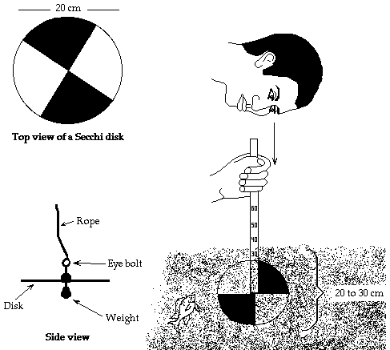

**Figure 2. Showing the use of a secchi disc (Bocek, 2009)**

**FOOD CHAINS**

The nutrients in chemical fertilizers are "food" for green plants, and have no direct food value to fish. Chemical fertilizers when added to a pond cause thephytoplankton to become more abundant. It is then consumed directly by fish or by zooplankton and insects, which are subsequently eaten by fish. This step-by-step process is called a food chain. See figure 3 below. (Bocek, 2009)

Adding manure instead of chemical fertilizer to a pond eliminates a step in the food chain since many fish will consume manure directly. Manure is consumedby zooplankton or insects which are later eaten by fish or it may be decomposed by bacteria and other organisms. Assimilation by phytoplankton occurs when nutrients are decomposed. A simplified food chain illustrating direct and indirect consumption of fertilizer nutrients by fish follows. **See figure 3** (Bocek, 2009)

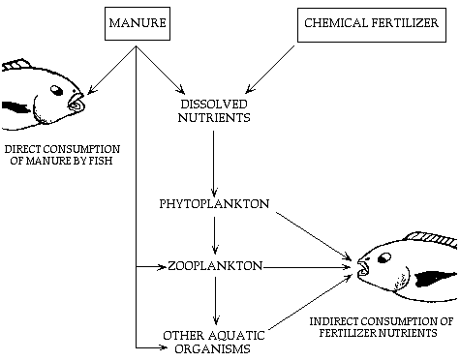

**Figure 3. Showing Simplified food chain showing pathways through which fertilizer nutrients are turned into fish flesh. (Bocek, 2009)**

During work on the growth of algae in experimental tubs, it was found that when certain small planktonic animals became numerous, their feeding had very striking effects on the numbers of algae and on the general conditions in the tub. Similar effects were later observed in ponds. The importance of the phytoplankton, including the nannoplankton, as a source of food for rotifers and Cladocera, is generally recognized, but it is perhaps not so widely realized how seriously these small animals can reduce the numbers of the phytoplankton.

Dieffenbach&Sachse (1912), working on the biology of rotifers in ponds, noted that a rich growth of planktonic algae was frequently followed by a great increase in the number of rotifers, which fed on the algae and rapidly reduced their numbers. When the food supply was exhausted, the number of rotifers decreased.

The plankton-feeding animals *Brachionuspala* and *Daphnia pulex,* when present in sufficient numbers, can reduce the numbers of the phytoplankton very rapidly. In all cases observed, such a rapid reduction of the phytoplankton was accompanied by almost complete oxygen depletion, and death of the animals, after which the numbers of algae again increased. This cycle of events, first observed in experimental tubs, has been found to occur in ponds. It is suggested that in addition to such rapid and sudden reduction in numbers of algae, plankton-feeding animals may have important effects on the rate of increase in numbers of algae at any stage of the annual cycle (Pennington,1941).

The dominant algae of the plankton were nearly always small members of the *Chlorococcales-Chlorella, Scenedesmus*, or a minute alga which has been described (Pennington, 1941), under the name of *Diogenes rotundus*, and which, apart from its method of reproduction, resembles a small Chlorella.

At the time when the population of a tub had reached a high, more or less constant, level, *Diogenes rotundus* almost invariably formed the bulk of the phytoplankton, and in bright summer weather its numbers often exceeded 20,000 per cu. mm., when the water would be bright green and almost opaque (Pennington,1941).

In such a tub, it was frequently observed that in the course of a few days the colour changed from bright green to a dull olive green, and then to black, and at the same time became sufficiently clear to show the bottom of the tub.

Counts of the algae showed that their numbers had decreased very rapidly, and on examination, the water was found to contain enormous numbers of small animals-in every case either the rotifer, *Brachionuspala*, or the crustacean, *Daphnia pulex*. This sudden destruction of the algae by small invertebrate animals is here termed a 'crash'(Pennington,1941).

When the significance of the 'crash' phenomenon was appreciated, further investigations of the feeding habits of small animals from the tubs were carried out. The gut contents were examined, and those species which appeared to feed on plankton algae were kept and observed in cultures in beakers. Then closer investigations were made of their feeding habits in the tubs, and the course of a crash followed in detail.

Gut contents

Of all the small animals whose gut contents were investigated, it appeared that only rotifers and Daphnia were important in reducing the numbers of plankton algae. *Brachionuspala* and *Daphnia pulex* both had large numbers of the smaller plankton algae from the tubs in their stomachs-in fact, these algae appeared to be their main diet in the tub environment. Live individuals of *Brachionuspala* in a culture of *Diogenes* were observed to take in large numbers of the algae by the action of the cilia on their trochal disks. Once eaten by a rotifer, the algae fairly rapidly became unrecognizable, only the somewhat misshapen cell wall surviving digestion. In the gut of *Daphnia*, the algae retained their shape over a longer period. Neither of these animals appeared to show any selectivity in feeding, apart from that imposed by the relative sizes of animals and algae. *Brachionus* ate Chlorella as well as *Diogenes rotundus*, when both were present, but nothing larger. Daphnia ate any alga occurring in the cultures in which it was grown, up to the size of *PediastrumBoryanum*, small individuals of which were found in its gut (Pennington,1941) .

The other animals commonly present in the tubs were not important in reducing the numbers of plankton algae. The only other plankton feeder was the larva of Culex sp., which was frequent in the summer. The guts of these were full of plankton algae, but the larvae did not occur in sufficiently large numbers to cause an appreciable reduction in the numbers of algae in the tub (Pennington,1941).

**The Objectives of the experiment were as follows:**

1. To determine the effects of plankton on growth rates of tilapia.
2. To compare the differences between organic fertilizers (cow manure) and inorganic fertilizers (Triple Super Phosphate (TSP) and urea) on phytoplankton “bloom”
3. What causes phytoplankton bloom to “crash or die off”

**Materials used in the experiments are:**

|  |  |
| --- | --- |
| Four tanks each measuring 7.3 m.  Triple Super Phosphate (TSP)  Urea  Cow manure  1 Secchi disk  Agricultural lime  Biological microscope | Slides  Digital camera  pH meter  DO meter  Temperature meter  40 fishes, 10 fish per tank |

**Procedure used for conducting the experiment:**

1. The tanks 1, 2, 3 and 4 at the SatyadeowSawh Aquaculture were treated with agriculture lime to kill any unwanted fish and increase the pH of the water.
2. Water sample was collected from the concrete ponds, using a microscope the samples were examine to identify the algae present; chlorella was isolated and culture in the lab. It was then used to inoculate the selective tanks.
3. Tank 1 was not fertilized nor inoculated with chlorella, tank 2 was fertilized with cow manure (0.14g/m2) and inoculated with chlorella, tank 3 was fertilized with TSP (0.014g/m2) and Urea (0.014g/m2) not inoculated with chlorella, while tank 4 was fertilized with cow manure (0.14g/m2), TSP (0.014g/m2) and Urea (0.014g/m2) and inoculated with chlorella.
4. Ten fishes between 20 – 25g were placed into each tank.
5. Every two weeks they were weighted and the figures recorded
6. The transparency of the water was checked twice weekly (Tuesday and Friday) using a secchi disc to monitor the fertilization process.
7. The pH meter was used to check the pH daily (morning at 9 hrs and afternoon at 15 hrs).
8. The DO meter was used to check the dissolved oxygen level daily (morning at 9 hrs and afternoon at 15 hrs).
9. The thermometer was used to check the temperature of the water daily (morning at 9 hrs and afternoon at 15 hrs).
10. Water samples were collected once a week and observed under the microscope.
11. Water exchange was conducted on Mondays and Fridays or as a need arise.

**Results**

**Table 1 showing the types of plankton found in tanks**

|  |  |  |
| --- | --- | --- |
| **Tanks #** | **Photoplanktons** | **Zooplanktons** |
| 1 | Chlorella | Cladocers (*Daphnia pulex* ) Rotifers (*Brachionuspala),*and copepods |
| 2 | Chlorella | Mosquito larvae (*Aedes or* Culex) |
| 3 | Blue green algae | Cladocers (*Daphnia pulex* ) Rotifers (*Brachionuspala),*and copepods |
| 4 | Chlorella | Cladocers (*Daphnia pulex* ) Rotifers (*Brachionuspala),*and copepods |

|  |  |  |  |  |
| --- | --- | --- | --- | --- |
|  | No feeding | Organic fertilizer | Inorganic fertilizer | Combined organic and inorganic fertilizer |
| Final average weight (grams) | 38.9 | 42 | 45.8 | 51.2 |
| Initial average weight (grams) | 22.8 | 22.6 | 22.4 | 22.6 |
| Change in weight (grams) | 16.1 | 19.4 | 23.4 | 28.6 |

**Table 2 showing the weight of the fishes that consumed the plankton**

**Figure 4. Showing the growth rates of the fishes**

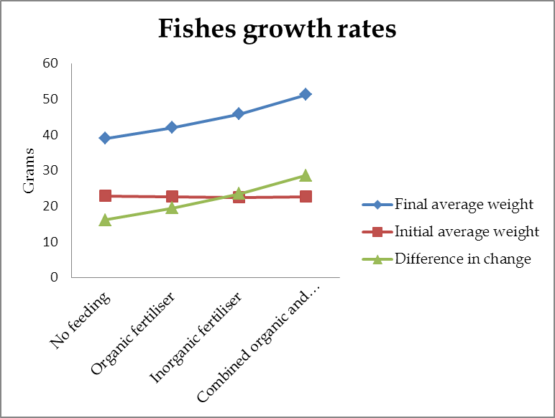

**Figure 5. Showing the water quality reading**

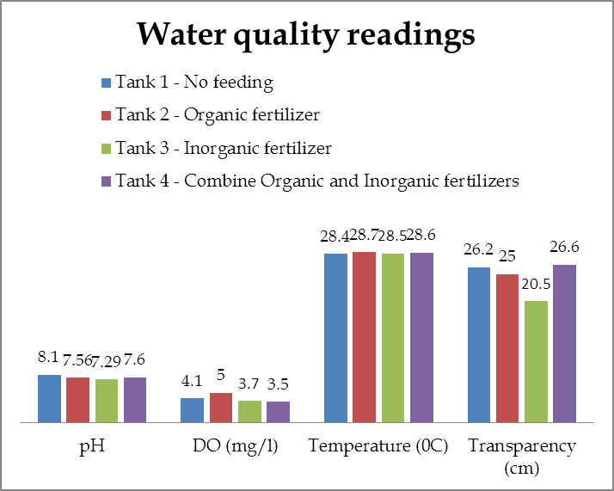

**Discussion**

Table 1, shows the planktons found in each of the tanks. Tank # 1 which was not fertilized had a bloom of both phytoplankton and zooplankton. There was also blue green alga present. The plankton blooms could have resulted from the fecal contents produced by the fishes.

Tank # 2 which was fertilized with the organic manure maintained the chlorella algae alone. There was no zooplankton or other algae. This could have resulted from the properties of the cow manure. Organic fertilizers have small amounts of nitrogen.

Tank # 3 was fertilized with the inorganic fertilizer, Triple superphosphate and Urea, this resulted in a bloom in zooplanktons, Cladocers (*Daphnia pulex*) Rotifers (*Brachionuspala),*and copepods. The copepods however, were not in significant amounts as compared to the cladocers and rotifers. There were also small concentrations of blue-green algae. An inorganic fertilizer such as Triple superphosphate is a [fertilizer](http://en.wikipedia.org/wiki/Fertilizer) produced by the action of concentrated [phosphoric acid](http://en.wikipedia.org/wiki/Phosphoric_acid) on ground [phosphate rock](http://en.wikipedia.org/wiki/Phosphate_rock).

Ca3 (PO4)2(*s*) + 4 H3PO4 (*aq*) → 3 Ca2+(*aq*) + 6 H2PO41-(*aq*) → 3 Ca(H2PO4)2(*aq*)

The active ingredient of the product, monocalcium phosphate, is identical to that of superphosphate, but without the presence of [calcium sulfate](http://en.wikipedia.org/wiki/Calcium_sulfate) that is formed if [sulfuric acid](http://en.wikipedia.org/wiki/Sulfuric_acid) is used instead of [phosphoric acid](http://en.wikipedia.org/wiki/Phosphoric_acid). The phosphorus content of triple superphosphate (17 - 23% P; 44 to 52% P2O5) is therefore greater than that of superphosphate (7 - 9.5% P; 16 to 22% P2O5).

Urea fertilizer, also known as carbamide, is the most important nitrogenous fertilizer. It is a white crystalline organic chemical compound containing about 46 percent nitrogen. It is a waste product formed naturally by metabolizing protein in humans as well as other mammals, amphibians and some fish. Synthetic urea is produced commercially from ammonia and carbon dioxide.

The blue-green algae produced could have resulted from too much nitrogen in the tank since the fishes also excrete ammonia into the water. The combinations of the inorganic fertilizer, urea with the ammonia may cause the undesirable growth of the blue green algae.

Tank #4 had planktons chlorella which was inoculated into the tank and the same zooplanktons as found in tank # 3, which were Cladocers (*Daphnia pulex* ) Rotifers (*Brachionuspala),*and copepods.

Table # 2 and Figure # 4 shows the weight gain and the growth rates of the fishes. The highest increase in weight and growth rate came from tank # 4 probably due to the phytoplankton and zooplanktons that were consumed by the fishes. The minimum growth rate was from tank # 1 while the second highest growth rate was from tank # 3, which contained the zooplanktons. This maybe due to the fact that zooplanktons would have a higher amount of protein as compared to the phytoplankton is a tiny aquatic plant, which comprises of more water and less protein. Tank # 2 growth rates were higher than tank 1 but less than tank 3 and tank 4.For centuries fish farmers have increased fish yields in ponds by using inorganic or chemical fertilizers and organic fertilizers or "manures." (Bocek, 2009).

Figure 5. Shows the water quality readings for pH, dissolved oxygen, temperature and transparency. The pH was significantly different in tank # 1 as compared to the other tanks where there was no significant difference. However, tank # 2 had the highest dissolved oxygen (DO), which was significantly different from tanks # 3 and 4. When tank # 1 was compared to tank # 2 there was no significant difference, where as, there were significant differences when compared to tank # 3 and 4. We hypothesized that tank # 2 had the highest DO because there was a higher amount of phytoplankton in that tank. The zooplankton population was higher in tanks # 3 and # 4, which consumed the phytoplankton, hence a lower DO.Bocek, 2009 had observed this action.

There was no significant difference in temperature between all the tanks.

There was significant difference in tank # 3 as it related to the transparency, which was measured using a Secchi disc where as there were no significant differences in the other tanks. There reasons why tank # 2 had the lowest transparency is probably because the zooplankton population was higher in the tanks, which consumed the phytoplankton. This was similar to what Bocek, 2009 had observed.

Phytoplankton populations, or blooms, can grow rapidly, particularly on sunny days when the water is warm and nutrients are available. Alternatively, they can die-off quickly, especially in the spring and fall as water temperatures change rapidly with weather fronts. However, a bloom die-off can occur at any time of the year with little or no warning.

Typically during a bloom die-off, the color of the water will start to change. Leading up to a bloom die-off, the pond water may have a “streaky” appearance. Streaks of brown or gray-black through the otherwise green water of the pond is an indication that the algae are starting to die. As the die-off progresses, the whole pond will turn from green to gray, brown, or clear. The pond water will typically clear after a die-off as the dead algae settle to the bottom.

Plankton die-offs cause rapid oxygen depletions for two reasons: 1) the remaining dissolved oxygen is consumed by aerobic bacteria and fungi in the process of decaying the dead algae and 2) few live phytoplankton’s remain to produce more oxygen. Secchi disks can be used to monitor bloom densities. Any bloom that reduces visibility in the pond to 25 cm or less may cause oxygen problems.

Plankton-feeding animals control the numbers of the phytoplankton and havean impact on the numbers of the phytoplankton found in the tanks. This depends on the numbers of animals and algae present. When the numbers of algae are tiny, a small number of animals may prevent any increase in algal numbers. It is believed that this occurred in the tanks in which the algal inoculum failed to grow and disappeared.

Once the algae started to increase, the sequence of events described a crash. Initially, there is a steady increase in the numbers of algae, the reproduction rate is sufficient to compensate for the numbers eaten by animals. However, as the algae reproduction rate begins to slow down, a critical stage is reached when the reproduction rate, where the numbers balances the daily increase in numbers consumed by animals. Further, an increase in the number of animals at this stage resulted in a crash, whereby the numbers of algae were rapidly reduced, until nearly all was destroyed. This produced important changes in water composition, notably almost complete oxygen depletion, as a result of this the animals are frequently destroyed. The few remaining algae are not destroyed, and after the death of the animals begin to multiply rapidly once more. This may have been the reason why tanks # 3 and #4 had the low oxygen level and tank # 3 had the lowest Secchi reading.

The time at which the critical stage is reached is not the same. This is may be due to differences from one tank to another, in the respective reproduction rates of animals and algae. The factors controlling these reproduction rates are still unknown. Sometimes the critical stage was reached soon after inoculation, before the numbers of algae were very high, and there was no sudden asphyxiation, but only a gradual disappearance, apparently from starvation, following the disappearance of the algae. While no direct proof can be offered, it seems likely that the differences were due to variation in the animal population, arising from chance inoculation with animals from previous experiments.

Pennington, (1941) found a phenomenon that was similar to what was described from the experimental tubs. In the rich culture solution of the tubs, both animals and algae were present in greater concentration than is found in ponds, but there was no reason why similar crashs should not occur in eutrophic ponds. A crash was observed in a pond near Burghfield Common, Reading, in the autumn of 1938. A rich growth of algae, comprising mainly of flagellates, developed in the water, and then suddenly disappeared, the disappearance coincided with the appearance of large numbers of Cladoceran (probably *Daphnia sp*.) and a Copepod. The water became black and acquired a foul smell, which was typical of anaerobic waters. The late phase of a crash, in which the zooplankton is concentrated in the upper layers of the water, which are more oxygenated, and algae have practically disappeared from the water, is common in farm ponds.

The differences in the growth of algae in similarly treated tanks may be due to the chance of variation in the number of plankton-feeding animals. In tanks, the effects of plankton-feeding animals on the phytoplankton showed no relation to season.

## Conclusion

It was found that when organic fertilizers are used there is a higher phytoplankton bloom and higher oxygen level in the tanks where as when inorganic fertilizers are used there is a greater zooplankton population.

When organic and inorganic fertilizers are combined it provides food for fishes and the fishes in the combined tank had the highest weight gained. Obtaining maximum fish production, it is necessary to maintain the nutrient status of the pond to an optimum range. (Brunson et al, 1999).

*Brachionuspala* and *Daphnia pulex* which are plankton-feeding animals, will decrease the numbers of the phytoplankton very rapidly when present in high numbers.

It was observed that a rapid reduction of the phytoplankton was accompanied by almost complete oxygen depletion, and death of the animals, after which the algae population increased again. This cycle of events observed in experimental tubs, has been found to occur in ponds, Pennington, (1941). In addition to rapid and sudden reduction in numbers of algae, plankton-feeding animals may have important effects on the rate of increase in numbers of algae at any stage of the annual cycle.

**References**

* Bocek, A. 2009.***Water Harvesting and Aquaculture for Rural Development.*** International Center for Aquaculture and Aquatic Environments, Swingle Hall. Auburn University, Alabama 36849-5419 USA.
* Brunson, W., Stone, N. and Hargreaves, J. 1999. ***Fertilization of Fish Ponds.*** PR SRAC Publication No. 471 SRAC Publication No. 471.
* Dieffenbach, H. &Sachse, R. (1912). BiologischeUntersuchungenanRadertieren in Teichgewassern. Internat. Rev. Hydrobiol., Biol. Supp. 4.
* Pennington, Winifred (1941). Diogenes rotundus, gen. et sp. nov.-a new alga from experimental tubs. J. Bot. 1941 (in the press).
* Winifred Pennington (Aug., 1941) The Control of the Numbers of Freshwater Phytoplankton by Small Invertebrate Animals, Journal of Ecology, Vol. 29, No. 2 (Aug., 1941), pp. 204-211 Published by: British Ecological Society

**ANNEXES**

**Annex 1** How they use fertilizers to increase the production of natural food for fish

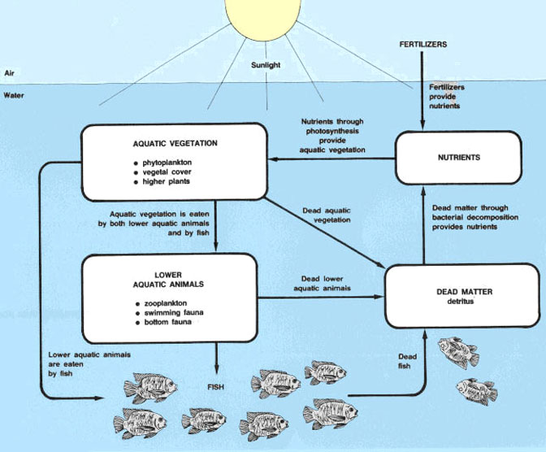

**Annex 2**

|  |  |  |
| --- | --- | --- |
| **Item** | **Organic fertilizers** | **Inorganic fertilizers** |
| Storage | Difficult, only short time | Easy, possibly for long time |
| Distribution | Difficult, esp. on larger scale | Easy |
| Mineral content | Variable, low | Consistent, high to very high |
| Organic matter | Present | Absent |
| Effect on soil structure | Improvement | No |
| Direct food for fish | Yes | No |
| Decomposition process | Yes, with oxygen consumption | No |
| Price | Low to medium | High to very high |
| Cost per nutrient unit | Higher | Lower |
| Availability | Possibly in neighborhood or even on own farm | Commercial suppliers only; sometimes imported |
| Direct pond fertilization | Possible by raising animals on or near the pond | Not feasible |